**MINISTRY OF EDUCATION AND**



**TRAINING**

**FPT UNIVERSITY**

Capstone Project Document

**Diamond Evaluation System**



**GSP23SE27**

|  | Nguyễn Vũ Nguyên – Team Leader – SE173423 |
| --- | --- |
| **Group Members** | Lê Phúc Trường – Team Member – SE173387 |
| Phan Văn Trường – Team Member – SE173394 |
|  |
|  | Trần Anh Vỹ – Team Member – SE173411 |
|  | Nguyễn Tuấn An – Team Member – SE173412 |
|  |  |
| **Supervisor** | Mr. Tôn Thất Hoàng Minh |
|  |  |
| **Capstone Project code** | **SE23SE37** |
|  |  |
|  |  |

**- Ho Chi Minh, June 2024 -**

**Table of Contents**

|  |  |
| --- | --- |
| Table of Contents | 2 |
| List of Tables | 11 |
| List of Figures | 14 |
| Acknowledgements | 17 |
| Definition and Acronyms | 18 |
| I. Project Introduction | 19 |
| 1. Overview | 19 |
| 1.1 Project Information | 19 |
| 1.2 Project Team | 19 |
| a. Supervisors | 19 |
| b. Team Members | 19 |
| 2. Product Background | 19 |
| 3.1 Richdad | 20 |
| 3.2 Business Tour | 20 |
| 4. Business Opportunity | 21 |
| 5. Software Product Vision | 21 |
| 6. Project Scope & Limitations | 21 |
| 6.1 Major Features | 21 |
| 6.2 Limitations | 22 |
| II. Project Management Plan | 23 |
| 1. Overview | 23 |

2

|  |  |
| --- | --- |
| 1.1 Scope & Estimation | 23 |
| 1.2 Project Objectives | 24 |
| 1.3 Project Risks | 25 |
| 2. Management Approach | 25 |
| 2.1 Project Process | 25 |
| 2.2 Quality Management | 26 |
| 2.3 Training Plan | 27 |
| 3. Project Deliverables | 27 |
| 4. Responsibility Assignments | 28 |
| 5. Project Communications | 28 |
| 5.2 External Interface | 29 |
| a. FU Contacts | 29 |
| 6. Configuration Management | 29 |
| 6.1 Document Management | 29 |
| 6.2 Source Code Management | 30 |
| 6.3 Tools & Infrastructures | 30 |
| III. Software Requirements Specification | 31 |
| 1. Product Overview | 31 |
| 1.1 Guest Requirements | 31 |
| 1.2 Player Requirements | 31 |
| 1.3 Admin Requirements | 31 |
| 2. User Requirements | 32 |
| 2.1 Actors | 32 |

3

|  |  |
| --- | --- |
| 2.2 Use Cases | 33 |
| 2.2.1 Diagram | 33 |
| 2.2.2 Use Case List with description | 34 |
| 3. Functional Requirements | 38 |
| 3.1 System Functional Overview | 38 |
| 3.1.1 Screens Flow | 38 |
| 3.1.2 Functional requirements | 40 |
| 3.1.4 Non-Screen Functions | 57 |
| 3.2 Entity Relationship Diagram | 57 |
| 4. Non-Functional Requirements | 66 |
| 4.1 External Interfaces | 66 |
| 4.2 Quality Attributes | 66 |
| 4.2.1 Usability | 66 |
| 4.2.2 Reliability | 66 |
| 4.2.3 Performance | 67 |
| 4.2.4 Design constraints | 67 |
| 4.2.5 Security | 67 |
| 5. Requirement Appendix | 67 |
| 5.1 Business Rules | 67 |
| 5.2 Application Messages List | 69 |
| IV. Software Design Description | 72 |
| 1. System Design | 72 |
| 1.1 System Architecture Overview | 72 |

4

|  |  |
| --- | --- |
| 1.2 Package Diagram | 73 |
| 1.2.1 Web API Package Diagram | 73 |
|  | 73 |
| 1.2.2 Web Application Package Diagram | 74 |
| 1.2.3 Game Application Package Diagram | 75 |
| 2. Database Design | 76 |
| 3. Detailed Design | 86 |
| 3.1 Start game match Feature | 86 |
| 3.1.1 Class Diagram | 86 |
| 3.1.2 Class Specification | 87 |
| 3.1.3 Start Game Sequence Diagram | 88 |
| 3.1.4 Join Room Sequence Diagram | 89 |
| 3.1.5 Host Room Sequence Diagram | 90 |
| 3.2 Buy Item In Shop Feature | 91 |
| 3.2.1 Class Diagram | 91 |
| 3.2.2 Class Specification | 91 |
| 3.2.3 Get Asset in Shop Sequence Diagram | 92 |
| 3.2.4 Buy Character Sequence Diagram | 93 |
| 3.3 Change outfit Feature | 94 |
| 3.3.1 Class Diagram | 94 |
| 3.3.2 Class Specification | 94 |
| 3.3.3 Get Player Asset Sequence Diagram | 95 |
| 3.3.4 Update Character Selected Sequence Diagram | 96 |

5

|  |  |
| --- | --- |
| 3.4 Change Job Feature | 97 |
| 3.4.1 Class Diagram | 97 |
| 3.4.2 Class Specification | 97 |
| 3.4.3 Get Job Sequence Diagram | 98 |
| 3.4.3 Update Player Job Sequence Diagram | 99 |
| 3.5 Play Game Match Feature | 100 |
| 3.5.1 Class Diagram | 100 |
| 3.5.2 Class Specification | 100 |
| 3.5.3 Get Title Sequence Diagram | 103 |
| 3.5.4 Get Dreams Sequence Diagram | 104 |
| 3.5.5 Get Event Card Sequence Diagram | 105 |
| 3.6 Manage Event Card Feature | 106 |
| 3.6.1 Class Diagram | 106 |
| 3.6.2 Class Specification | 106 |
| 3.6.3 Create event card Sequence Diagram | 107 |
| 3.6.4 Update event card Sequence Diagram | 108 |
| 3.6.5 InActive event card Sequence Diagram | 109 |
| 3.7 Manage Dream Feature | 110 |
| 3.7.1 Class Diagram | 110 |
| 3.7.2 Class Specification | 110 |
| 3.7.3 Update dream Sequence Diagram | 111 |
| 3.8 Manage Game Account Feature | 112 |
| 3.8.1 Class Diagram | 112 |

6

|  |  |
| --- | --- |
| 3.8.2 Class Specification | 112 |
| 3.8.3 Create game account Sequence Diagram | 113 |
| 3.8.4 Update game account Sequence Diagram | 114 |
| 3.8.5 Inactive game account Sequence Diagram | 115 |
| 3.9 Manage Job Feature | 116 |
| 3.9.1 Class Diagram | 116 |
| 3.9.2 Class Specification | 116 |
| 3.9.3 Update Job Sequence Diagram | 117 |
| 3.10 Match History Feature | 118 |
| 3.10.1 View History Sequence Diagram | 118 |
| 3.10.2 Create Match History | 119 |
| 3.10.3 Update Match History | 120 |
| 3.11 Manage Asset Feature | 121 |
| 3.11.1 Class Diagram | 121 |
| 3.11.2 Class Specification | 121 |
| 3.11.3 Manage asset Sequence Diagram | 122 |
| 4. Game Design | 123 |
| 4.1 Concept Board | 123 |
| 4.2 Art | 123 |
| 4.2.1 Art Button | 123 |
| 4.2.2 Art UI | 127 |
| 4.2.3 Art Character | 130 |
| 4.3 Game Feature | 132 |

7

|  |  |
| --- | --- |
| 4.3.1 Control Character | 132 |
| 4.3.2 Create an online match | 134 |
| 4.3.3 Play Game | 134 |
| 4.3.4 Owning and changing outfits | 140 |
| 4.3.5 Change Job | 143 |
| 4.3.6 Build map and chessboards | 143 |
| 4.3.7 Make UI for game | 144 |
| 4.3.8 Add sounds | 147 |
| 4.3.8 Game optimization | 148 |
| V. Software Testing Documentation | 149 |
| 1. Overall Description | 149 |
| 1.1 Test Scope | 149 |
| 1.2 Test Model | 149 |
| 1.3 Testing Levels | 149 |
| 2. Test Plan | 149 |
| 2.1 Test Stages | 149 |
| 2.2 Resources | 149 |
| 2.3 Test Milestones | 150 |
| 3. Test Cases and Test Reports | 150 |
| VI. Release Package & User Guides | 151 |
| 1. Deliverable Package | 151 |
| 1.1 Source codes & documents | 151 |
| 1.2 Known Issues, Limitations & Restrictions | 151 |

8

|  |  |
| --- | --- |
| 2. Installation Guides | 152 |
| 2.1 System Requirements | 152 |
| 2.1.1 Web application | 152 |
| 2.1.2 Game application | 152 |
| 2.2 Setup Files | 152 |
| 2.3 Installation Instruction | 153 |
| 2.3.1 Setup Database | 153 |
| 2.3.2 Setup Backend API | 153 |
| 2.3.3 Setup Management Web | 155 |
| 3 User Manual | 157 |
| 3.1 Overview | 157 |
| 3.2 Application Usage | 157 |
| 3.2.1 Guest register account | 157 |
| 3.2.2 Player login into game | 159 |
| 3.2.3 Create name and choose job | 159 |
| 3.2.3 Talk npc to switch scene lobby | 160 |
| 3.2.4 Player View list room and join or create room | 160 |
| 3.2.5 Play game | 161 |
| 3.2.6 Roll Dice | 162 |
| 3.2.7 Do Ratrace event | 162 |
| 3.2.8 View financial report | 164 |
| 3.2.9 Move out Fasttrack | 165 |
| 3.2.10 Do event in Fasttrack | 165 |

9

|  |  |
| --- | --- |
| 3.2.11 View financial report in Fasttrack | 166 |
| 3.2.12 Finish game | 167 |
| 3.2.13 View match history | 169 |
| 3.2.14 Buy item | 170 |
| 3.2.15 Change outfit | 171 |
| 3.2.16 Admin login | 173 |
| 3.2.17 Admin Create Event Card | 174 |
| 3.2.18 Admin update event card | 175 |
| 3.2.19 Admin delete event card | 177 |
| 3.2.20 Admin update job | 178 |
| 3.2.21 Admin update dream | 179 |
| 3.2.22 Admin create game account | 180 |
| 3.2.23 Admin update game account | 182 |
| 3.2.24 Admin delete game account | 183 |
| 3.2.25 Admin Update asset | 184 |

10

**List of Tables**

|  |  |
| --- | --- |
| Table 1 - Definition and Acronyms | 18 |
| Table 2 - Supervisors | 19 |
| Table 3 - Team Members | 19 |
| Table 4 - Limitations | 22 |
| Table 5 - Scope & Estimation | 24 |
| Table 6 - Project Objectives | 24 |
| Table 7 - Project Risks | 25 |
| Table 8 - Training plan | 27 |
| Table 9 - Project deliverables | 27 |
| Table 10 - Responsibility Assignments | 28 |
| Table 11 - Project Communications | 29 |
| Table 12 - FU contact | 29 |
| Table 13 - Tools & Infrastructures | 30 |
| Table 14 - Actors list and description | 32 |
| Table 15 - Use Case list | 37 |
| Table 16 - User Management Function | 40 |
| Table 17 - Job Manage Function | 42 |
| Table 18 - Authenticate Function | 43 |
| Table 19 - Profile Management Function | 44 |
| Table 20 - Register Function | 45 |

11

|  |  |
| --- | --- |
| Table 21 - Dream Management Function | 45 |
| Table 22 - Event Card Management Function | 50 |
| Table 23 - Game Account Management Function | 51 |
| Table 24 - Asset Management Function | 52 |
| Table 25 - View Match History Function | 52 |
| Table 26 - Invitation Management Function | 53 |
| Table 27 - Invitation Management Function | 53 |
| Table 28 - Play Game Function | 54 |
| Table 29 - Change Outfit Function | 54 |
| Table 30 - Edit Settings Function | 55 |
| Table 31 - Change Job Function | 55 |
| Table 32 <Screen authorization> Web application and Game application | 57 |
| Table 33 - Non-screen functions | 57 |
| Table 34 - Logic entities and attributes description | 66 |
| Table 35 - Business rules | 69 |
| Table 36 - Application messages | 71 |
| Table 37 - Table Data Descriptions | 78 |
| Table 38 - Attribute Data Description | 86 |
| Table 39 - Start Game Service Class Specification | 87 |
| Table 40 - Buy Item Service Class Specification | 92 |
| Table 41 - Change outfit Service Class Specification | 95 |
| Table 42 - Change job Service Class Specification | 98 |
| Table 43 - Play game Service Class Specification | 101 |

12

|  |  |  |
| --- | --- | --- |
| Table 44 - Player Service Class Specification | | 102 |
| Table 45 - Game board Service Class Specification | | 103 |
| Table 46 - Manage event card Service Class Specification | | 107 |
| Table 47 - Mange dream Service Class Specification | | 110 |
| Table 48 - Manage game account Service Class Specification | | 112 |
| Table 49 - Mange Job Service Class Specification | | 116 |
| Table 50 - Manage Asset Service Class Specification | | 121 |
| Table 51 - Test Stages | | 149 |
| Table 52 - Resources | | 150 |
| Table 53 | - Test Milestones | 150 |
| Table 54 | - Source codes & documents | 151 |
| Table 55 | - <System Requirements> Web application | 152 |
| Table 56 | - <System Requirements> Software requirement | 152 |

13

**List of Figures**

|  |  |
| --- | --- |
| Figure 1 - Scum process | 25 |
| Figure 2 - Context diagram | 31 |
| Figure 3 - <Use case overview> CashFlow Application | 33 |
| Figure 4 - <Screen flow diagram> Game application | 38 |
| Figure 5 - <Screen flow diagram> Admin web application | 39 |
| Figure 6 - Conceptual Entity Relationship Diagram | 58 |
| Figure 7 - Logical Entity Relationship Diagram | 59 |
| Figure 8 - System architecture | 72 |
| Figure 9 - Web API Package Diagram | 73 |
| Figure 10 - Web Application Package Diagram | 74 |
| Figure 11 - Game Application Package Diagram | 75 |
| Figure 12 - MS SQL Database Design | 76 |
| Figure 13 - MongoDB Database Design | 77 |
| Figure 14 - Start game match Feature Class Diagram | 86 |
| Figure 15 - Start Game Sequence Diagram | 88 |
| Figure 16 - Start Game Sequence Diagram | 89 |
| Figure 17 - Start Game Sequence Diagram | 90 |
| Figure 18 - Buy item in shop Feature Class Diagram | 91 |
| Figure 19 - Get asset in shop Activity Diagram | 92 |
| Figure 20 - Buy character Sequence Diagram | 93 |
| Figure 21 - Change outfit Feature Class Diagram | 94 |

14

|  |  |
| --- | --- |
| Figure 22 - Get Player Asset Sequence Diagram | 95 |
| Figure 23 - Update Character Selected Sequence Diagram | 96 |
| Figure 24 - Change Job Feature Class Diagram | 97 |
| Figure 25 - Get Job Sequence Diagram | 98 |
| Figure 26 - Update Player Job Sequence Diagram | 99 |
| Figure 27 - Play Game Match Feature Class Diagram | 100 |
| Figure 28 - Get Title Sequence Diagram | 103 |
| Figure 29 - Get Dreams Sequence Diagram | 104 |
| Figure 30 - Get Event Cards Sequence Diagram | 105 |
| Figure 31 - <Class Diagram> Admin manage event card | 106 |
| Figure 32 <Sequence Diagram> Admin create event card | 107 |
| Figure 33 - <Sequence Diagram> Admin update event card | 108 |
| Figure 34 - <Sequence Diagram> Admin inactive event card | 109 |
| Figure 35 - <Class Diagram> Admin manage dream | 110 |
| Figure 36 - <Sequence Diagram> Admin update dream | 111 |
| Figure 37 - <Class Diagram> Admin manage game account | 112 |
| Figure 38 - <Sequence Diagram> Admin create game account | 113 |
| Figure 39 - <Sequence Diagram> Admin update game account | 114 |
| Figure 40 - <Sequence Diagram> Admin inactive game account | 115 |
| Figure 41 - <Class Diagram> Admin update job | 116 |
| Figure 42 - <Sequence Diagram> Admin update job | 117 |
| Figure 43 - <Sequence Diagram> view history | 118 |
| Figure 44 - <Sequence Diagram> Create Match history | 119 |

15

|  |  |  |
| --- | --- | --- |
| Figure 45 - <Sequence Diagram> Update Match history | | 120 |
| Figure 46 - <Class Diagram> Mange asset feature | | 121 |
| Figure 47 - <Sequence Diagram> Admin update asset | | 122 |
| Figure 48 - Setup Backend API | | 153 |
| Figure 49 - Setup Backend API | | 154 |
| Figure 50 - Setup Backend API | | 154 |
| Figure 51 | - Setup Backend API | 155 |
| Figure 52 - Setup Management Web | | 155 |
| Figure 53 | - Setup Management Web | 156 |
| Figure 54 | - Setup Management Web | 156 |

16

**Acknowledgements**

We would like to express our heartfelt gratitude to the individuals and organizations who have contributed to the development of our diamond evaluation system at FPT University (FPTU). Their guidance, support, and expertise have been invaluable throughout this journey.

Faculty and Academic Staff

* Mr. Ton That Hoang Minh, our project supervisor, for his continuous guidance, insightful feedback, and unwavering support throughout the development of this system.
* Ms. Le Thi Quynh Chi, whose lectures on lecture on the actual steps to valuing a diamond have provided the foundational knowledge critical to our project.
* The Faculty of Engineering and Technology, for providing us with the necessary resources, tools, and laboratory facilities to conduct our research and experiments.

Secondly, we would like to express our sincere thanks to Mr. Lâm Hữu Khánh Phương for his support as well as enthusiastically answering the team's questions about the technical issues of the project.

Through the process of completing this capstone project, we would like to pay respect to:

* FPT University Lecturers who have shared us with precious knowledge and guided us when we first stepped into FPT University.
* Thanks to ****and all other lecturers for pointing out the flaws in our project and providing constructive feedback to improve the project's quality.
* Finally, special thanks to Mr. Minh the direct supervisors who helps us a lot about technologies, business, and documents.

Last but not least, we want to say thank you to our family and friends who helped us to complete this project.

Due to the lack of experience and unfamiliarity with some technology using in the project, mistakes are inevitable. We hope people will overlook and forgive us for our mistakes.

Thank you for all your support.

Regards.

17

**Definition and Acronyms**

|  |  |
| --- | --- |
| **Acronym** | **Definition** |
|  |  |
| BA | Business Analysis |
|  |  |
| BR | Business Rule |
|  |  |
| ERD | Entity Relationship Diagram |
|  |  |
| GUI | Graphical User Interface |
|  |  |
| PM | Project Manager |
|  |  |
| SDD | Software Design Description |
|  |  |
| SRS | Software Requirement Specification |
|  |  |
| UAT | User Acceptance Test |
|  |  |
| UC | Use Case |
|  |  |
| API | Application Programming Interface |
|  |  |
| BE | Backend |
|  |  |
| FE | Frontend |
|  |  |
|  | Table 1 - Definition and Acronyms |

18

**I. Project Introduction**

**1. Overview**

**1.1 Project Information**

* Project name: Diamond Valuation System
* Project code: SE23SE37
* Group name: GSP23SE27
* Software type: Evaluation System

**1.2 Project Team**

1. ***Supervisors***

|  |  |  |  |
| --- | --- | --- | --- |
| **Full Name** | **Role** | **Email** | **Mobile** |
| ***Tôn Thất Hoàng Minhh*** | Lecturer |  |  |

|  |  |  |  |  |  |
| --- | --- | --- | --- | --- | --- |
|  |  |  |  | Table 2 - Supervisors |  |

1. ***Team members***

|  |  |  |  |  |  |  |  |  |  |  |  |  |  |
| --- | --- | --- | --- | --- | --- | --- | --- | --- | --- | --- | --- | --- | --- |
|  | **Full Name** |  |  |  | **Email** | | | | **Mobile** | | | **Role** |  |
|  |  |  |  |  |  |  |  |  |  | | |  |  |
|  | Nguyễn Vũ Nguyên |  | Nguyennvse173423@fpt.edu.vn | | | | | | 0948 260 825 | | | Leader |  |
|  | Phan Văn Trường |  |  | Truongpvse173394@fpt.edu.vn | | | | | 0909 357 273 | | | Team member |  |
|  | Lê Phúc Trường |  |  | Truonglpse173387@fpt.edu.vn | | | | | 0832 234 312 | | | Team member |  |
|  | Trần Anh Vỹ |  |  |  | Vytase173411@fpt.edu.vn | | | |  |  |  | Team member |  |
|  | Nguyễn Tuấn An |  |  |  | Anntse173412@fpt.edu.vn | | | |  |  |  | Team member |  |

**2. Product Background**

The diamond valuation system was created to bring more objectivity and transparency to the diamond trade. The system uses standardized criteria, often the 4Cs (Cut, Color, Clarity, Carat), to provide a more reliable approach to diamond pricing.

1. **Business Opportunity**

The opportunity to develop a diamond valuation system is significant, with the potential to transform the industry by enhancing transparency, efficiency, and trust. While there are challenges to overcome, the benefits for consumers, businesses, and investors make it a compelling endeavor. By leveraging technology and fostering industry collaboration, a robust valuation system can be established, driving the diamond market towards a more transparent and efficient future.

**4. Software Product Vision**

To create a universally trusted, technologically advanced, and user-friendly diamond valuation system that ensures transparency, fairness, and efficiency in the diamond market, empowering consumers, traders, and investors worldwide.

**5. Project Scope & Limitations**

**6.1 Major Features** ● **Guest:**+

FE-01: Register account

* **Moderator:**+
  + FE-02: Manage event cards
  + FE-03: Manage users
  + FE-04: Manage game mod
  + FE-05: Manage job
  + FE-06: Manage dream
  + FE-07: Manage asset

FE-08: Manage game account

* **Player:**

21

|  |  |
| --- | --- |
| + | FE-09: Create room |
| FE-10: Join room |
| + | FE-11: Play game |
| + | FE-12: View history |
| + | FE-13: View shop |
| + | FE-14: Buy outfit in shop |
| + | FE-15: Change outfit |
| + |
| + | FE-16: Change job |

**6.2 Limitations**

|  |  |
| --- | --- |
| **#** | **Limitations** |
| **LI-01** | One of the main scientific challenges is improving the signal to noise ratio of the captured diamond images. |
| **LI-02** | Find the image features of each type of signals, such as inclusions and reflection. |
| **LI-03** | Difficulty in gathering comprehensive and accurate data from all market participants. |

|  |
| --- |
| Table 4 - Limitations |

22

1. **Project Management Plan**

**1. Overview**

|  |  |  |  |  |
| --- | --- | --- | --- | --- |
| **1.1 Scope & Estimation** | | |  |  |
|  | **#** | **WBS Item** | **Complexity** | **Est. Effort** |
|  |  |  |  | **(man-days)** |
|  | ***1*** | ***Requirement analysis*** |  | ***12*** |
|  |  |  |  |  |
| 1.1 | Define background and context of product | Complex | 7 |
|  |  |  |  |  |
| 1.2 | Find problems of users | Medium | 2 |
|  |  |  |  |  |
| 1.3 | Existed system analysis | Simple | 1 |
|  |  |  |  |  |
| 1.4 | Business opportunity analysis | Medium | 2 |
|  |  |  |  |  |
| ***2*** | ***Technology training*** |  | ***42*** |
|  |  |  |  |  |
| 2.1 | Learn .Net API framework | Complex | 6 |
|  |  |  |  |  |
| 2.2 | Learn ReactJS framework | Complex | 6 |
|  |  |  |  |  |
| 2.3 | Learn Unity and Photon fusion | Complex | 30 |
|  | ***3*** | **Workspace setup** |  | ***7*** |
|  |  |  |  |  |
| 3.1 | Setup resources storage workspace | Medium | 3 |
|  |  |  |  |  |
| 3.2 | Setup resources and version control | Medium | 4 |
|  |  |  |  |  |
| ***4*** | **Document writing** |  | ***35*** |
|  |  |  |  |  |
| 4.1 | Write project introduction | Medium | 2 |
|  |  |  |  |  |
| 4.2 | Write project management plan | Medium | 3 |
|  |  |  |  |  |
| 4.3 | Write software requirement specification | Complex | 6 |
|  |  |  |  |  |
| 4.4 | Write software design document | Complex | 6 |
|  |  |  |  |  |
| 4.5 | Write test document | Medium | 4 |
|  |  |  |  |  |
| 4.6 | Write user guide document | Medium | 4 |
|  |  |  |  |  |
| 4.7 | Write final document | Complex | 10 |
|  |  |  |  |  |
| ***5*** | **Interface design** |  | ***45*** |
|  |  |  |  |  |
| 5.1 | Design web application interface | Complex | 25 |
|  |  |  |  |  |

23

|  |  |  |  |
| --- | --- | --- | --- |
| 5.2 | Design game application interface | Complex | 20 |
|  |  |  |  |
| ***6*** | ***Implementation*** |  | **97** |
|  |  |  |  |
| 6.1 | Implement authentication/authorization | Complex | 7 |
|  | features |  |  |
| 6.2 | Implement admin features | Complex | 40 |
|  |  |  |  |
| 6.5 | Implement player features | Complex | 50 |
|  |  |  |  |
| ***7*** | ***Testing*** |  | **24** |
|  |  |  |  |
| 7.1 | Unit Test | Complex | 8 |
|  |  |  |  |
| 7.2 | Integration Test | Complex | 8 |
|  |  |  |  |
| 7.3 | System Test | Complex | 8 |
|  |  |  |  |
| ***8*** | ***Closing*** |  | **8** |
|  |  |  |  |
| 8.1 | Maintenance | Medium | 5 |
|  |  |  |  |
| 8.2 | Prepare slides for thesis defence | Medium | 3 |

|  |  |  |  |  |  |  |  |  |
| --- | --- | --- | --- | --- | --- | --- | --- | --- |
|  |  |  |  | ***Total Estimated Effort (man-days)*** | | | ***270*** |  |
|  |  |  | Table 5 - Scope & Estimation | | | |  |  |
| **1.2 Project Objectives** | | |  |  |  |  |  |  |
|  | **#** | **Testing Stage** | **No. of** |  | **% Of Defect** | **Notes** |  |  |
|  |  |  | **Defects** | |  |  |  |  |
|  | 1 | Reviewing | 12 |  | 20 |  |  |  |
|  | 2 | System Test | 42 |  | 70 |  |  |  |
|  |  |  |  |  |  |  |  |  |
|  | 3 | Acceptance Test | 6 |  | 10 |  |  |  |
|  |  |  |  |  |  |  |  |  |
|  | Total | | 60 |  | 100% |  |  |  |
|  |  |  |  | Table 6 - Project Objectives | | |  |  |

24

**1.3 Project Risks**

|  |  |  |  |  |  |
| --- | --- | --- | --- | --- | --- |
| **#** | **Risk Description** | **Impact** |  | **Possibility** | **Response Plans** |
|  |  |  |  |  |  |
| 1 | High weight points | Critical |  | Medium | Assign more members and spend |
|  | are skewed to |  |  |  | more time doing frontend tasks. |
|  | Frontend |  |  |  |  |
|  |  |  |  |  |  |
|  |  |  | Table 7 - Project Risks | | |

1. **Management Approach**

**2.1 Project Process**

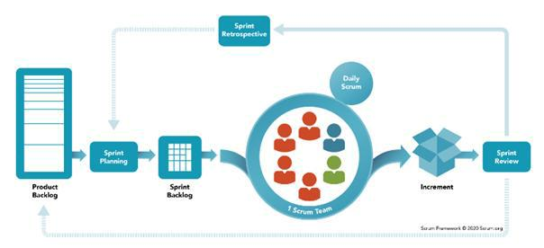

References: [*https://www.scrum.org/*](https://www.scrum.org/)

Figure 1 - Scum process

This project is developed under the Scrum framework of Agile methodology. We choose this process model because of the following reasons:

* Because customers really don't know what they want their website to look like, changing requirements often take place, we need to develop from part to part to output the most suitable process for our system to satisfy organization.
* Using Agile for web application testing, teams get feedback almost daily and can act on that feedback immediately.

25

* Our team does not have any experience in working on the website for patients which is why we need to directly communicate, research and work to deliver to customers as soon as possible so that we can get improvement feedback.

**2.2 Quality Management**

In this project, to improve the project quality, we use the following approach:

* API convention:

1. Name the API Route that maps to the entity in the system
   1. Each API response must return the following general information:
      * Status code: 200, 204, 400, 401, 404, ...
      * Status text: fail, success
      * Total: number of data items have been returned
      * Data: an array that contains all data items

* Coding convention:
  1. Set the meaningful names for variables

1. Add comments to code can be confusing
   1. Use Pascal casing for naming Enum, Class and Interface

* Unit Testing: Each member has the responsibility to write a unit test to ensure a function/method works appropriately.
* Integration Testing: After finishing coding one module/screen both members working on the client-side and server-side need to execute integration testing to ensure the module/screen can work smoothly from client-side to server-side.
* System Testing: After finishing coding for whole systems, all team members need to re-execute all test cases and free tests to ensure the system is working stable.

26

**2.3 Training Plan**

|  |  |  |  |
| --- | --- | --- | --- |
| **Training Area** | **Participants** | **When, Duration** | **Waiver Criteria** |
|  |  |  |  |
| Nodejs, Expressjs | Nguyên, An, P. Trường, V. Trường | 3 weeks | Mandatory |
|  |  |  |  |
| ReactJS | Vỹ | 2 weeks | Mandatory |
|  |  |  |  |
| GitHub | All member | 2 days | Mandatory |
|  |  |  |  |
|  | Table 8 - Training plan | |  |

**3. Project Deliverables**

|  |  |  |  |  |  |
| --- | --- | --- | --- | --- | --- |
| **Sprint #** | **Sprint objective** | **Duration** | **Deliverable** |  | |
|  |  |  |  |  | |
| 1 | Project Plan Document, SRS | 14 days | Project Planning, Software |  | |
| Document | Requirement |  |  |
|  |  |  |  |
|  |  |  |  |  |  |
| 2 | Design Document |  | Design, Detail Design and |  |  |
|  |  | 14 days | Database Design |  | |
|  |  |  |  |  |  |
|  | Authentication Module, |  |  |  |  |
| 3 | User Module, Role Module, | 14 days | Code & System test cases |  | |
|  | Team Module |  |  |  |  |
|  |  |  |  |  |  |
|  | CRUD Module, Topic |  |  |  |  |
| 4 | Module, Comment Module | 14 days | Code & System test cases |  | |
|  |  |  |  |  |  |
|  | Payment Method Module, |  |  |  | |
| 5 | Task Module | 14 days | Code & System test case |  |  |
|  |  |  |  |  |  |
|  | Table 9 - Project deliverables | | |  |  |

27

**4. Responsibility Assignments**

|  |  |  |  |  |  |
| --- | --- | --- | --- | --- | --- |
| RESPONSIBILITY | Nguyễn Vũ Nguyên | Trần Anh Vỹ | Nguyễn Tuấn An | Phan Văn Trường | Lê Phúc Trường |
| Backend for system | x |  | x | x | x |
| Frontend web |  | x |  |  |  |
| Others | x | x | x | x | x |

Table 10 - Responsibility Assignments

**5. Project Communications**

|  |  |  |  |  |
| --- | --- | --- | --- | --- |
| **Communication**  **Item** | **Who/Target** | **Purpose** | **When, Frequency** | **Type, Tool, Method(s)** |
| Working with advisor | Supervisor (Tôn Thất Hoàng Minh) | -Review documentation  -Demonstrate features  -Evaluate progress and result | 1 time per week | Face to face |
| Working with team | Team members | - Raise problem  - Review source code  - Evaluate progress and result | Always | Messenger, Google meet, and Face to Face |

Table 11 - Project Communications

1. **Configuration Management**

**6.1 Document Management**

Because of the real-time data synchronization, we use Google Drive to manage documents. Google Drive allows team members to conveniently collaborate in real-time. We create documents on Google Drive based on the document template, then divide the document writing work for members based on their predefined responsibilities. Each member can see the results of the other members' work instantly.

**6.2 Source Code Management**

We choose GitHub to manage our source code. The version control system allows members to collaboratively work on a source code efficiently, conveniently, and easily to resolve conflict, especially helpful for looking back in time and quickly identifying changes a collaborator made.

**6.3 Tools & Infrastructures**

|  |  |
| --- | --- |
| **Category** | **Tools / Infrastructure** |
|  |  |
| **IDEs/Editors** | Visual Studio Code |
|  |  |
| **UML tools** | Draw.io, Drasql.app |
|  |  |
| **Source Version** | GitHub |
| **Control** |
|  |
|  |  |
| **Project** | Google Drive |
| **Management Tool** |
|  |
|  |  |
| **Framework** | ReactJS (Frontend), Node.JS(Backend) |
|  |  |
| **Programming** | Javascript |
| **Languages** |
|  |
|  |  |
| **DBMS** | MongoDB |
|  |  |
|  | Table 13 - Tools & Infrastructures |

30

1. **Software Requirements Specification**

**1. Product Overview**

* 1. **Guest Requirements**

For guests who require a diamond valuation system that is more than just a basic assessment tool. A system that offers an intuitive interface to input diamond characteristics and receive accurate valuations. Access educational resources to understand the valuation process, and obtain comprehensive reports. Can secure personal data and ensure compliance with privacy regulations.

* 1. **Customer Requirements**

For customers who require a diamond valuation system that is more than just a basic assessment tool. A system that provides an intuitive interface to input diamond characteristics and receive accurate valuations. Access comprehensive reports, market insights, and educational resources. Can secure personal data, export detailed valuation certificates, and ensure compliance with privacy regulations.

**1.3 Consulting Staff Requirements**

Consulting staff engage with clients using an intuitive interface designed to simplify diamond valuation consultations. The system offers comprehensive client management tools, allowing consultants to efficiently input and analyze diamond data, provide accurate assessments, and generate detailed reports. Access to educational resources and real-time market insights empowers consulting staff to offer informed guidance, enhancing client satisfaction and trust in their advisory services.

**1.4 Valuation Staff Requirements**

Valuation staff utilize advanced AI technology and comprehensive criteria within the system to conduct precise diamond assessments. The platform supports detailed evaluation of the 4Cs—Carat, Cut, Color, and Clarity—along with additional factors like fluorescence and symmetry. Real-time market data ensures valuations reflect current market trends, while customizable tools enable staff to generate thorough valuation reports swiftly and accurately, maintaining high standards of professionalism and accuracy.

**1.5 Manager Requirements**

Managers overseeing diamond valuation operations benefit from a sophisticated platform that streamlines data management and enhances decision-making. The system provides robust reporting tools with real-time analytics, enabling managers to monitor performance metrics, track market trends, and optimize resource allocation. With secure data handling and compliance features, managers can confidently oversee operations while ensuring adherence to regulatory standards, fostering efficiency and accountability within their teams.

**1.6 Admin Requirements**

Admins manage the operational framework of the diamond valuation system, overseeing user permissions, data security protocols, and regulatory compliance. The system provides admin-friendly dashboards for efficient monitoring and management of user activities and system functionalities. Admins can customize settings, generate audit trails, and ensure data integrity across all transactions, supporting a secure and compliant environment for all system users.

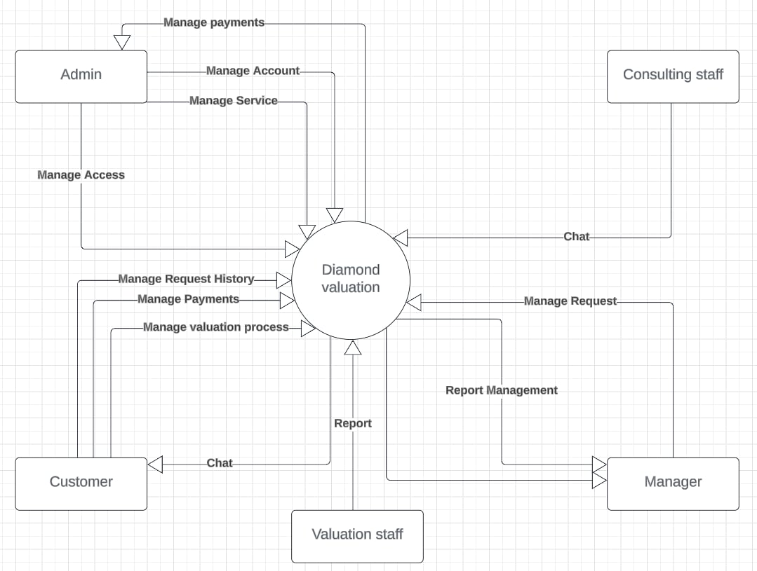

Figure 2 - Context diagram

31

1. **User Requirement**

**2.1 Actors**

|  |  |  |
| --- | --- | --- |
| **#** | **Actor** | **Description** |
| 1 | Administrator | The administrators who are responsible for managing the system. Concretely, they can manage permission, manage accounts, and manage request. |
| 2 | Customer | The customers who are responsible for managing evaluation.  Moreover, they can chat and view history ratings. |
| 3 | Guest | Guests are customers who can visit the web pages. |
| 4 | Consulting Staff | Advice on samples and time for customer to bring samples to the store for evaluation. |
| 5 | Valuation Staff | Responsible for receiving customer samples and conducting  valuation. |
| 6 | Manager | Manage user accounts in the system. |

Table 14 - Actors list and description

**2.2 Use Cases**

***2.2.1 Diagram***

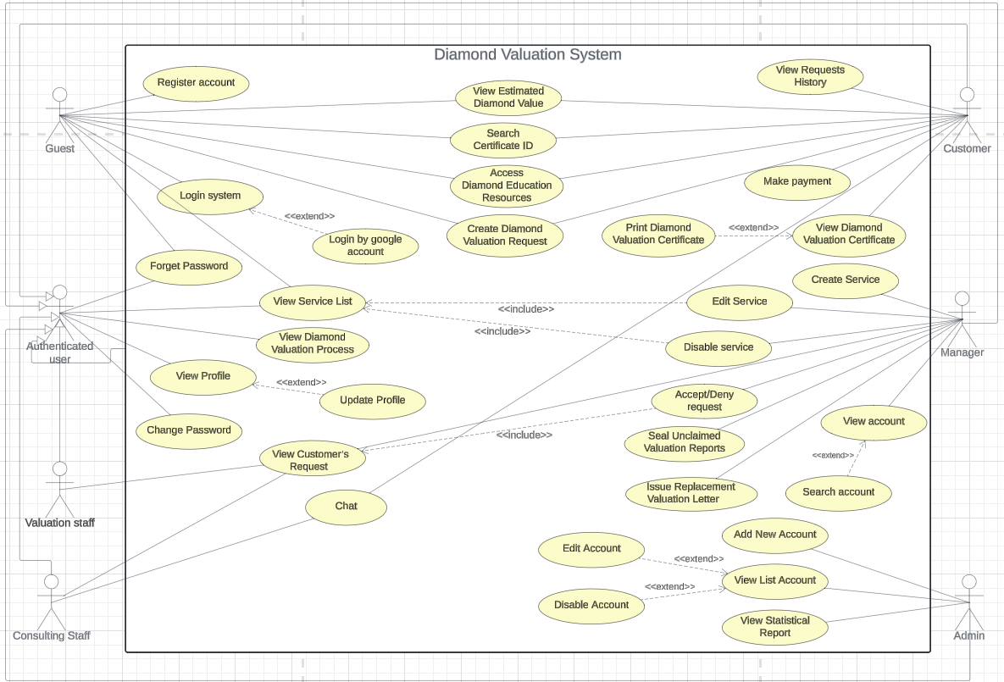

Figure 3 - Use Case Diagram

***2.2.2 Use Case List with description***

|  |  |  |  |
| --- | --- | --- | --- |
| **ID** | **Use Case** | **Actors** | **Description** |
| UC01 | Register account | Guest | This feature allows Guests to register for an account. |
| UC02 | Login by usernam and password | Guest | This feature allows Guests to login to the system by "usernam and password". |
| UC03 | Login by google account | Guest | This feature allows Guests to login to the system by google account. |
| UC04 | Forget Password | Guest, Customer, Consulting staff, Valuation staff, Manager, Admin | This feature allows All Users to reset their password in case of forgotten it. |
| UC05 | Change Password | Customer, Consulting staff, Valuation staff, Manager, Admin | This feature allows Loged-in Users to update their password. |
| UC06 | View Profile | Customer, Consulting staff, Valuation staff, Manager, Admin | This feature allows Loged-in Users to view their profile. |
| UC07 | Update Profile | Customer, Consulting staff, Valuation staff, Manager, Admin | This feature allows Loged-in Users to edit and update their profile. |
| UC08 | Logout | Customer, Consulting staff, Valuation staff, Manager, Admin | This feature allows Loged-in Users to logout the system. |
| UC09 | View Service List | Guest, Customer, Consulting staff, Valuation staff, Manager | This feature allows All Users to view all services in the system. |
| UC10 | Create Service | Manager | This feature allows Manager to create a new service. |
| UC11 | Edit Service | Manager | This feature allows Manager to edit service information. |
| UC12 | Disable service | Manager | This feature allows Manager to disable the enable service. |
| UC13 | Create Diamond Valuation Request | Guest, Customer | This feature allows Guests and Customers to request a diamond valuation by submitting relevant details. |
| UC14 | Search Certificate ID | Guest, Customer | This feature allows Guests and Customers to search for a diamond's details by entering its certificate ID. |
| UC15 | Access Diamond Education Resources | Guest, Customer | This feature allows Guests and Customers to access educational materials and resources about diamonds. |
| UC16 | View Estimated Diamond Value | Guest, Customer | This feature allows Guests and Customers to view an estimated value for the diamond based on input criteria. |
| UC17 | View Requests History | Customer | This feature allows Customers to view the history of their submitted requests, including status updates and outcomes. |
| UC18 | Chat | Customer, Consulting staff | This feature allows Customers and Consulting Staff to communicate via a chat system. |
| UC19 | View Diamond Valuation Process | Customer, Consulting staff, Valuation staff, Manager | This feature allows All Users to view the diamond valuation process’s step and its state. |
| UC20 | Make payment | Customer | This feature allows Customers to provide payment information and confirm the transaction. |
| UC21 | Print Diamond Valuation Certificate | Customer | This feature allows Customers to print a certificate of valuation for their diamond. |
| UC22 | View account | Manager | This feature allows Managers to view a list of staffs, customers and their detail information. |
| UC23 | Search account | Manager | This feature allows Managers to search staffs and customers account. |
| UC24 | Seal Unclaimed Valuation Reports | Manager | This feature allows the Manager to seal and archive reports for valuation requests that customers did not claim. |
| UC25 | Issue Replacement Valuation Letter | Manager | This feature allows the Manager to issue a replacement letter for a previously provided diamond valuation. |
| UC26 | View Customer’s Request | Consulting staff, Valuation staff, Manager | This feature allows Staffs and Managers to view detailed requests submitted by customers. |
| UC27 | Accept or Deny Request | Manager | This feature allows Managers to review and either accept or deny customer requests based on provided information. |
| UC28 | Add New Account | Admin | This feature allows the Admin to create and add a new account to the system. |
| UC29 | View List Account | Admin | This feature allows the Admin to view all account information in the system. |
| UC30 | Edit Account | Admin | This feature allows the Admin to edit and update account information. |
| UC31 | Disable Account | Admin | This feature allows the Admin to disable an enable account. |
| UC32 | View Statistical Report | Admin | This feature allows Admins to view reports and statistics related to service usage, customer requests, and other metrics. |

Table15-UseCaselist

1. **Functional Requirements**

**3.1 System Functional Overview**

***3.1.2 Functional Requirements***

**3.1.2.1 User Management**

|  |  |  |  |  |  |  |  |  |  |  |  |  |
| --- | --- | --- | --- | --- | --- | --- | --- | --- | --- | --- | --- | --- |
| ***No*** | ***Actor*** | ***Function Name*** | |  | ***Purpose*** | | |  | ***Data requirements*** |  | ***Data validation*** | ***Business*** |
|  |  |  |  |  |  |  |  |  |  |  |  | ***Rules*** |
| 1 | Admin | View User |  | View a user | | | |  | Account name |  | Account name: | BR-01 |
|  |  |  |  |  |  |  |  |  |  |  | + Type: text field (string) | BR-35 |
|  |  |  |  |  |  |  |  |  |  |  | + Max Length= 200 |  |
|  |  |  |  |  | Table 16 - User Management Function | | | | |  |  |  |

40

|  |  |  |  |  |  |  |
| --- | --- | --- | --- | --- | --- | --- |
| **3.1.2.3 Authenticate** | |  |  |  |  |  |
|  |  |  |  |  |  |  |
| ***No*** | ***Actor*** | ***Function Name*** | ***Purpose*** | ***Data requirements*** | ***Data validation*** | ***Business*** |
|  |  |  |  |  |  | ***Rules*** |
| 1 | Admin, | Login | Login to website | Username | Username: | BR-01 |
|  |  |  |  | Password | + Type: text field(string) | BR-02 |
|  |  |  |  |  | + Max Length= 20 |  |
|  |  |  |  |  | Password: |  |
|  |  |  |  |  | + Type: text field(string) |  |
|  |  |  |  |  | + Max Length= 100 |  |
|  |  |  |  |  |  |  |
| 2 | Users | Login | Login to website | Username | Username: | BR-03 |
|  |  |  |  | Password | + Type: text field(string) |  |
|  |  |  |  |  | + Max Length= 20 |  |
|  |  |  |  |  |  |  |



Table 18 - Authenticate Function

Password:

* Type: text field(string)
* Max Length= 20

|  |  |  |  |  |  |  |
| --- | --- | --- | --- | --- | --- | --- |
| **3.1.2.4 Profile Management** | | |  |  |  |  |
|  |  |  |  |  |  |  |
| ***No*** | ***Actor*** | ***Function*** | ***Purpose*** | ***Data requirements*** | ***Data validation*** | ***Business*** |
|  |  | ***Name*** |  |  |  | ***Rules*** |
| 1 | Users | View profile | View profile | Profile: profile table |  | BR-04 |
|  | Admin |  |  |  |  |  |
|  |  |  |  |  |  |  |
| 2 | Users | Update | Update new data | Name | Name: | BR-05 |
|  | Admin | profile | for profile | Email | + Type: text field(string) |  |
|  |  |  | Password | + Max Length = 12 |  |
|  |  |  |  |  |
|  |  |  |  | Address | Email: |  |
|  |  |  |  | Phone | + Type: text field(string) |  |
|  |  |  |  |  | + Max Length= 50 |  |
|  |  |  |  |  | Password: |  |
|  |  |  |  |  | + Type: text field(string) |  |
|  |  |  |  |  | + Min Length = 6 |  |
|  |  |  |  |  |  |  |

43



Table 19 - Profile Management Function

* Max Length= 20 Address:
* Type: text field(string)
* Max Length= 300 Phone:
* Type: text field(string)
* Max Length= 10

|  |  |  |  |  |  |  |
| --- | --- | --- | --- | --- | --- | --- |
| **3.1.2.5 Register** | |  |  |  |  |  |
|  |  |  |  |  |  |  |
| ***No*** | ***Actor*** | ***Function*** | ***Purpose*** | ***Data requirements*** | ***Data validation*** | ***Business*** |
|  |  | ***Name*** |  |  |  | ***Rules*** |
| 1 | Guest | Register | Register | User Name | User Name: | BR-06 |
|  |  |  | account | Email | + Type: text field(string) | BR-08 |
|  |  |  |  | Password | + Max Length = 20 | BR-09 |
|  |  |  |  | Confirm password | Email: | BR-10 |
|  |  |  |  |  | + Type: text field(string) | BR-11 |
|  |  |  |  |  | + Max Length= 50 |  |
|  |  |  |  |  | + True format |  |
|  |  |  |  |  | Password: |  |
|  |  |  |  |  | + Type: text field(string) |  |
|  |  |  |  |  | + Min Length = 6 |  |
|  |  |  |  |  |  |  |

44



Table 20 - Register Function

* Max Length= 20 Confirm password:
* Type: text field(string)
* Equal with password

|  |  |  |  |  |  |  |
| --- | --- | --- | --- | --- | --- | --- |
| **3.1.2.6 Service Management** | | |  |  |  |  |
|  |  |  |  |  |  |  |
| ***No*** | ***Actor*** | ***Function Name*** | ***Purpose*** | ***Data requirements*** | ***Data validation*** | ***Business*** |
|  |  |  |  |  |  | ***Rules*** |
|  |  |  |  |  |  |  |
| 1 | Guest | View service | View service in |  |  |  |
|  | Users |  | web |  |  |  |
|  |  |  |  |  |  |  |
| 3 | Manager | Create service | Create service | Name | Name: | BR-34 |
|  |  |  |  | Description  Cost | + Type: text field (string) | BR-39 |
|  |  |  |  |  |
|  |  |  |  |  | + Max Length= 50  Description:  +Type: text field (string)  +Max Length = 100 |  |
|  |  |  |  |  | Cost: |  |
|  |  |  |  |  | + Type: text field (double) |  |
|  |  |  |  |  |  |  |
| 3 | Manager | Edit service | Edit service | Name  Description  Cost | Name:  +Type: text field (string)  +Max Length = 50  Description:  +Type: text field (string)  +Max Length = 100  Cost:  +Type:text field (double) | BR-34 |

**3.1.2.10 View Request History**

|  |  |  |  |  |  |  |
| --- | --- | --- | --- | --- | --- | --- |
| ***No*** | ***Actor*** | ***Function Name*** | ***Purpose*** | ***Data requirements*** | ***Data validation*** | ***Business*** |
|  |  |  |  |  |  | ***Rules*** |
| 1 | Customer | View history | View request | None |  | BR-16 |
|  |  |  | history |  |  |  |
|  |  |  | Table 25 - View Match History Function | |  |  |

54

***3.1.3* Screen Authorization**

**3.1.3.1 Web and Game Application Screen Authorization**

56

***3.1.4 Non-Screen Functions***

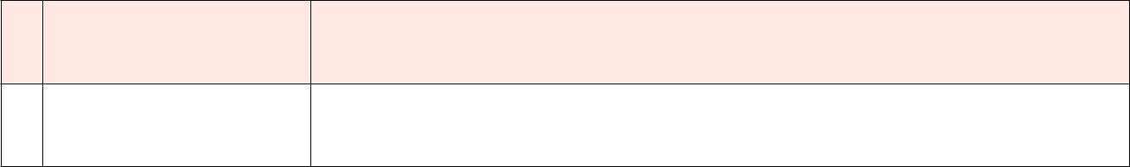

**# System function**

**Description**

Table 33 - Non-screen functions

**3.2 Entity Relationship Diagram**

* Conceptual ERD

57

Figure 6 - Conceptual Entity Relationship Diagram

* Logical ERD

58

Figure 7 - Logical Entity Relationship Diagram

|  |  |  |
| --- | --- | --- |
| **Entity Name** | **Attributes** | **Description** |
|  |  |  |
|  |  |  |
|  | Table 34 - Logic entities and attributes description | |

1. **Non-Functional Requirements**

**4.1 External Interfaces**

***4.1.1 User Interfaces***

* All the texts, labels and should be written in Vietnamese.

**4.2 Quality Attributes**

***4.2.1 Usability***

* Admin should need less than 2 days of training to be productive in using the system.

-Staff and Manager must join the 1 hour of training to use the system effectively.

***4.2.2 Reliability***

***4.2.3 Performance***

* All common response time is under 5 seconds (except define pickup points feature).

***4.2.4 Design constraints***

* Application use Vietnamese
* Website use English

***4.2.5 Security***

* + Each role of user has a specific permission to interact with system

1. **Requirement Appendix**

**5.1 Business Rules**

|  |  |
| --- | --- |
| **ID** | **Rule Definition** |
|  |  |
| BR-01 | Admin have to login web by admin account. |
|  |  |
| BR-02 | Admin can not login game by admin account |
|  |  |
| BR-03 | When first login game, player obligatory create name and job first |
|  |  |
| BR-04 | Player and admin can view profile after login to system |
|  |  |
| BR-05 | Player can update profile after login to game |
|  |  |
| BR-06 | Username must be unique |
|  |  |
| BR-07 | Player cannot buy item if don’t have enough money |
|  |  |
| BR-08 | Username length of account must be 6 - 30 characters |
|  |  |
| BR-09 | Password length of account must be 8 - 20 characters |
|  |  |
| BR-10 | Confirm password obligatory like password |
|  |  |

67

|  |  |
| --- | --- |
| BR-11 | Email must be true format Ex: name@gmail.com |
|  |  |
| BR-12 | Name length of account must be 2 - 15 characters |
|  |  |
| BR-13 | Player have to wait other player end turn to continue roll dice |
|  |  |
| BR-14 | Player obligatory enough cash flow to be moved fasttrack |
|  |  |
| BR-15 | Player must only can win by two ways |
|  |  |
| BR-16 | Player only can match history if finish match |
|  |  |
| BR-17 | Player cannot change outfit if don’t buy it in shop |
|  |  |
| BR-18 | Player have to open inventory to change outfit |
|  |  |
| BR-19 | Player or other player cannot start match if don’t ready in room |
|  |  |
| BR-20 | Player can’t buy 2 of the same item |
|  |  |
| BR-21 | Player obligatory have internet to play game |
|  |  |
| BR-22 | Player must be talk to npc to create/join room |
|  |  |
| BR-23 | Player only one way to have money when finish match |
|  |  |
| BR-24 | Player obligatory create room name first to created room |
|  |  |
| BR-25 | Player cannot control another player’s character |
|  |  |
| BR-26 | Player cannot view event card of other players |
|  |  |
| BR-27 | Player cannot view financial report of other players |
|  |  |
| BR-28 | Player must be login first to play game |
|  |  |
| BR-29 | Player choose job when first login |
|  |  |
| BR-30 | Player only change job if choose job and create name before |
|  |  |

68

|  |  |  |  |  |  |
| --- | --- | --- | --- | --- | --- |
| BR-31 | | Game account name must be unique | | | |
|  | |  | | | |
| BR-32 | | Account name of event card must be exist in the system | | | |
|  | |  | | | |
| BR-33 | | Job name must be unique | | | |
|  | |  | | | |
| BR-34 | | Dream name must be unique | | | |
|  | |  | | | |
| BR-35 | | Asset name must be unique | | | |
|  | |  | | | |
| BR-36 | | Value can not negative | | | |
|  | |  | | | |
| BR-37 | | Only the admin can manage the event card | | | |
|  | |  | | | |
| BR-38 | | Only the admin can manage the game account | | | |
|  | |  | | | |
| BR-39 | | Only the admin can manage the dream | | | |
|  | |  | | | |
| BR-40 | | Only the admin can manage the job | | | |
|  | |  | | | |
| BR-41 | | Only the admin can manage the asset | | | |
|  | |  | | | |
|  | | Table 35 - Business rules | | | |
| **5.2 Application Messages List** | | | | | |
| **#** | **Message** | | **Message** | **Context** | **Content** | |
|  | **code** | | **Type** |  |  | |
|  |  | |  |  |  | |
| 1 | MSG01 | | Toast | Create account successfully | Tạo tài khoản thành | |
|  |  | | message |  | công | |
|  |  | |  |  |  | |
| 2 | MSG02 | | Toast | Input-required fields are | Không ô nào được bỏ | |
|  |  | | message | empty | trống | |
|  |  | |  |  |  | |
| 3 | MSG03 | | Toast | Input username fields are | Tên đăng nhập không | |
|  |  | |  |  |  | |

69

|  |  |  |  |  |
| --- | --- | --- | --- | --- |
|  |  | message | invalid | được bé hơn 6 và lớn |
|  |  |  |  | hơn 20 |
|  |  |  |  |  |
| 4 | MSG04 | Toast | Authentication failed | Sai tên đăng nhập hoặc |
|  |  | message |  | mật khẩu |
|  |  |  |  |  |
| 5 | MSG05 | Toast | Exit match | Bạn có chắc rằng muốn |
|  |  | message |  | thoát game không? |
|  |  |  |  |  |
| 6 | MSG06 | Toast | Input password fields are | Mật khâu không được |
|  |  | message | invalid | bé hơn 8 |
|  |  |  |  |  |
| 7 | MSG07 | Toast | Input confirm password | Xác nhận mật khẩu |
|  |  | message | fields are not like password | không trùng khớp |
|  |  |  |  |  |
| 8 | MSG08 | Toast | Register successfully | tạo tài khoản thành |
|  |  | message |  | công |
|  |  |  |  |  |
| 9 | MSG09 | Toast | Create event card | Create event card |
|  |  | message | successfully | successfully |
|  |  |  |  |  |
| 10 | MSG10 | Toast | Update event card | Update event card |
|  |  | message | successfully | successfully |
|  |  |  |  |  |
| 11 | MSG11 | Toast | Delete event card | Delete event card |
|  |  | message | successfully | successfully |
|  |  |  |  |  |
| 12 | MSG12 | Toast | Create game account | Create game account |
|  |  | message | successfully | successfully |
|  |  |  |  |  |

70

|  |  |  |  |  |  |
| --- | --- | --- | --- | --- | --- |
| 13 | MSG13 | Toast |  | Update game account | Update game account |
|  |  | message |  | successfully | successfully |
|  |  |  |  |  |  |
| 14 | MSG14 | Toast |  | Delete game account | Delete game account |
|  |  | message |  | successfully | successfully |
|  |  |  |  |  |  |
| 15 | MSG15 | Toast |  | Update job successfully | Update job successfully |
|  |  | message |  |  |  |
|  |  |  |  |  |  |
| 16 | MSG16 | Toast |  | Update dream successfully | Update dream |
|  |  | message |  |  | successfully |
|  |  |  |  |  |  |
| 17 | MSG17 | Toast |  | Update asset successfully |  |
|  |  | message |  |  |  |
|  |  |  |  |  |  |
|  |  |  | Table 36 - Application messages | |  |

71

**IV. Software Design Description**

**1. System Design**

**1.1 System Architecture Overview**

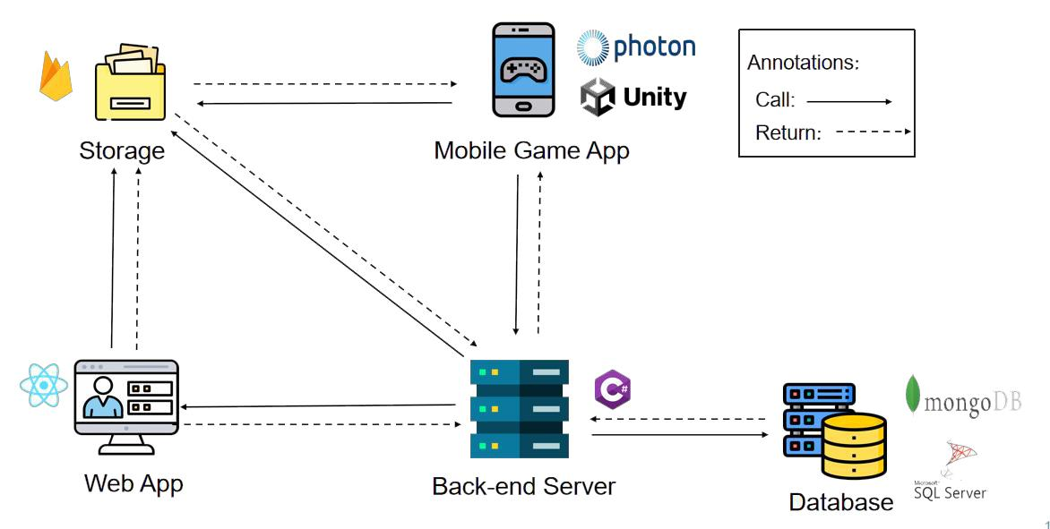

Figure 8 - System architecture

* The Cashflow Board game system consists of two components, the .NET Core web server provides APIs, Reactjs is used for the web application. Web application is provide for admin.
* Cashflow Boardgame System uses several third-party services such as FireBase Storage to store Image Ui in game. Use Unity to build overall game , use photon to build server for game.

72

**1.2 Package Diagram**

***1.2.1 Web API Package Diagram***

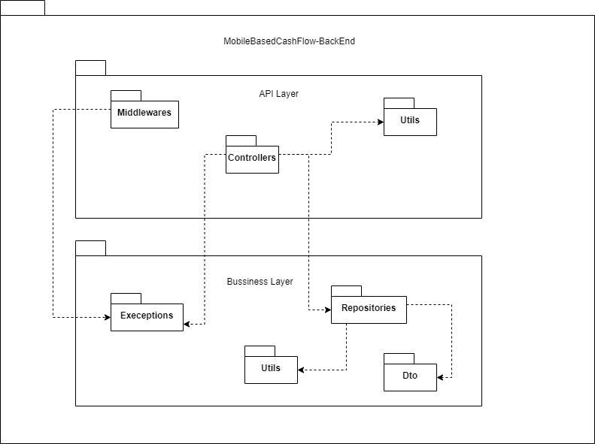

Figure 9 - Web API Package Diagram

73

***1.2.2 Web Application Package Diagram***

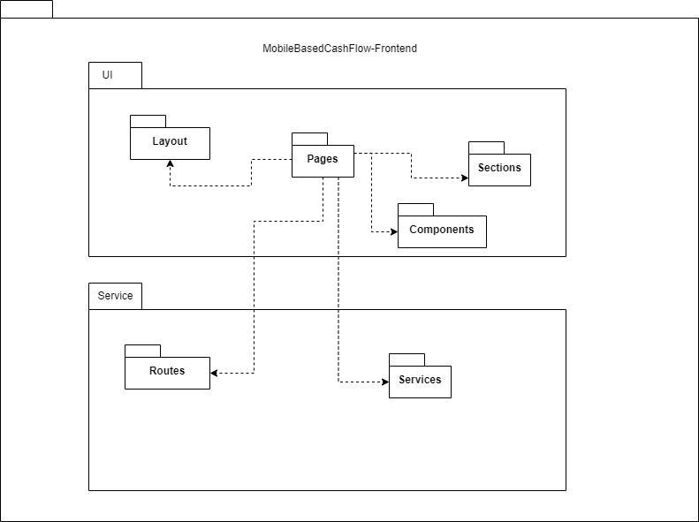

Figure 10 - Web Application Package Diagram

74

***1.2.3 Game Application Package***

***Diagram***

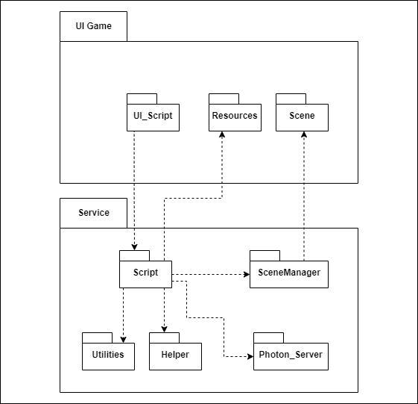

Figure 11 - Game Application Package Diagram

75

**2. Database Design**

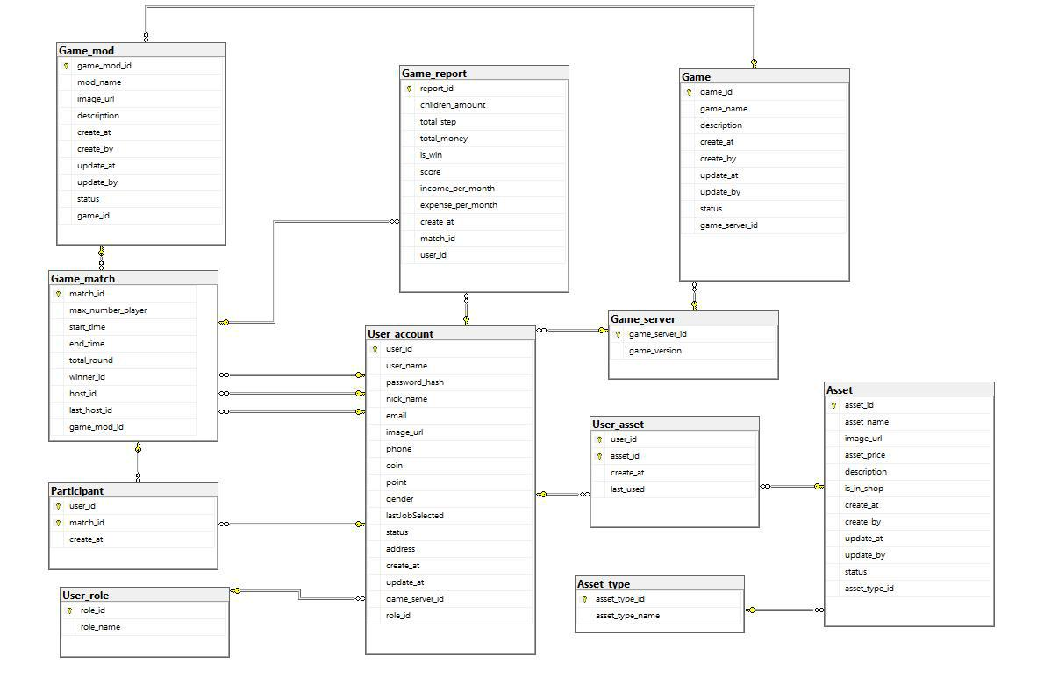

Figure 12- MS SQL Database Design

76

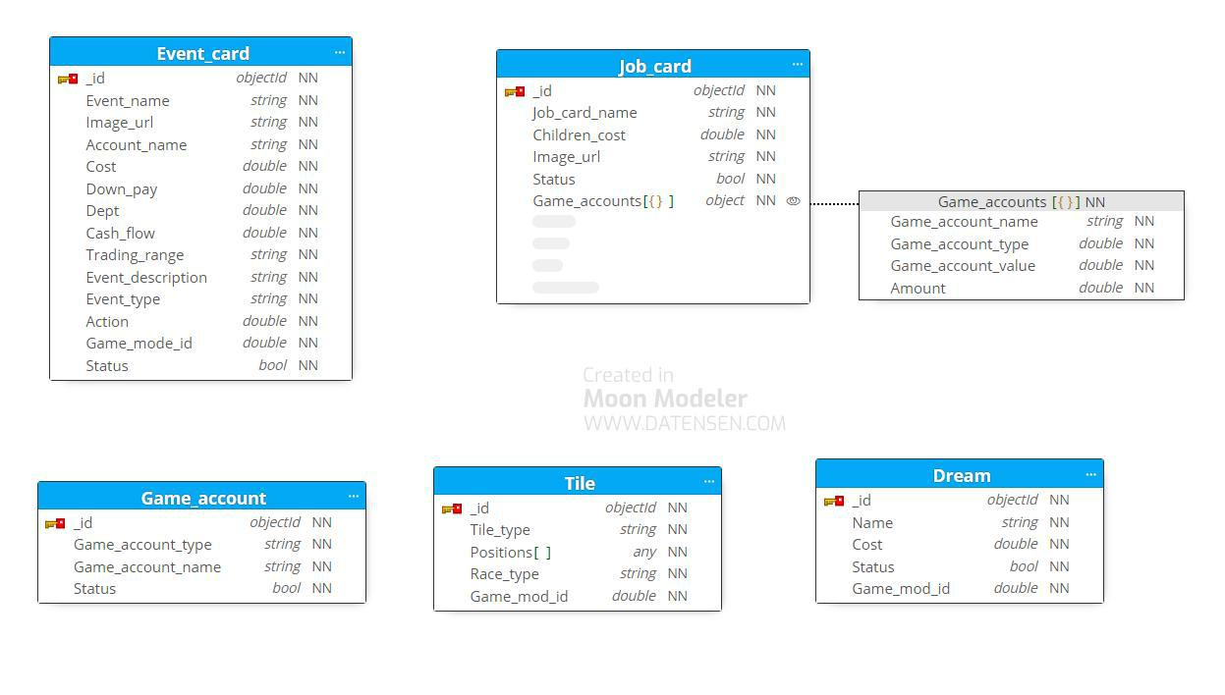

|  |  |  |  |  |
| --- | --- | --- | --- | --- |
|  |  |  |  | Figure 13 - MongoDB Database Design |
|  | ***Table Descriptions*** | | |  |
|  |  |  |  |  |
| **No** | | **Table** | | **Description** |
|  | |  | |  |
| 01 | | User_role | | Describe role in the system |
|  | |  | |  |
| 02 | | Game_server | | Describe game server in the system |
|  | |  | |  |
| 03 | | Game | | Describe game in the system |
|  | |  | |  |
| 04 | | Game_mod | | Describe game mod in the system |
|  | |  | |  |
| 05 | | User_account | | Describe user account in the system |
|  | |  | |  |
| 06 | | Asset_type | | Describe asset type in the system |
|  | |  | |  |
| 07 | | Asset | | Describe asset in the system |
|  | |  | |  |
| 08 | | User_asset | | Describe user asset in the system |
|  |  |  |  |  |

77

|  |  |  |  |  |  |  |  |  |  |  |  |  |  |  |
| --- | --- | --- | --- | --- | --- | --- | --- | --- | --- | --- | --- | --- | --- | --- |
|  |  | 09 | | Game_match | | |  | Describe game match in the system | | | |  |  |  |
|  |  |  |  |  |  | |  |  |  |  |  |  |  |  |
|  |  | 10 | | Participant | | |  | Describe participant in the system | | | |  |  |  |
|  |  |  |  |  |  | |  |  |  |  |  |  |  |  |
|  |  | 11 | | Game_report | | |  | Describe game report in the system | | | |  |  |  |
|  |  |  |  |  |  | |  |  |  |  |  |  |  |  |
|  |  | 12 | | Event_card | | |  | Describe event card in the system | | | |  |  |  |
|  |  |  |  |  |  | |  |  |  |  |  |  |  |  |
|  |  | 13 | | Job_card | | |  | Describe job card in the system | | | |  |  |  |
|  |  |  |  |  |  |  |  |  |  |  |  |  |  |  |
|  |  | 14 | | Dream | |  |  | Describe dream in the system | | | |  |  |  |
|  |  |  |  |  |  |  |  |  |  |  |  |  |  |  |
|  |  | 15 | | Tile | |  |  | Describe tile in the system | | | |  |  |  |
|  |  |  |  |  |  | |  |  |  |  |  |  |  |  |
|  |  | 16 | | Game_account | | |  | Describe game account in the system | | | |  |  |  |
|  |  |  |  |  |  |  |  |  |  |  |  |  |  |  |
|  |  |  |  |  |  |  |  | Table 37 - Table Data Descriptions | | | |  |  |  |
|  |  |  | ***Attribute Data Dictionary*** | | | | |  |  |  |  |  |  |  |
|  |  | | | |  |  | | |  |  |  |  |  |  |
|  | **Entity Name** | | | |  | **Attributes** | | |  | **Description** |  | **Domain** |  | **Null** |
|  |  | | | |  |  | |  |  |  |  |  |  |  |
|  | User_role | | | |  | role_id{PK} | |  |  | Unique identifier of role |  | int | No | |
|  |  |  |  |  |  |  | |  |  |  |  |  |  |  |
|  |  |  |  |  |  | role_name | |  |  | Name of role |  | nvarchar(10) | No | |
|  |  | | | |  |  | | |  |  |  |  |  |  |
|  | Game_server | | | |  | game_server_id {PK} | | |  | Unique identifier of |  | int | No | |
|  |  |  |  |  |  |  |  |  |  | game server |  |  |  |  |
|  |  |  |  |  |  |  | | |  |  |  |  |  |  |
|  |  |  |  |  |  | game_version | | |  | Version of game |  | nvarchar(20) | No | |
|  |  | | |  |  |  | |  |  |  |  |  |  |  |
|  |  | | |  |  |  | |  |  |  | |  |  |  |
|  | Game | | |  |  | game_id | |  |  | Unique identifier of | | int |  | No |
|  |  |  |  |  |  |  |  |  |  | Game | |  |  |  |
|  |  |  |  |  |  |  | |  |  |  | |  |  |  |
|  |  |  |  |  |  | game_name | |  |  | Name of game | | varchar(20) |  | No |
|  |  |  |  |  |  |  | |  |  |  | |  |  |  |
|  |  |  |  |  |  | description | |  |  | Description of game | | varchar(200) |  | No |
|  |  |  |  |  |  |  |  |  |  |  |  |  |  |  |

78

|  |  |  |  |  |
| --- | --- | --- | --- | --- |
|  | create_at | Game create date | datetime | No |
|  |  |  |  |  |
|  | create_by | Unique identifier of user | int | No |
|  |  | account |  |  |
|  |  |  |  |  |
|  | update_at | Game update date | datetime | Yes |
|  |  |  |  |  |
|  | update_by | Unique identifier of user | int | Yes |
|  |  | account |  |  |
|  |  |  |  |  |
|  | status | Status of game | boolean | No |
|  |  |  |  |  |
|  | game_server_id{FK} | Foreign key, game | int | No |
|  |  | server identifier |  |  |
|  |  |  |  |  |
| Game_mod | game_mod_id | Unique identifier of | int | No |
|  |  | game mod |  |  |
|  |  |  |  |  |
|  | mod_name | Name of game mod | nvarchar(20) | No |
|  |  |  |  |  |
|  | image_url | Image url of game mod | nvarchar(200) | No |
|  |  |  |  |  |
|  | description | Description of game | nvarchar(200) | No |
|  |  | mod |  |  |
|  |  |  |  |  |
|  | create_at | Game mod update date | datetime | No |
|  |  |  |  |  |
|  | create_by | Unique identifier of user | int | No |
|  |  | account |  |  |
|  |  |  |  |  |
|  | update_at | Game mod up | datetime | Yes |
|  |  |  |  |  |
|  | update_by | Unique identifier of user | int | Yes |
|  |  | account |  |  |
|  |  |  |  |  |
|  | status | Status of game mod | boolean | No |
|  |  |  |  |  |

79

|  |  |  |  |  |
| --- | --- | --- | --- | --- |
|  | game_id {FK} | Foreign key, game | int | No |
|  |  | identifier |  |  |
|  |  |  |  |  |
| User_account | user_id {PK} | Unique identifier of user | varchar(50) | No |
|  |  | account |  |  |
|  |  |  |  |  |
|  | user_name | User name of user | nvarchar(200) | No |
|  |  | account |  |  |
|  |  |  |  |  |
|  | pashword_hash | Password hash of user | nvarchar(200) | No |
|  |  | account |  |  |
|  |  |  |  |  |
|  | nick_name | Nick name of user | nvarchar(12) | No |
|  |  | account |  |  |
|  |  |  |  |  |
|  | email | Email of user account | varchar(50) | No |
|  |  |  |  |  |
|  | image_url | Image of user account | varchar(50) | Yes |
|  |  |  |  |  |
|  | phone | Phone of user account | varchar(10) | Yes |
|  |  |  |  |  |
|  | coin | Coin of user account | float | No |
|  |  |  |  |  |
|  | point | Point of user account | float | No |
|  |  |  |  |  |
|  | gender | Gender of user account | nvarchar(20) | Yes |
|  |  |  |  |  |
|  | lastJobSelected | Last job selected by user | nvarchar(20) | Yes |
|  |  | account |  |  |
|  |  |  |  |  |
|  | status | Status of user account | boolean | No |
|  |  |  |  |  |
|  | address | Address of user account | nvarchar(300) | Yes |
|  |  |  |  |  |
|  | create_at | User account create | datetime | No |
|  |  | date |  |  |
|  |  |  |  |  |
|  | update_at | User account update | datetime | Yes |
|  |  |  |  |  |

80

|  |  |  |  |  |
| --- | --- | --- | --- | --- |
|  |  | date |  |  |
|  |  |  |  |  |
|  | game_server_id | Unique identifier of | int | No |
|  |  | game server |  |  |
|  |  |  |  |  |
|  | role_id {FK} | Unique identifier of role | int | No |
|  |  |  |  |  |
| Asset_type | asset_type_id {PK} | Unique identifier of | int | No |
|  |  | asset type |  |  |
|  |  |  |  |  |
|  | asset_type_name | Note of rating | nvarchar(200) | No |
|  |  |  |  |  |
| Asset | asset_id{PK} | Unique identifier of | int | No |
|  |  | asset |  |  |
|  |  |  |  |  |
|  | asset_name | Foreign key, account | varchar(50) | No |
|  |  | identifier |  |  |
|  |  |  |  |  |
|  | image_url | Image of asset | nvarchar(200) | No |
|  |  |  |  |  |
|  | asset_price | Price of asset | float | No |
|  |  |  |  |  |
|  | description | Description of asset | nvarchar(500) | No |
|  |  |  |  |  |
|  | is_in_shop | Verify this asset is in the | boolean | No |
|  |  | shop or not |  |  |
|  |  |  |  |  |
|  | create_at | Game mod update date | datetime | No |
|  |  |  |  |  |
|  | create_by | Unique identifier of user | int | No |
|  |  | account |  |  |
|  |  |  |  |  |
|  | update_at | Game mod up | datetime | Yes |
|  |  |  |  |  |
|  | update_by | Unique identifier of user | int | Yes |
|  |  | account |  |  |
|  |  |  |  |  |
|  | status | Status of asset | boolean |  |
|  |  |  |  |  |

81

|  |  |  |  |  |
| --- | --- | --- | --- | --- |
|  | asset_type_id{FK} | Unique identifier of | int | No |
|  |  | asset type |  |  |
|  |  |  |  |  |
| User_asset | user_id{PK, FK} | Unique identifier of user | int | No |
|  |  | account |  |  |
|  |  |  |  |  |
|  | asset_id {Pk, FK} | Unique identifier of | int | No |
|  |  | asset |  |  |
|  |  |  |  |  |
|  | create_at | Datetime user buy asset | datetime | No |
|  |  |  |  |  |
|  | last_used | Last time user use asset | datetime | No |
|  |  |  |  |  |
| Game_match | match_id{PK} | Unique identifier of | character(36) | No |
|  |  | game match |  |  |
|  |  |  |  |  |
|  | max_number_player | Max number of player in | int | No |
|  |  | match |  |  |
|  |  |  |  |  |
|  | start_time | Datetime match start | datetime | No |
|  |  |  |  |  |
|  | end_time | Datetime match end | datetime | Yes |
|  |  |  |  |  |
|  | total_round | Foreign key, translator | int | No |
|  |  | identifier |  |  |
|  |  |  |  |  |
|  | winner_id | Unique identifier of user | int | No |
|  |  | account |  |  |
|  |  |  |  |  |
|  | host_id | Unique identifier of user | int | No |
|  |  | account |  |  |
|  |  |  |  |  |
|  | last_host_id | Unique identifier of user | int | No |
|  |  | account |  |  |
|  |  |  |  |  |
|  | game_mod_id {FK} | Unique identifier of | int | No |
|  |  | game mod |  |  |
|  |  |  |  |  |
| Participant | user_id {PK, FK} | Unique identifier of user | int | No |
|  |  |  |  |  |

82

|  |  |  |  |  |
| --- | --- | --- | --- | --- |
|  |  | account |  |  |
|  |  |  |  |  |
|  | match_id {PK, FK} | Unique identifier of | character(36) | No |
|  |  | game match |  |  |
|  |  |  |  |  |
|  | create_at | Participant create date | datetime | No |
|  |  |  |  |  |
| Game_report | report_id {PK} | Unique identifier of | varchar(50) | No |
|  |  | game report |  |  |
|  |  |  |  |  |
|  | children_amount | Foreign key, project | varchar(50) | No |
|  |  | identifier |  |  |
|  |  |  |  |  |
|  | total_money | Total money of player in |  |  |
|  |  | match |  |  |
|  |  |  |  |  |
|  | total_step | Total step of player in | float | No |
|  |  | match |  |  |
|  |  |  |  |  |
|  | is_win | Verify player is win or | boolean | No |
|  |  | not |  |  |
|  |  |  |  |  |
|  | score | Score of player in match | float | No |
|  |  |  |  |  |
|  | income_per_month | Income per month of | float | No |
|  |  | player in match |  |  |
|  |  |  |  |  |
|  | expense_per_month | Expense per month of | float | No |
|  |  | player in match |  |  |
|  |  |  |  |  |
|  | create_at | Report create date | datetime | No |
|  |  |  |  |  |
|  | match_id | Unique identifier of | character(36) | No |
|  |  | game match |  |  |
|  |  |  |  |  |
|  | user_id | Unique identifier of user | int | No |
|  |  | account |  |  |
|  |  |  |  |  |
| Event_card | _id{PK} | Unique identifier of | objectId | No |
|  |  |  |  |  |

83

|  |  |  |  |  |
| --- | --- | --- | --- | --- |
|  |  | event card |  |  |
|  |  |  |  |  |
|  | card_name | Name of event card | string | No |
|  |  |  |  |  |
|  | Image_url | Image of event card | string | No |
|  |  |  |  |  |
|  | account_name | Game account name of | string | No |
|  |  | event card |  |  |
|  |  |  |  |  |
|  | cost | Cost of event card | double | No |
|  |  |  |  |  |
|  | down_pay | Down pay of event card | double | No |
|  |  |  |  |  |
|  | Dept | Dept of event card | double | No |
|  |  |  |  |  |
|  | cash_flow | Cash flow of event card | double | No |
|  |  |  |  |  |
|  | trading_range | Trading of event card | string | No |
|  |  |  |  |  |
|  | event_description | Description of event | string | No |
|  |  | card |  |  |
|  |  |  |  |  |
|  | event_type | Type of event card | string | No |
|  |  |  |  |  |
|  | action | Action of event card | int | No |
|  |  |  |  |  |
|  | game_mod_id {FK} | Unique identifier of | int | No |
|  |  | game mod |  |  |
|  |  |  |  |  |
|  | status | Status of event card | bool | Yes |
|  |  |  |  |  |
| Tile | _id{PK} | Unique identifier of tile | objectId | No |
|  |  |  |  |  |
|  | tile_type | Type of tile | string | No |
|  |  |  |  |  |
|  | position | Position of tile | array | No |
|  |  |  |  |  |

84

|  |  |  |  |  |
| --- | --- | --- | --- | --- |
|  | race_type | Type of tile race | string | No |
|  |  |  |  |  |
|  | game_mod_id | Unique identifier of | int | No |
|  |  | game mod |  |  |
|  |  |  |  |  |
| Game_accoun | _id{PK} | Unique identifier of | objectId | No |
| t |  | game account |  |  |
|  |  |  |  |  |
|  | game_account_type | Type of game account | string | No |
|  |  |  |  |  |
|  | game_account_name | Name of game account | string | No |
|  |  |  |  |  |
|  | status | Status of game account | bool | No |
|  |  |  |  |  |
| Dream | _id {PK} | Unique identifier of | objectId | No |
|  |  | dream |  |  |
|  |  |  |  |  |
|  | name | Name of dream | string | No |
|  |  |  |  |  |
|  | cost | Cost of dream | double | No |
|  |  |  |  |  |
|  | status | Status of dream | bool | No |
|  |  |  |  |  |
|  | game_mod_id | Unique identifier of | double | No |
|  |  | game mod id |  |  |
|  |  |  |  |  |
| Job_card | _id {PK} | Unique identifier of job | objectId | No |
|  |  | card |  |  |
|  |  |  |  |  |
|  | job_card_name | Name of job card | string | No |
|  |  |  |  |  |
|  | children_cost | Cost per child | double | No |
|  |  |  |  |  |
|  | image_url | Image of job card | string | No |
|  |  |  |  |  |

85

|  |  |  |  |  |
| --- | --- | --- | --- | --- |
| status |  |  | Status of job card | bool |
| game_accounts |  |  | List game account of job | object |
|  |  |  | card |  |
|  | Table 38 - |  | Attribute Data Description |  |
|  |  |  |

**3. Detailed Design**

**3.1 Start game match Feature**

**3.1.1 Class Diagram**

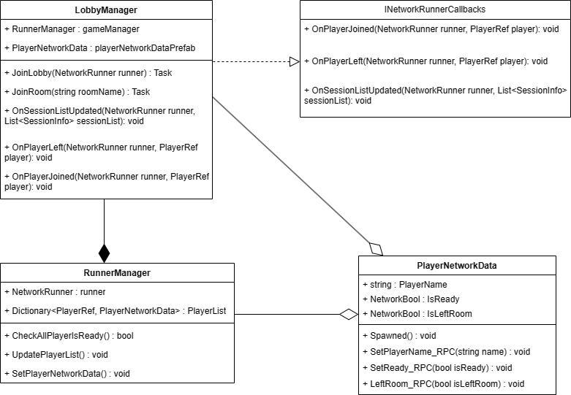

Figure 14 - Start game match Feature Class Diagram

No

No

86

**3.1.2 Class Specification**

**a. Start Game Service**

|  |  |  |
| --- | --- | --- |
| **No** | **Method** | **Description** |
|  |  |  |
| 1 | JoinLobby(NetworkRunner runner) | handles join lobby |
|  |  |  |
| 2 | JoinRoom(string roomName) | handles join room |
|  |  |  |
| 3 | OnSessionListUpdated(NetworkRun | handles update list rooms |
|  | ner runner, List<SessionInfo> | information |
|  | sessionList) |  |
|  |  |  |
| 4 | OnPlayerJoined(NetworkRunner | handles player joined room |
|  | runner, PlayerRef player) |  |
|  |  |  |
| 5 | OnPlayerLeft(NetworkRunner | handles player left room |
|  | runner, PlayerRef player) |  |
|  |  |  |
| 6 | CheckAllPlayerIsReady() | handle all players is ready |
|  |  |  |
| 7 | UpdatePlayerList() | handles start game |
|  |  |  |
| 8 | SetPlayerNetworkData() | handles set player information |
|  |  |  |
| 9 | Spawned() | handles player data after spawned |
|  |  |  |
| 10 | SetPlayerName_RPC(string name) | handles player name |
|  |  |  |
| 11 | SetReady_RPC(bool isReady) | handles player ready |
|  |  |  |
| 12 | LeftRoom_RPC(bool isLeftRoom) | handles player left room |
|  |  |  |
|  | Table 39 - Start Game Service Class Specification | |

87

**3.1.3 Start Game Sequence Diagram**

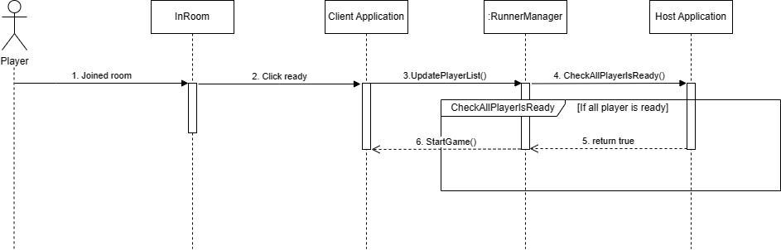

Figure 15- Start Game Sequence Diagram

88

**3.1.4 Join Room Sequence Diagram**

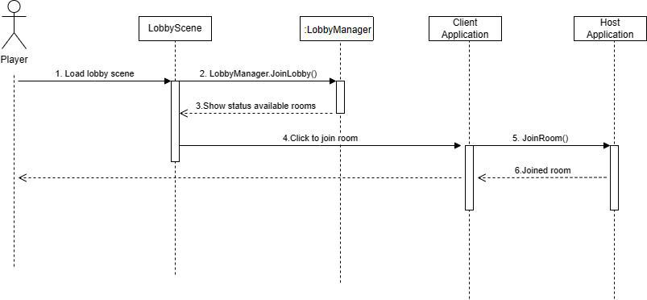

Figure 16- Start Game Sequence Diagram

89

**3.1.5 Host Room Sequence Diagram**

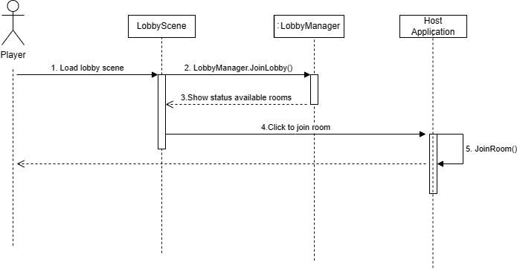

Figure 17- Start Game Sequence Diagram

90

**3.2 Buy Item In Shop Feature**

**3.2.1 Class Diagram**

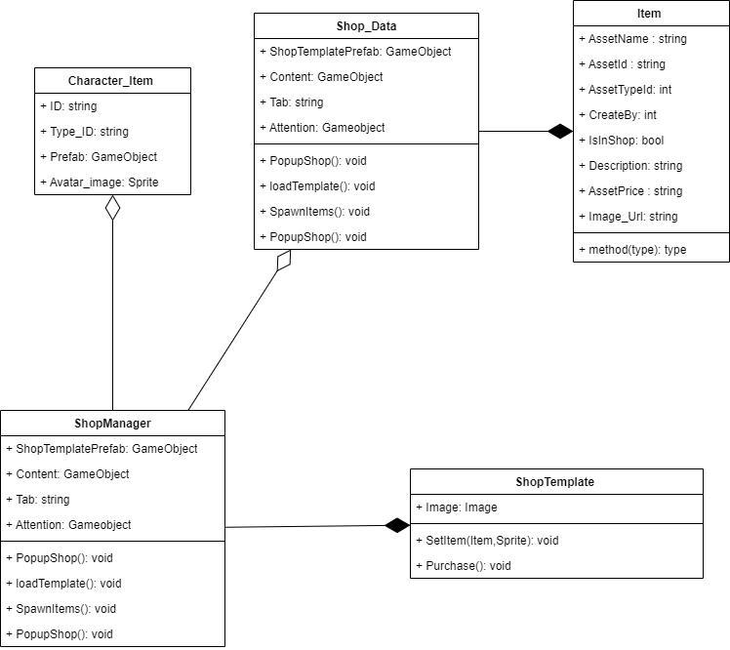

Figure 18 - Buy item in shop Feature Class Diagram

**3.2.2 Class Specification**

**a. Buy item Service**

91

|  |  |  |
| --- | --- | --- |
| **No** | **Method** | **Description** |
| 1 Purchase() |  | Send request to server for buy the |
|  |  | item |
|  | Table 40- Buy Item Service Class Specification | |

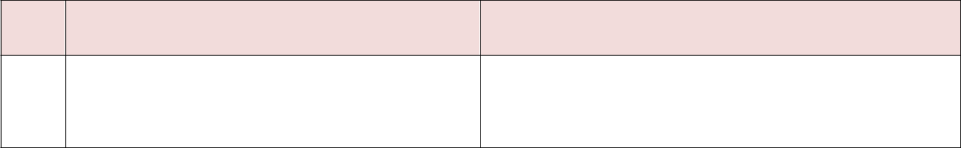

**3.2.3 Get Asset in Shop Sequence Diagram**

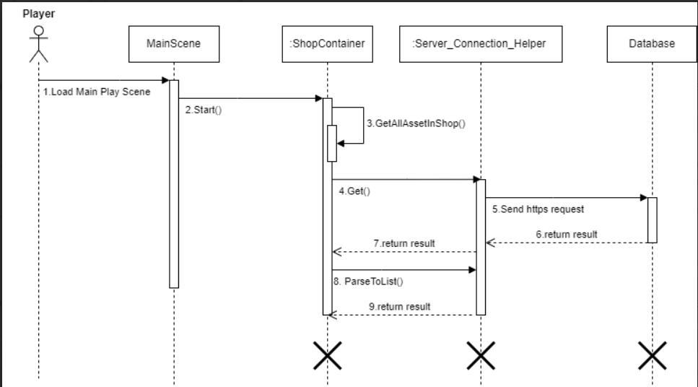

Figure 19 - Get asset in shop Activity Diagram

92

**3.2.4 Buy Character Sequence Diagram**

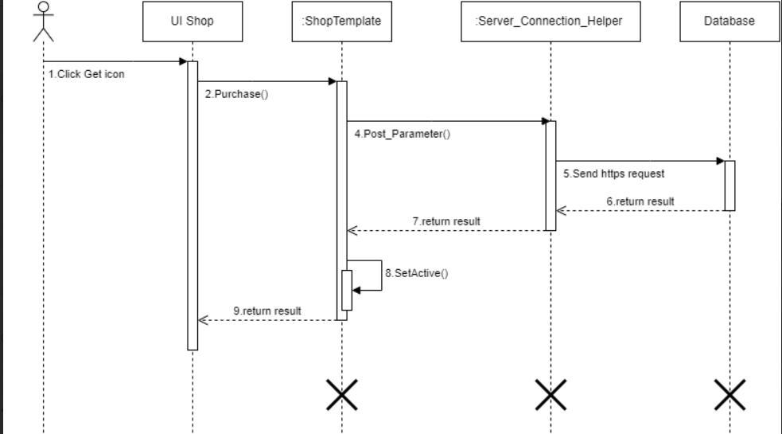

Figure 20 - Buy character Sequence Diagram

93

**3.3 Change outfit Feature**

**3.3.1 Class Diagram**

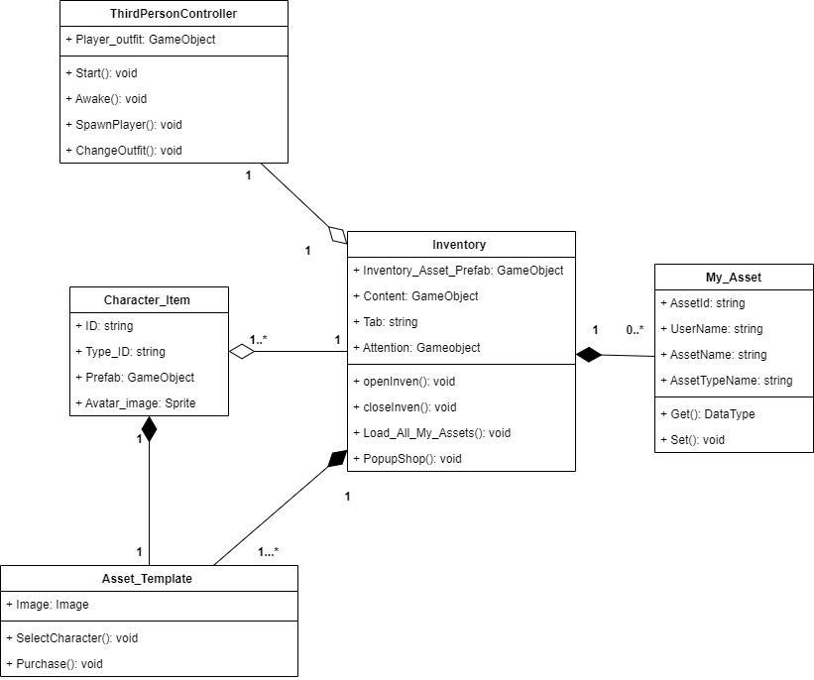

Figure 21 - Change outfit Feature Class Diagram

**3.3.2 Class Specification**

**a. Change outfit Service**

94

|  |  |  |
| --- | --- | --- |
| **No** | **Method** | **Description** |
|  |  |  |
| 1 | Load_All_My_Assets() | Send request to server to get all player’s asset |
|  |  |  |
| 2 | SelectCharacter() | Send request to server to update lasted |
|  |  | character (outfit) selected |
|  |  |  |
| 3 | ChangeOutfit(Character_Item) | Update 3D model in scene and apply |
|  |  | animation to new model. |
|  |  |  |
|  | Table 41 - Change outfit Service Class Specification | |
| **3.3.3 Get Player Asset Sequence Diagram** | |  |

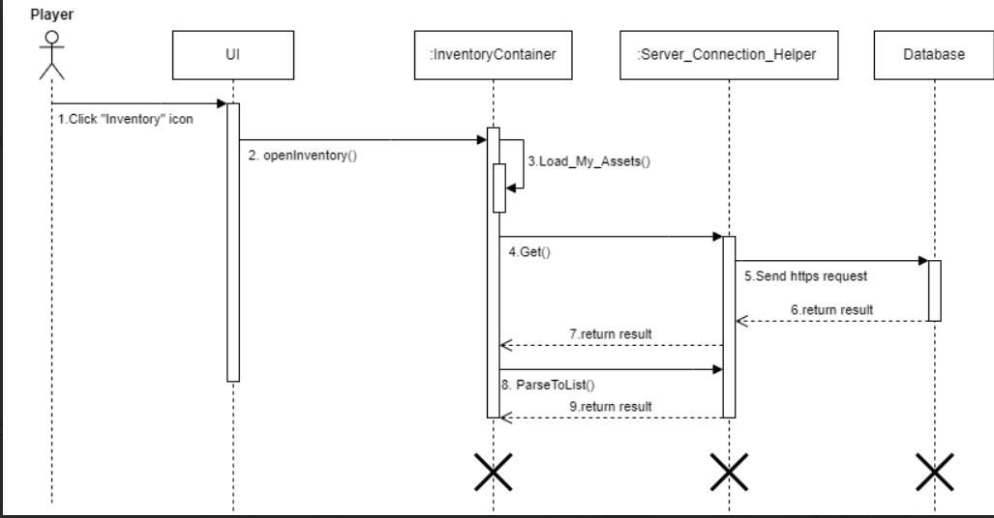

Figure 22 - Get Player Asset Sequence Diagram

95

**3.3.4 Update Character Selected Sequence Diagram**

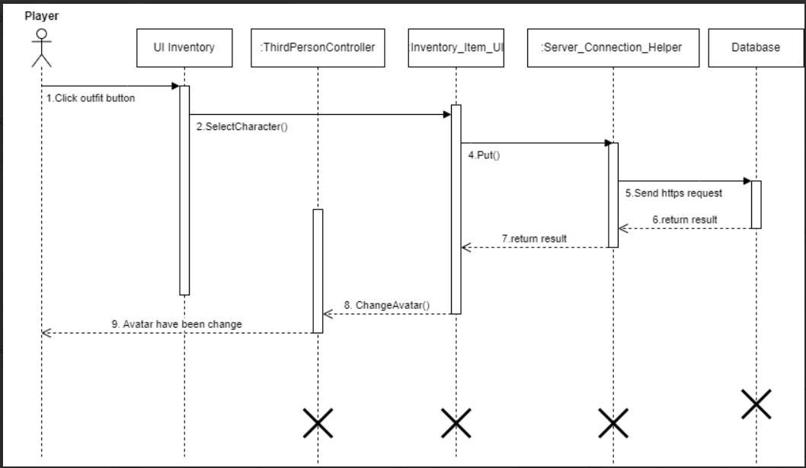

Figure 23 - Update Character Selected Sequence Diagram

96

**3.4 Change Job Feature**

**3.4.1 Class Diagram**

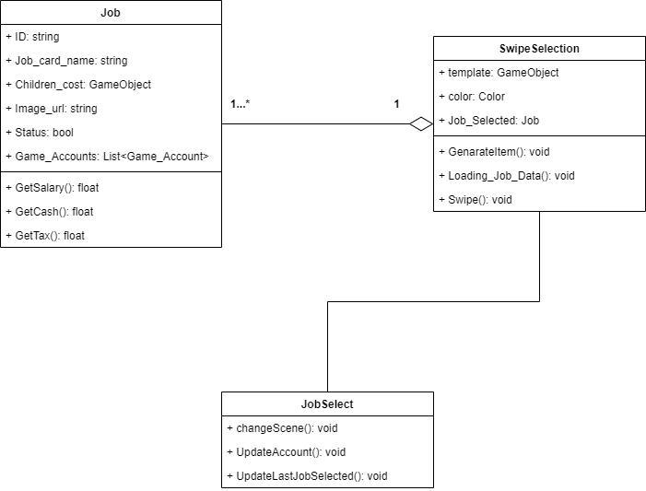

Figure 24 - Change Job Feature Class Diagram

**3.4.2 Class Specification**

**a. Change Job Service**

|  |  |  |
| --- | --- | --- |
| **No** | **Method** | **Description** |
|  |  |  |
| 1 | Loading_Job_Data() | send request to API to get Job |
|  |  | information |
|  |  |  |

97

|  |  |  |
| --- | --- | --- |
| 2 | UpdateLastJobSelected() | send update request to API to |
|  |  | update last job user selected |
|  |  |  |
| 3 | UpdateAccount() | send update request to API to |
|  |  | update player information |
|  |  |  |
|  | Table 42 - Change job Service Class Specification | |
| **3.4.3 Get Job Sequence Diagram** | |  |

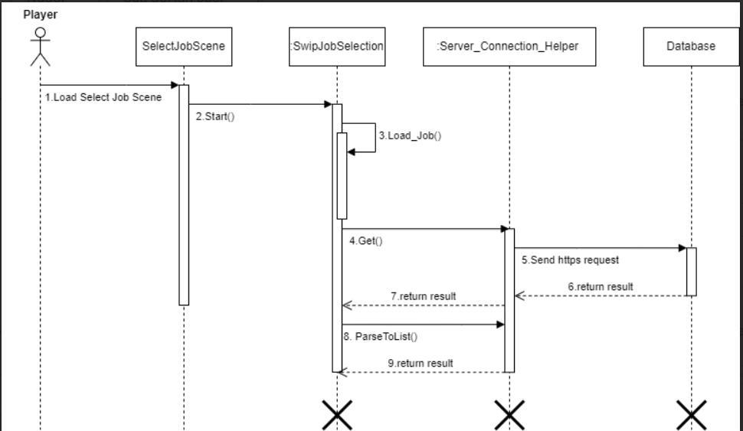

Figure 25- Get Job Sequence Diagram

98

**3.4.3 Update Player Job Sequence Diagram**

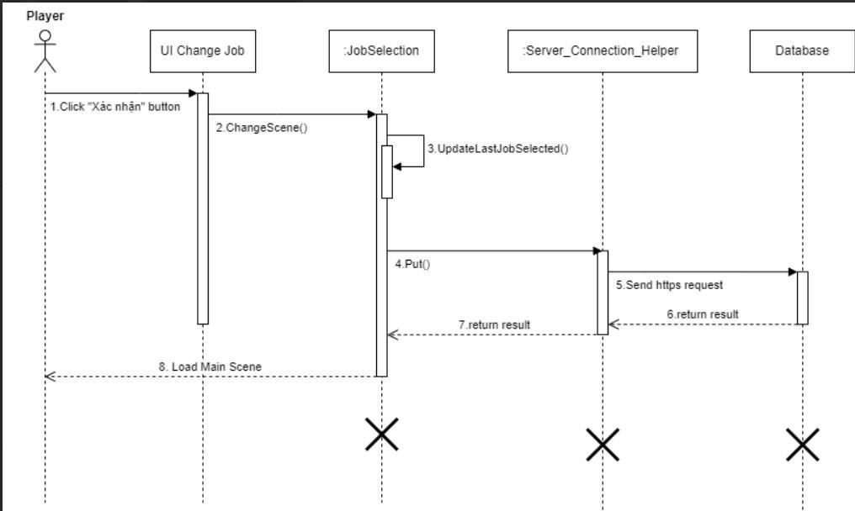

Figure 26 - Update Player Job Sequence Diagram

99

**3.5 Play Game Match Feature**

**3.5.1 Class Diagram**

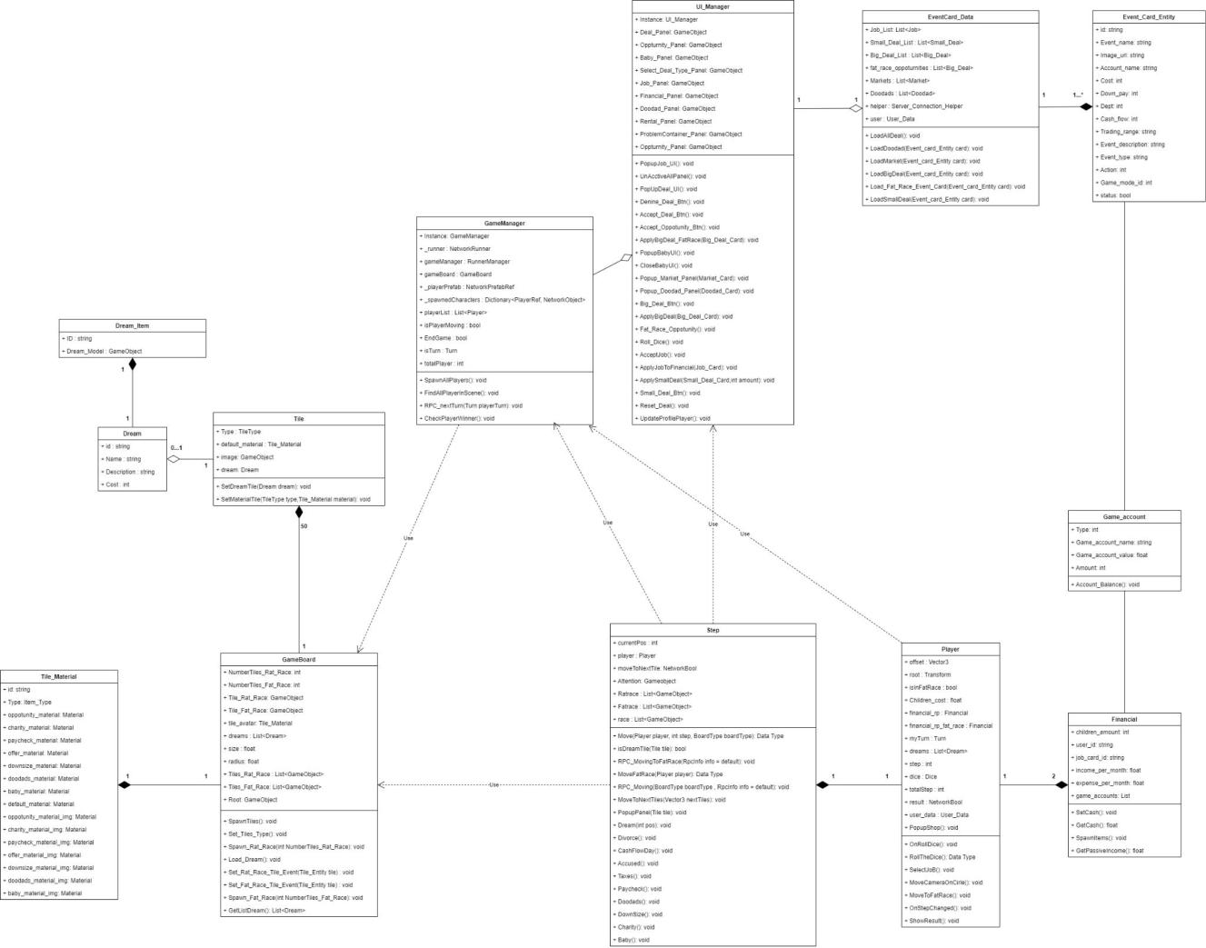

Figure 27 - Play Game Match Feature Class Diagram

**3.5.2 Class Specification**

**a. Play game Service**

|  |  |  |  |  |
| --- | --- | --- | --- | --- |
| **No** |  | **Method** | | **Description** |
|  |  |  |  |  |
| 1 |  | ApplyBigDeal_FatRace(Big_Deal_Card) |  | Apply the deal when player click to |
|  |  |  |  | button accept during play time |
|  |  |  |  |  |

100

|  |  |  |  |  |  |  |  |  |  |  |  |  |  |
| --- | --- | --- | --- | --- | --- | --- | --- | --- | --- | --- | --- | --- | --- |
| 2 |  | ApplyJobToFinancial(Job_Card) | | | | | |  |  |  |  | Apply the Job when player click to |  |
|  |  |  |  |  |  |  |  |  |  |  |  | button accept after load in to |  |
|  |  |  |  |  |  |  |  |  |  |  |  | scene |  |
|  |  |  |  |  |  |  |  | |  |  |  |  |  |
| 3 |  | ApplySmallDeal(Small_Deal_Card,int | | | | | | | |  |  | Apply the deal when player click to |  |
|  |  |  |  |  |  |  |  | |  |  |  | button accept during play time |  |
|  | amount) |
|  |  |  | |  |  |  |  | |  |  |  |  |  |
| 4 |  | LoadAllDeal() | |  |  |  |  | |  |  |  | Send request to API to get all event |  |
|  |  |  |  |  |  |  |  |  |  |  |  | card and filter the event card |  |
|  |  |  | | |  |  |  | |  |  |  |  |  |
| 5 |  | CheckPlayerWinner() | | | |  |  |  |  |  |  | Checking the winner, if exist, |  |
|  |  |  |  |  |  |  |  |  |  |  |  | EndGame Flag will set to true. |  |
|  |  |  | | |  | |  | |  |  |  |  |  |
| 6 |  | UpdateProfilePlayer() | | | | |  |  |  |  |  | Update information each player in |  |
|  |  |  |  |  |  |  |  |  |  |  |  | UI |  |
|  |  |  | | |  | | | |  |  |  |  |  |
| 7 |  | RPC_nextTurn(Turn playerTurn) | | | | | | |  |  |  | Handles check to next turn |  |
|  |  |  | | |  | | | | |  |  |  |  |
| 8 |  | SpawnAllPlayers() | | |  | | | | |  |  | Handles spawn all player |  |
|  |  |  |  |  |  | | | | | |  |  |  |
|  |  |  |  |  | Table 43 - Play game Service Class Specification | | | | | | | | |
| **b. Player Service** | | | | | | | | | |  |  |  |  |
|  |  |  |  |  | | | | | |  |  |  |  |
| **No** |  |  |  | **Method** | | | | | |  |  | **Description** |  |
|  |  | | | | | | | | |  |  | |  |
| 1 | OnRollDice() | | | | | | | | |  | handles player click roll dice | |  |
|  |  | | | | | | | | |  |  | |  |
| 2 | RollTheDice() | | | | | | | | |  | handles start roll dice | |
|  |  | | | | | | | | |  |  | |  |
| 3 | SelectJoB() | | | | | | | | |  | handles player’s job | |
|  |  | | | | | | | | |  |  | |  |
| 4 | MoveCameraOnCirle() | | | | | | | | |  | handles camera on board game | |
|  |  | | | | | | | | |  |  | |  |
| 5 | MoveToFatRace() | | | | | | | | |  | handles player move rat race to fat race | |
|  |  | | | | | | | | |  |  | |  |
| 6 | OnStepChanged() | | | | | | | | |  | handles player’s step changed | |
|  |  | | | | | | | | |  |  | |  |
| 7 | ShowResult() | | | | | | | | |  | handles show player’s result | |
|  |  | | | | | | | | |  |  | |  |
| 8 | Move(Player player, int step, | | | | | | | | |  | handles player’s move | |
|  |  |  |  |  |  |  |  |  |  |  |  |  |  |

101

|  |  |  |
| --- | --- | --- |
|  | BoardType boardType) |  |
|  |  |  |
| 9 | isDreamTile(Tile tile) | handles check dream tile |
|  |  |  |
| 10 | RPC_MovingToFatRace(RpcInfo info = | handles player move to fat race in |
|  | default) | multiplayer |
|  |  |  |
| 11 | MoveFatRace(Player player) | handles player move rat race to fat race |
|  |  |  |
| 12 | RPC_Moving(BoardType boardType , | handles player move in multiplayer |
|  | RpcInfo info = default) |  |
|  |  |  |
| 13 | MoveToNextTiles(Vector3 nextTiles) | handles player move to next tile |
|  |  |  |
| 14 | PopupPanel(Tile tile) | handles show popup of event |
|  |  |  |
| 15 | Dream(int pos) | handles player’s dream |
|  |  |  |
| 16 | Divorce() | handles player's divorce |
|  |  |  |
| 17 | CashFlowDay() | handles player's cash flow day |
|  |  |  |
| 18 | Accused() | handles player's accused |
|  |  |  |
| 19 | Taxes() | handles player's taxes |
|  |  |  |
| 20 | Paycheck() | handles player's paycheck |
|  |  |  |
| 21 | Doodads() | handles player's doodads event |
|  |  |  |
| 22 | DownSize() | handles player's downsize event |
|  |  |  |
| 23 | Charity() | handles player's charity event |
|  |  |  |
| 24 | Baby() | handles player’s baby |
|  |  |  |
|  | Table 44 - Player Service Class Specification | |
| **c. Game Board Service** | |  |

**No**

1

**Method**

SpawnTiles()

**Description**

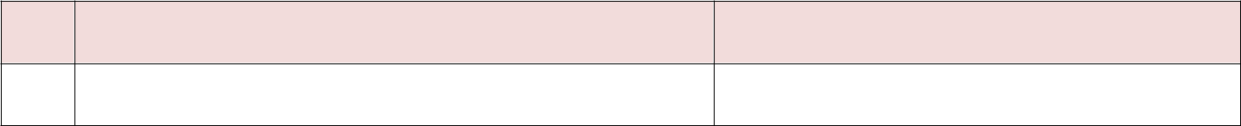

Spawn the tile to create the board

102

|  |  |  |  |  |  |
| --- | --- | --- | --- | --- | --- |
| 2 | Set_Tiles_Type | | () |  | Set the event type of Tile |
|  |  |  | |  |  |
| 3 | Spawn_Rat_Race(int NumberTiles_Rat_Race) | | | | Spawn the tile in Rat Race with |
|  |  |  |  |  | parameter |
|  |  |  | |  |  |
| 4 | Load_Dream() |  |  |  | Send request to API to get all dream |
|  |  |  |  |  | in match and set dream to tile |
|  |  | | |  |  |
| 5 | Spawn_Fat_Race(int NumberTiles_Fat_Race) | | |  | Spawn the tile in Fat Race with |
|  |  |  |  |  | parameter |

Table 45 - Game board Service Class Specification

**3.5.3 Get Title Sequence Diagram**

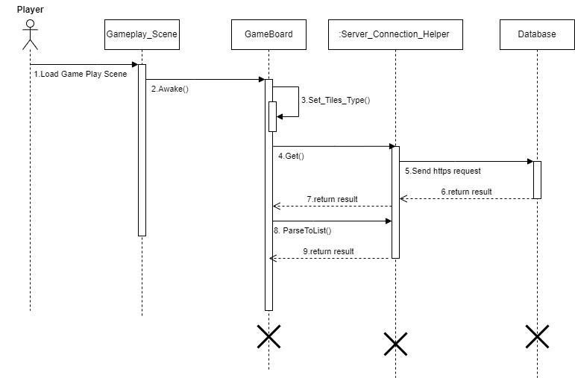

Figure 28 - Get Title Sequence Diagram

103

**3.5.4 Get Dreams Sequence Diagram**

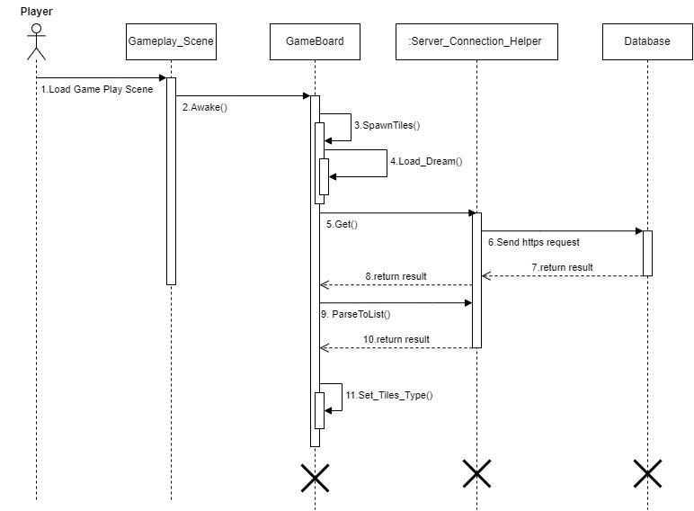

Figure 29 - Get Dreams Sequence Diagram

104

**3.5.5 Get Event Card Sequence Diagram**

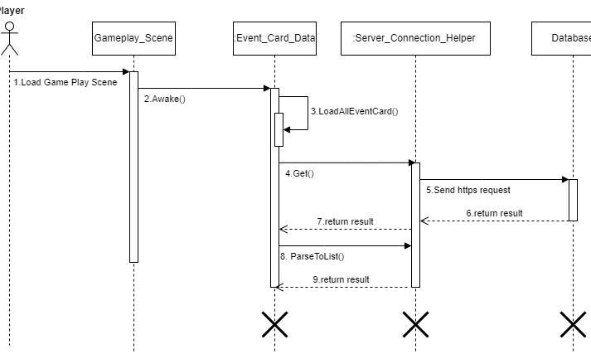

Figure 30 - Get Event Cards Sequence Diagram

105

**3.6 Manage Event Card Feature**

**3.6.1 Class Diagram**

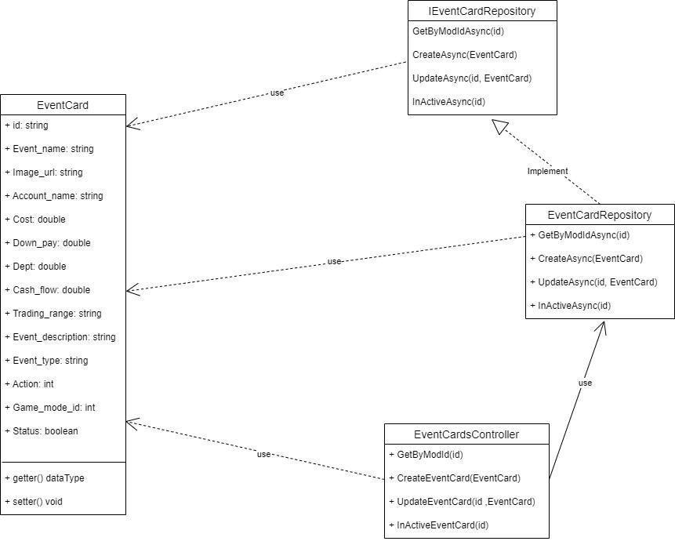

Figure 31 - <Class Diagram> Admin manage event card

**3.6.2 Class Specification**

**a. Manage Event Card Service**

**No**

1

**Method**

GetByModIdAsync(id)

**Description**

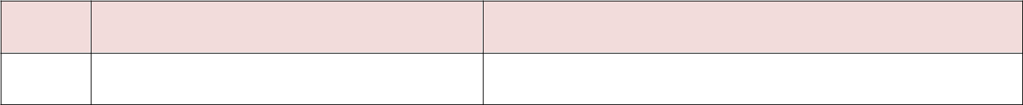

handles view list of by mod id

106

|  |  |  |
| --- | --- | --- |
| 2 | CreateAsync(EventCard) | handles create event card |
| 3 | UpdateAsync(id, EventCard) | handles update event card by id |
| 4 | InActiveAsync(id) | handles update status of event card to false |



Table 46 - Manage event card Service Class Specification

**3.6.3 Create event card Sequence Diagram**

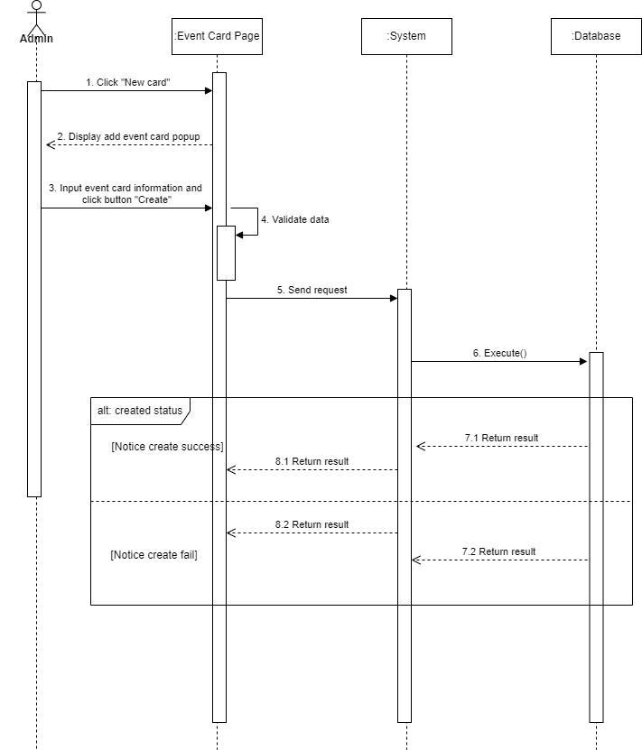

Figure 32<Sequence Diagram> Admin create event card

107

**3.6.4 Update event card Sequence Diagram**

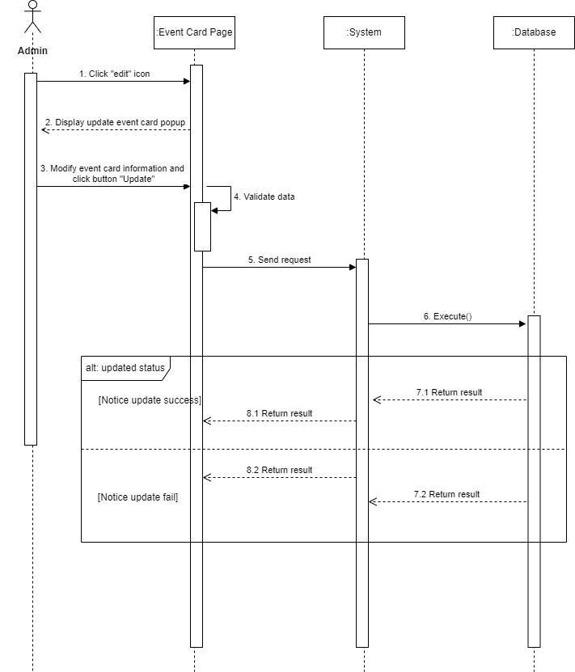

Figure 33- <Sequence Diagram> Admin update event card

108

**3.6.5 Delete event card Sequence Diagram**

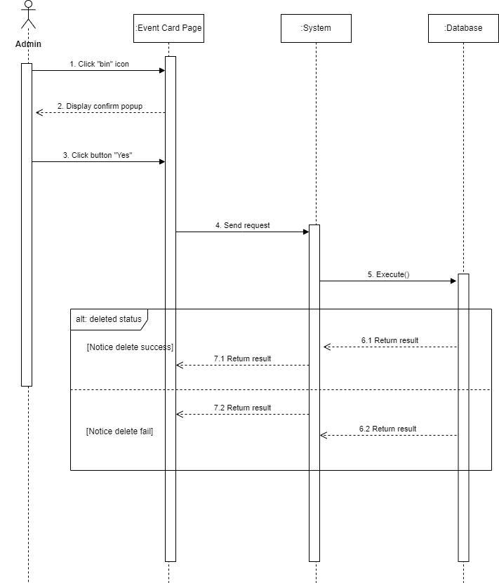

Figure 34 - <Sequence Diagram> Admin inactive event card

109

**3.7 Manage Dream Feature**

**3.7.1 Class Diagram**

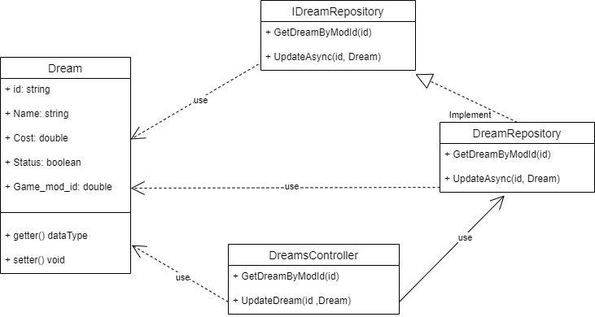

Figure 35 - <Class Diagram> Admin manage dream

**3.7.2 Class Specification**

**a. Update dream Service**

|  |  |  |
| --- | --- | --- |
| **No** | **Method** | **Description** |
| 1 | GetDreamByModId(id) | handles view list of dream by mod id |
| 2 | UpdateAsync(id, Dream) | handles update a dream |
|  | Table 47 - Mange dream Service Class Specification | |



110

**3.7.3 Update dream Sequence Diagram**

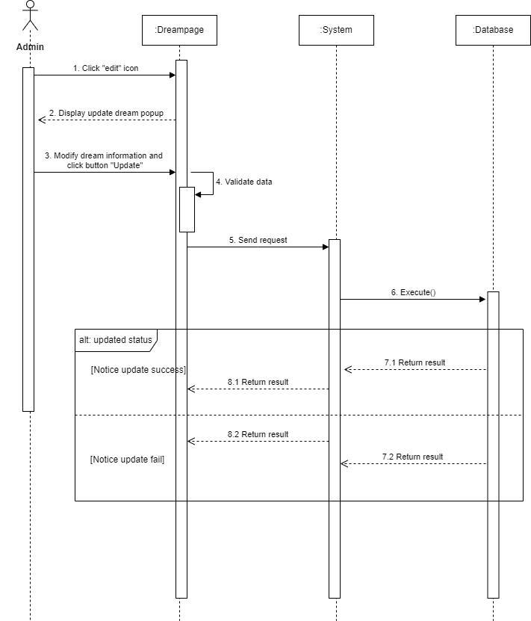

Figure 36 - <Sequence Diagram> Admin update dream

111

**3.8 Manage Game Account Feature**

**3.8.1 Class Diagram**

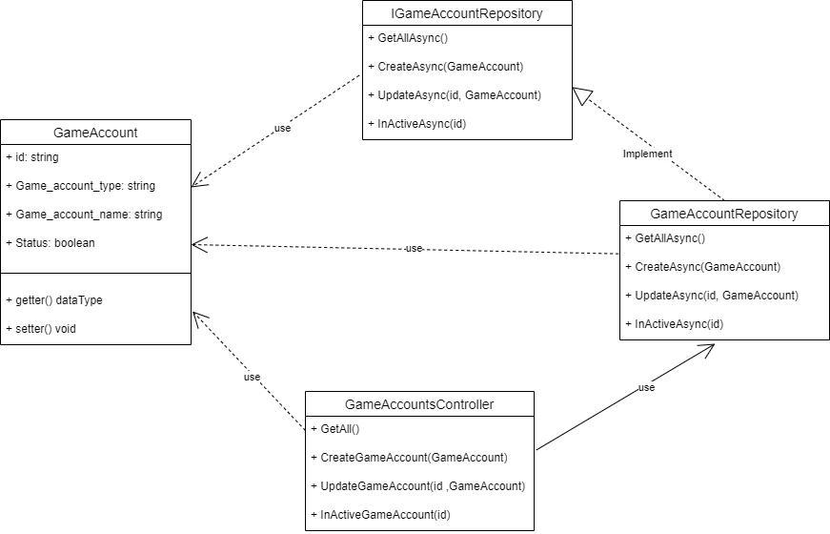

Figure 37 - <Class Diagram> Admin manage game account

**3.8.2 Class Specification**

**a. Manage game account Service**

|  |  |  |
| --- | --- | --- |
| **No** | **Method** | **Description** |
| 1 | GetAllAsync() | handles view list of game account |
| 2 | CreateAsync(GameAccount) | handles create game account |
| 3 | UpdateAsync(id, GameAccount) | handles update game account |
| 4 | InActiveAsync(id) | handles update status of dream to false |
|  | Table 48- Manage game account Service Class Specification | |

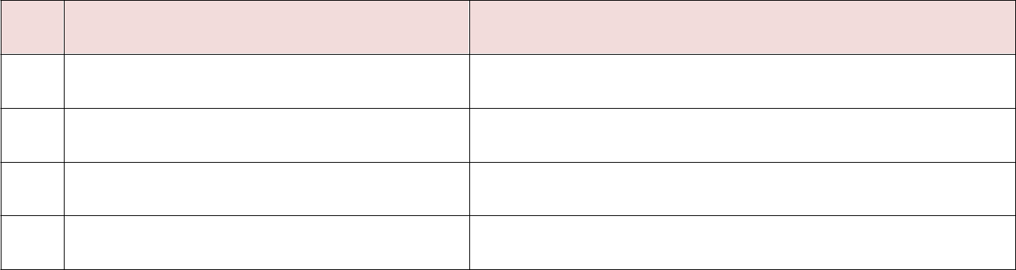

112

**3.8.3 Create game account Sequence Diagram**

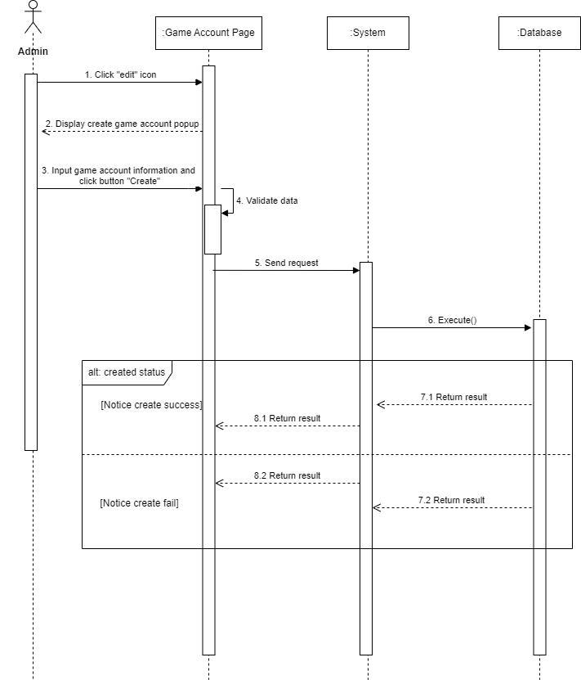

Figure 38 - <Sequence Diagram> Admin create game account

113

**3.8.4 Update game account Sequence Diagram**

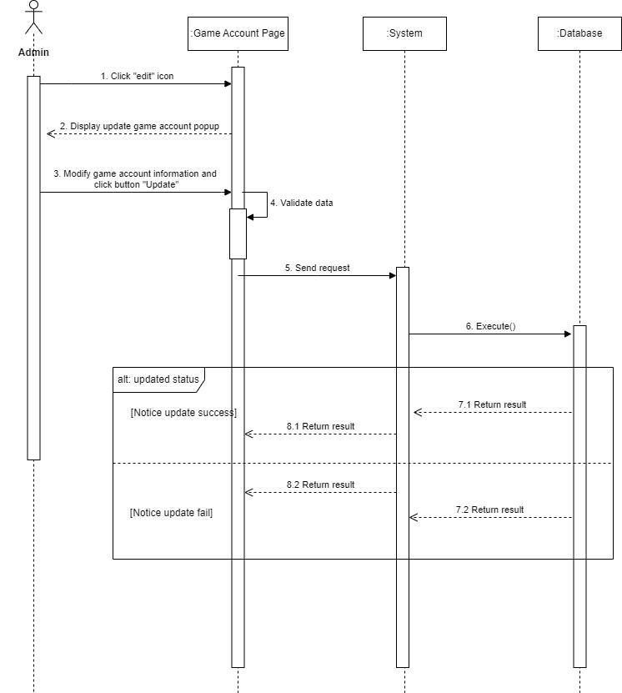

Figure 39- <Sequence Diagram> Admin update game account

114

**3.8.5 Delete game account Sequence Diagram**

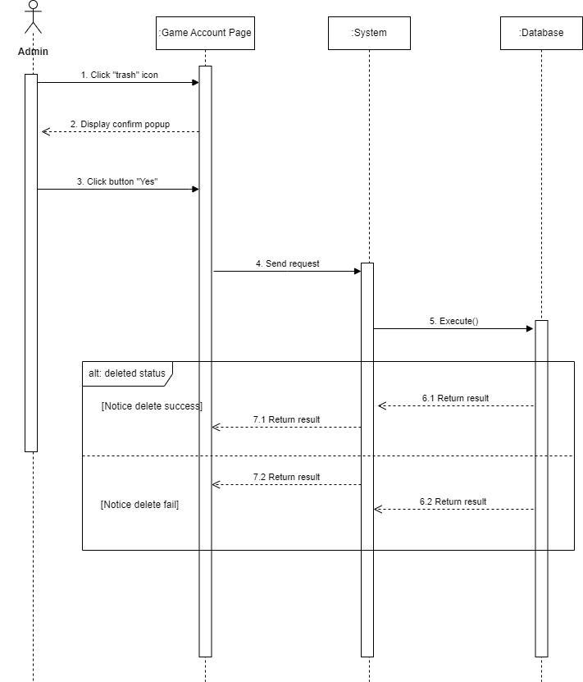

Figure 40 - <Sequence Diagram> Admin inactive game account

115

**3.9 Manage Job Feature**

**3.9.1 Class Diagram**

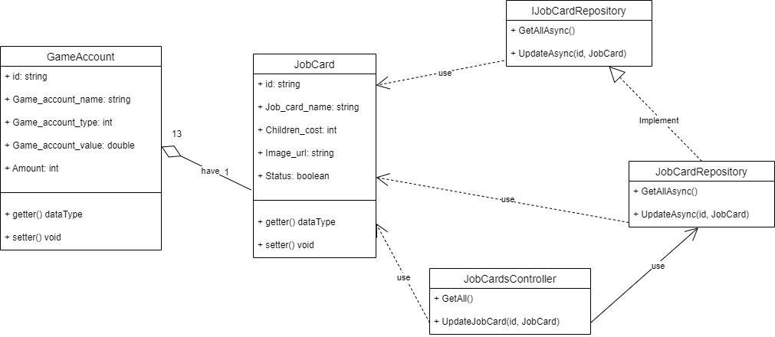

Figure 41 - <Class Diagram> Admin update job

**3.9.2 Class Specification**

**a. Update job Service**

|  |  |  |
| --- | --- | --- |
| **No** | **Method** | **Description** |
| 1 | GetAllAsync() | handles view list of job card |
| 2 | UpdateAsync(id, JobCard) | handles update job card |
|  | Table 49- Mange Job Service Class Specification | |



116

**3.9.3 Update Job Sequence Diagram**

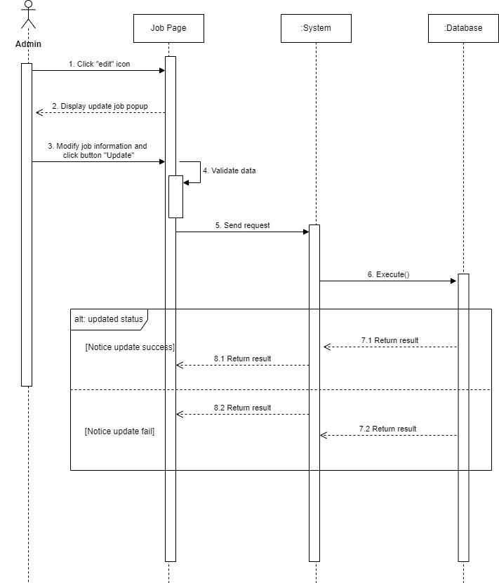

Figure 42 - <Sequence Diagram> Admin update job

117

**3.10 Match History Feature**

**3.10.1 View History Sequence Diagram**

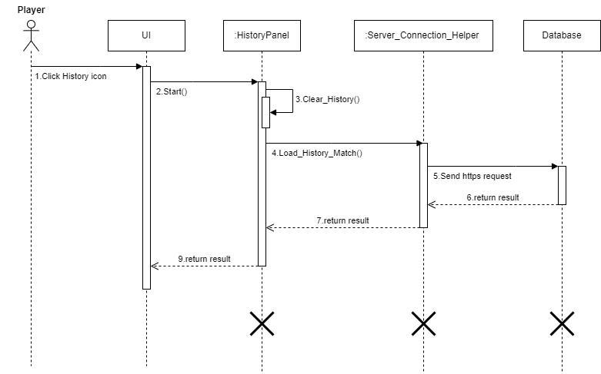

Figure 43 - <Sequence Diagram> view history

118

**3.10.2 Create Match History**

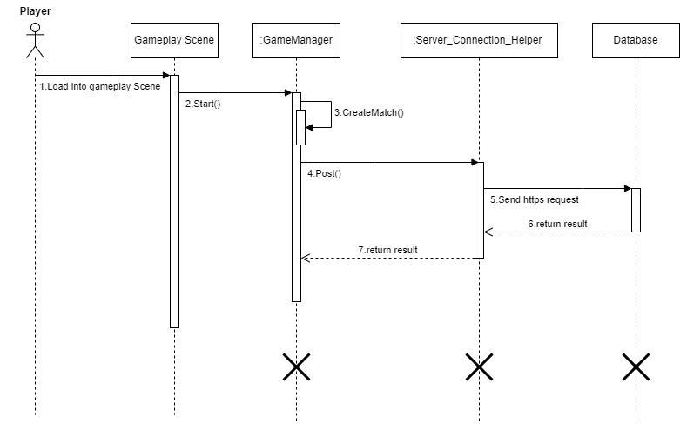

Figure 44 - <Sequence Diagram> Create Match history

119

**3.10.3 Update Match History**

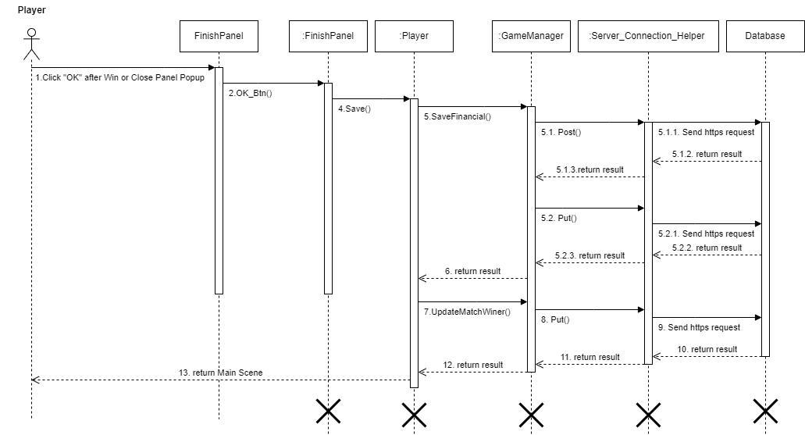

Figure 45 - <Sequence Diagram> Update Match history

120

**3.11 Manage Asset Feature**

**3.11.1 Class Diagram**

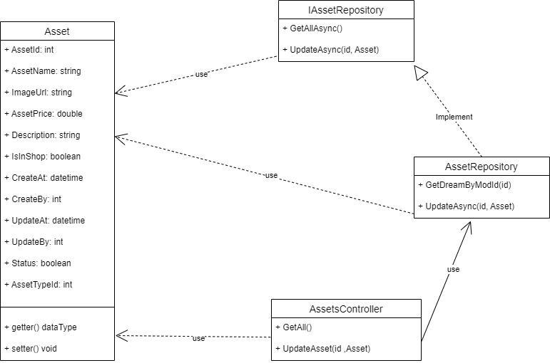

Figure 46- <Class Diagram> Mange asset feature

**3.11.2 Class Specification**

**a. Manage Asset Service**

|  |  |  |
| --- | --- | --- |
| **No** | **Method** | **Description** |
| 1 | GetAllAsync() | handles view list of asset |
| 2 | UpdateAsync(id, Asset) | handles update asset |



Table 50 - Manage Asset Service Class Specification

121

**3.11.3 Update Asset Sequence Diagram**

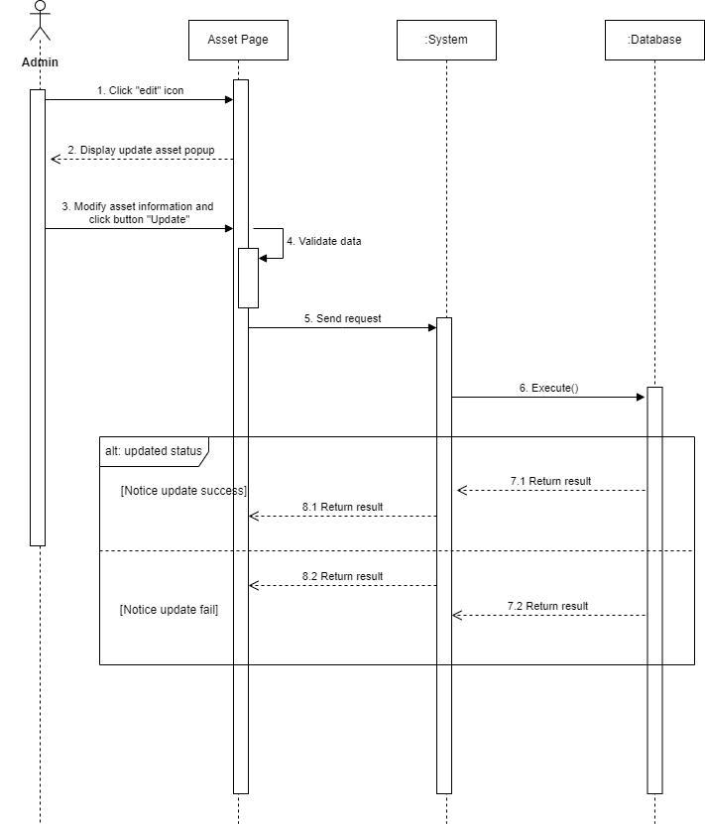

Figure 47 - <Sequence Diagram> Admin update asset

122

**4. Game Design**

[https://docs.google.com/document/d/1I8RrIUQ4vokPDTAnUo6cf-1owmzkzguPYsv0b-](https://docs.google.com/document/d/1I8RrIUQ4vokPDTAnUo6cf-1owmzkzguPYsv0b-6ZOnw/edit?usp=sharing)6ZOnw/edit?usp=sharing

**4.1 Concept Board**

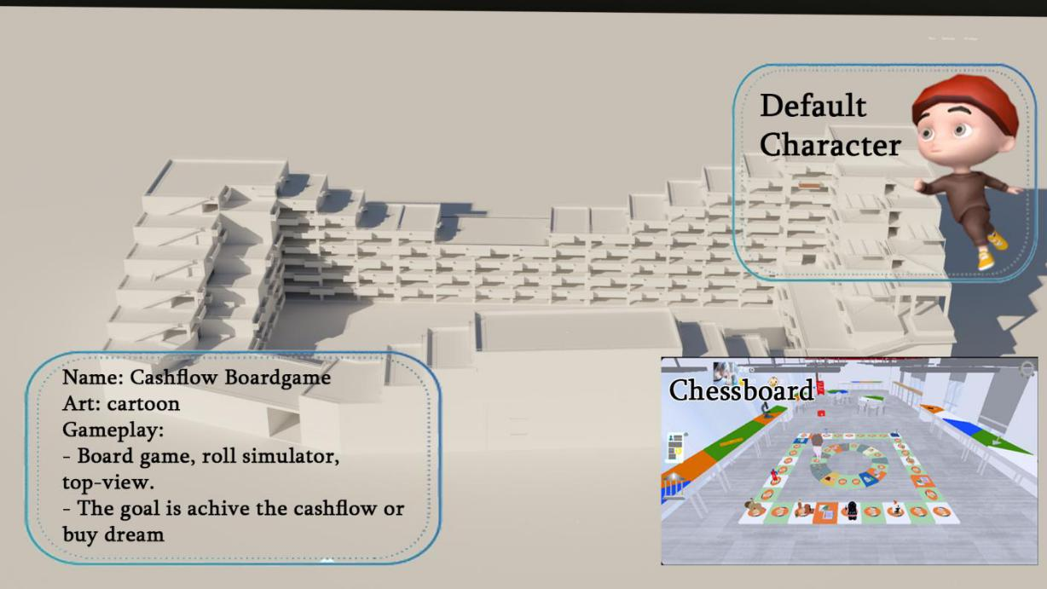

**4.2 Art**

**4.2.1 Art Button**

Drawing button pictures:



Image 1:Setting button

123

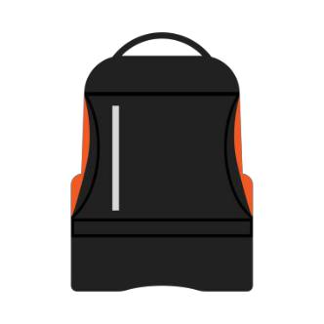

Image 2: Invetory button



Image 3: Friend button



Image 4: Bank button

124



Image 5: Achievement button



Image 6: Financial report button



Image 7: Shop button

125



Image 8: Match history button



Image 9: Pay loan button



Image 10: Change job

126



Image 11: Roll dice button

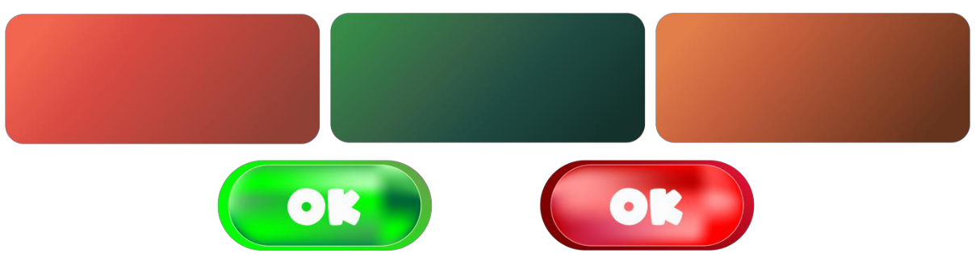

Image 12: Other button in game

**4.2.2 Art UI**

* Some picture was make by AI
* Drawing UI picture:



Image 13: Logo in game

-



Image 14: Icon job info

127



Image 15: Background login/register



Image 16: Art win/lose

128

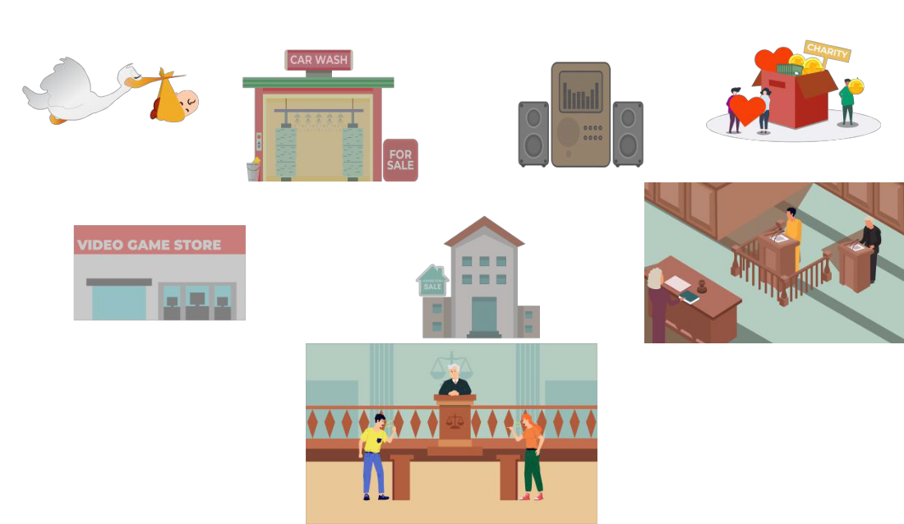

Image 17:Some of the pictures are used as event card in the match



Image 18: Some of the pictures are used as dream in the match

129



Image 19: Art show basic info player



Image 20: Attention in game



Image 21: Some other decorative images and icons

**4.2.3 Art Character**

* Due to limited ability to draw by yourself, there are some from the unity asset store.
* Player outfit:

130

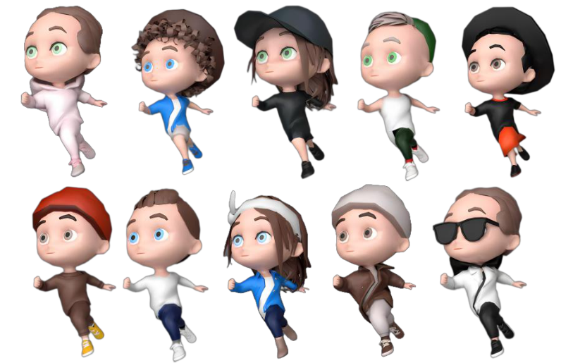

Image 22: Player outfit

● Player job:



Image 23: Player job

131

● Npc: NPCs will appear in the map so players can interact or do quests:

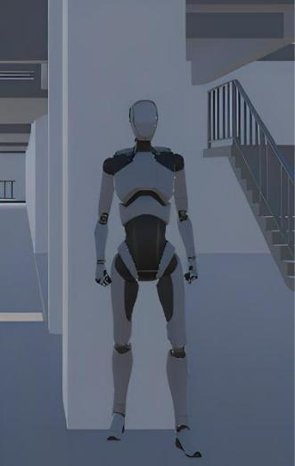

Image 24: NPC

**4.3 Game Feature**

**4.3.1 Control Character**

**4.3.1.1 PLayer move**

**Description**: Allows the player to move back and forth in many directions and has a moving animation.

**Content**: Made for player to move in the direction of joystick and have animation.

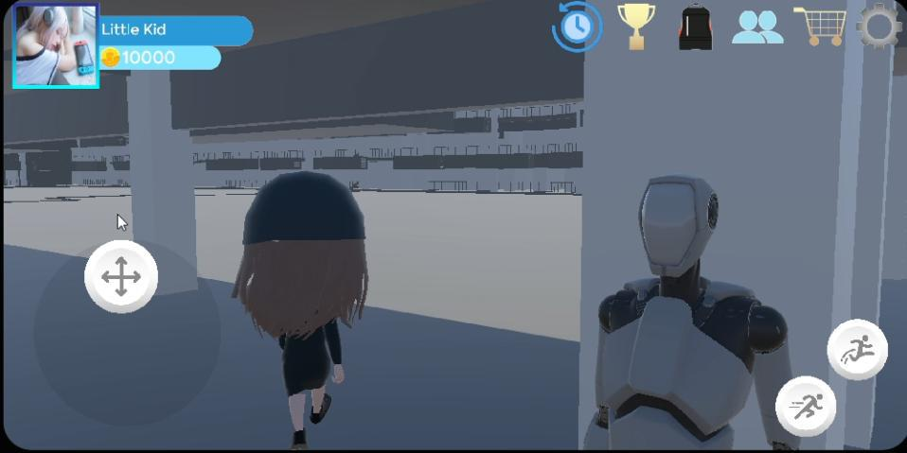

Image 25: The character moves in the direction of the joystick

132

**4.3.1.2 Player's fast running**

**Description**: Player will run quickly towards the joystick when pressing the button on the screen.

**Content**: Made for the player to run fast in the direction of the joystick that the player controls, if not, the player will not run

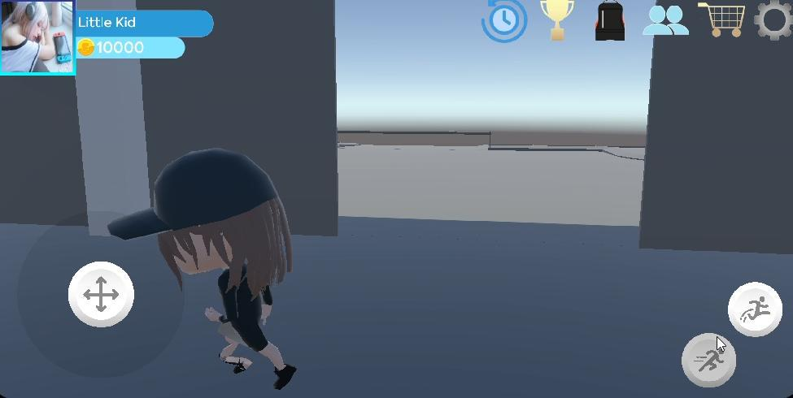

Image 26: The character runs when the run button is pressed

**4.3.1.3 Player's Jump**

**Description**: Player jumps when pressing the jump button on the screen.

**Content**: Implemented for the player to be able to jump when pressing the jump button. And when possible, combine moving and jumping at the same time.

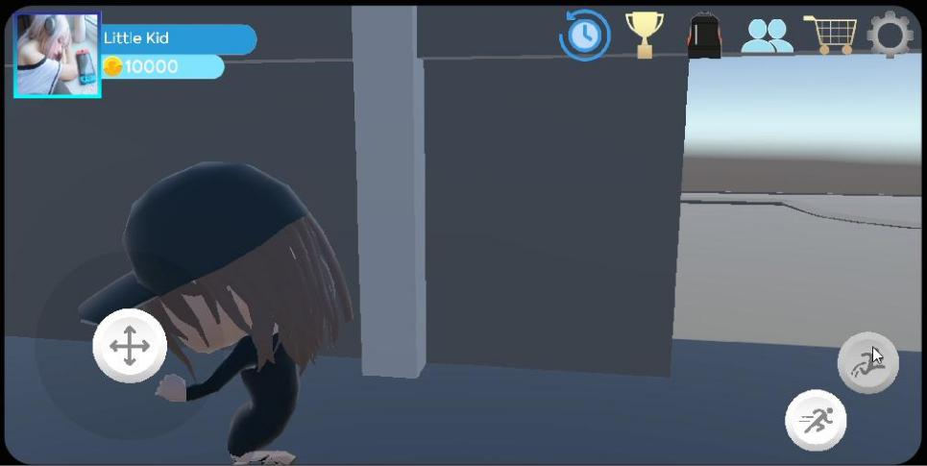

Image 27: The character runs when the jump button is pressed

133

**4.3.2 Create an online match**

**4.3.2.1 Create a playroom or join a playroom**

**Description**: Players can create or enter an existing playroom to start the match.

**Content**: Use Photon fusion to make a game server, and use it to create a playroom.

Some pictures:

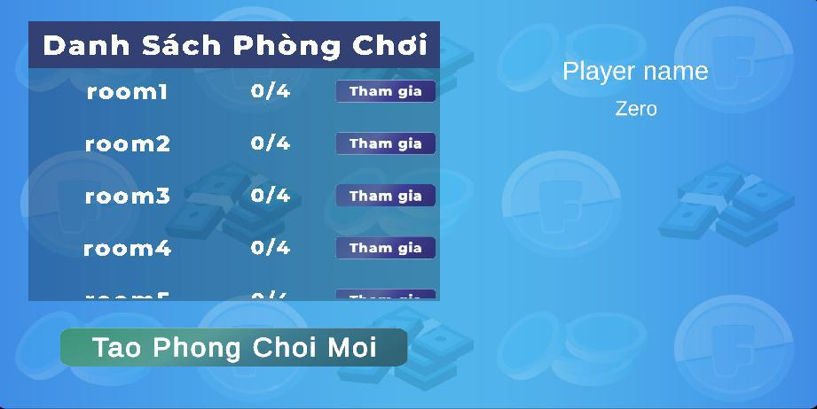

Image 28: List room

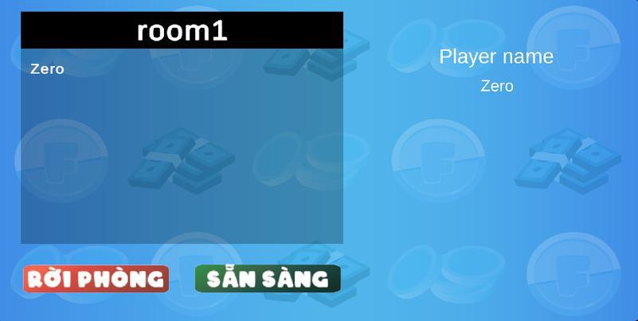

Image 29: In room

**4.3.3 Play Game**

**4.3.3.1 Move on the chessboard**

**Description**: Move the piece when the dice roll button is pressed.

**Content**: Move the correct number of squares to the number of dice rolled.

134

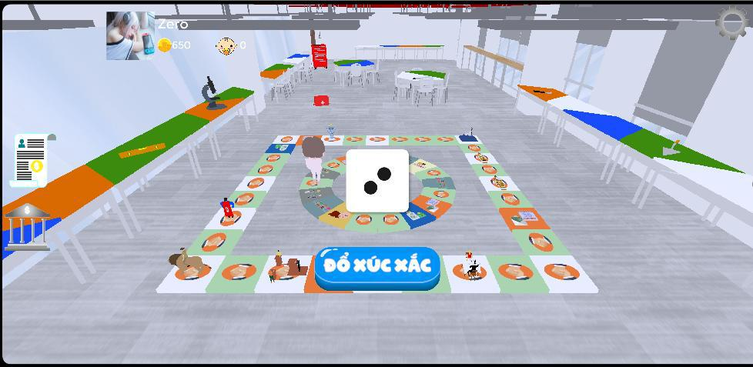

Image 30: Roll the dice and move

**4.3.3.2 Make events in the Rat Race**

**Description**: Player moves to cell and executes event within Ratrace

**Content**: The player rolls the dice and moves to the tile, and each tile contains an event type. Player can either fire the event or ignore it (if allowed). Some pictures:

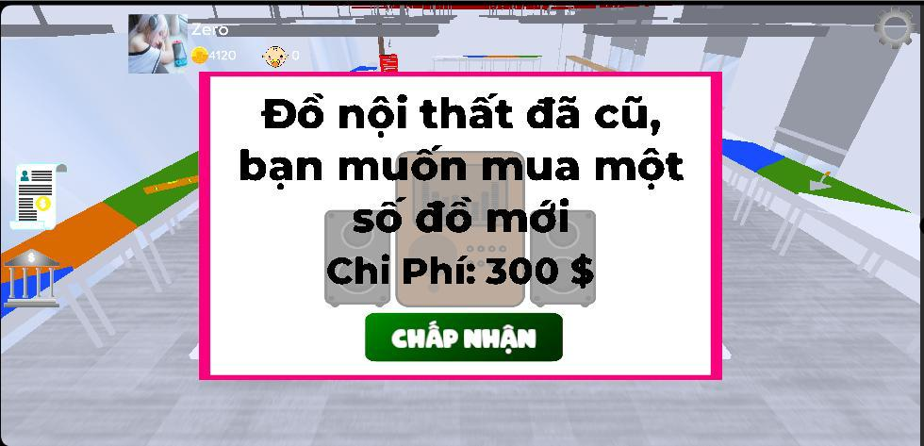

Image 31: Make a Doodad event

135

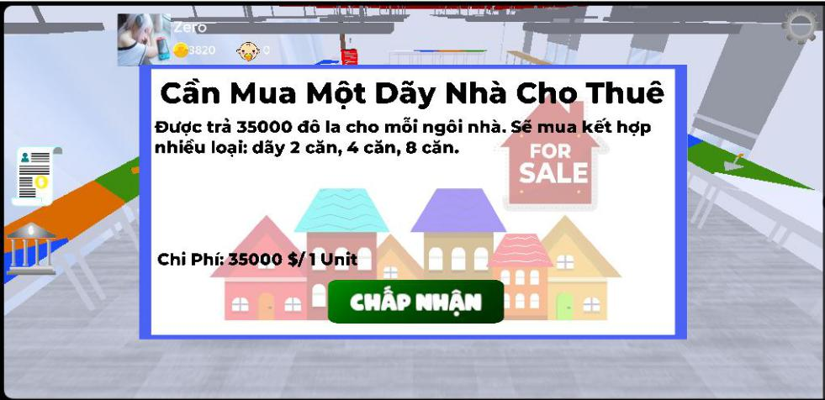

Image 32: Make a Market event

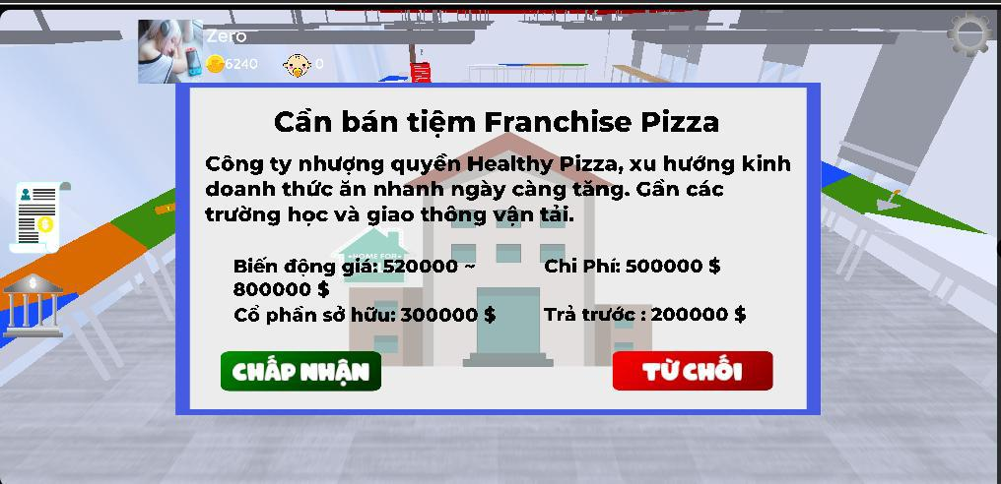

Image 33: Make a Big Deal/Small Deal event

**4.3.3.3 Move out the Fasttrack**

**Description**: From the Ratrace move outside the fasttrack

**Content**: Eligible cash flows in the financial statements within Rat Race will automatically move out of the Fasttrack. Some pictures:

136

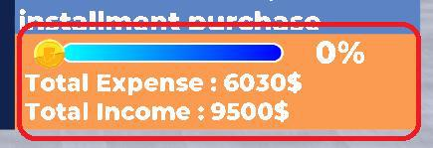

Image 34: Conditions to get out of Fasttrack

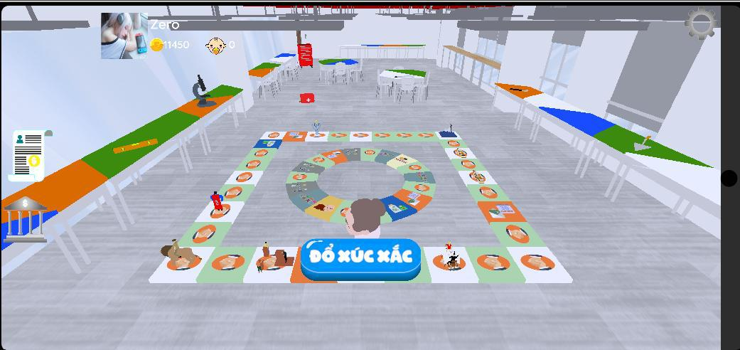

Image 35: Player moves to the Fasttrack

**4.3.3.4 Make events in the Fasttrack**

**Description**: Player moves to cell and executes event within Fasttrack

**Content**: The player rolls the dice and moves to the tile, and each tile contains an event type. Player can either fire the event or ignore it (if allowed). Some pictures:

137

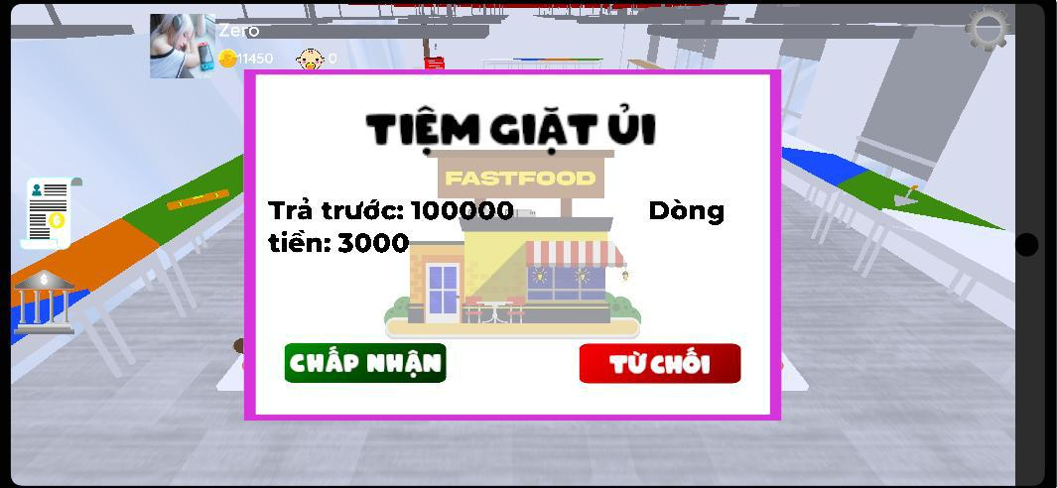

Image 36: Make an opportunity event

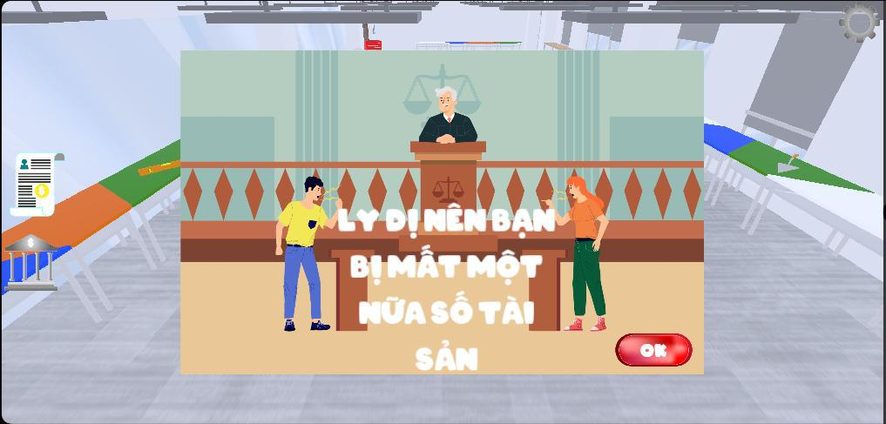

Image 37: Make an problem event

**4.3.3.5 Win match**

**Description**: Player reaches the condition and wins

**Content**: Player accumulates enough money that the game offers or enough money to

buy his dream to be able to win the match.

Some pictures:

138

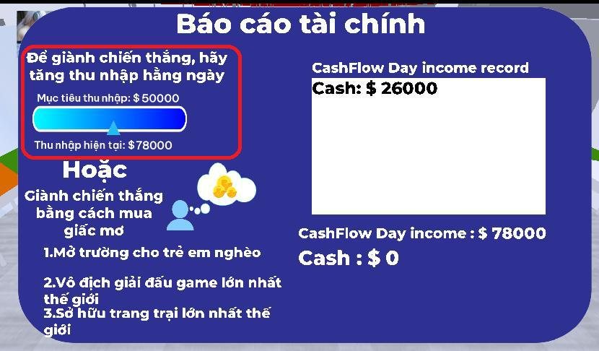

Image 38: Earn enough income to win

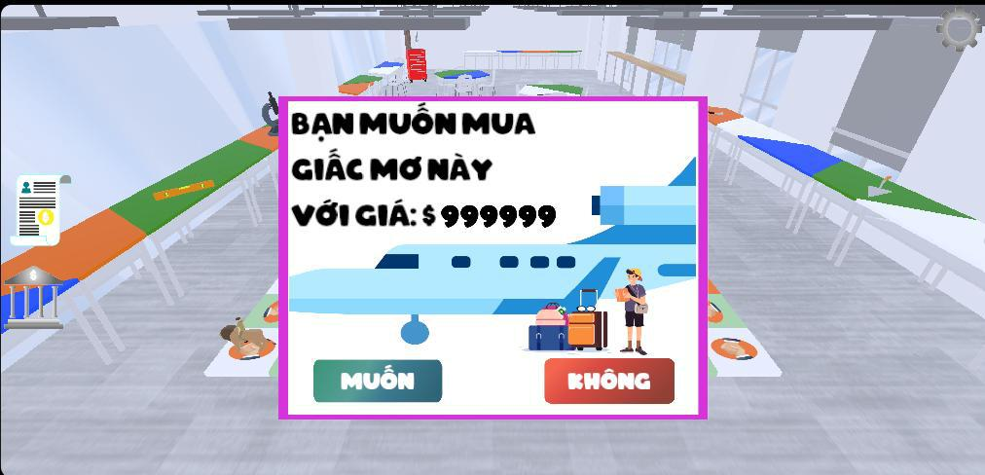

Image 39: Buy your dream to win

139

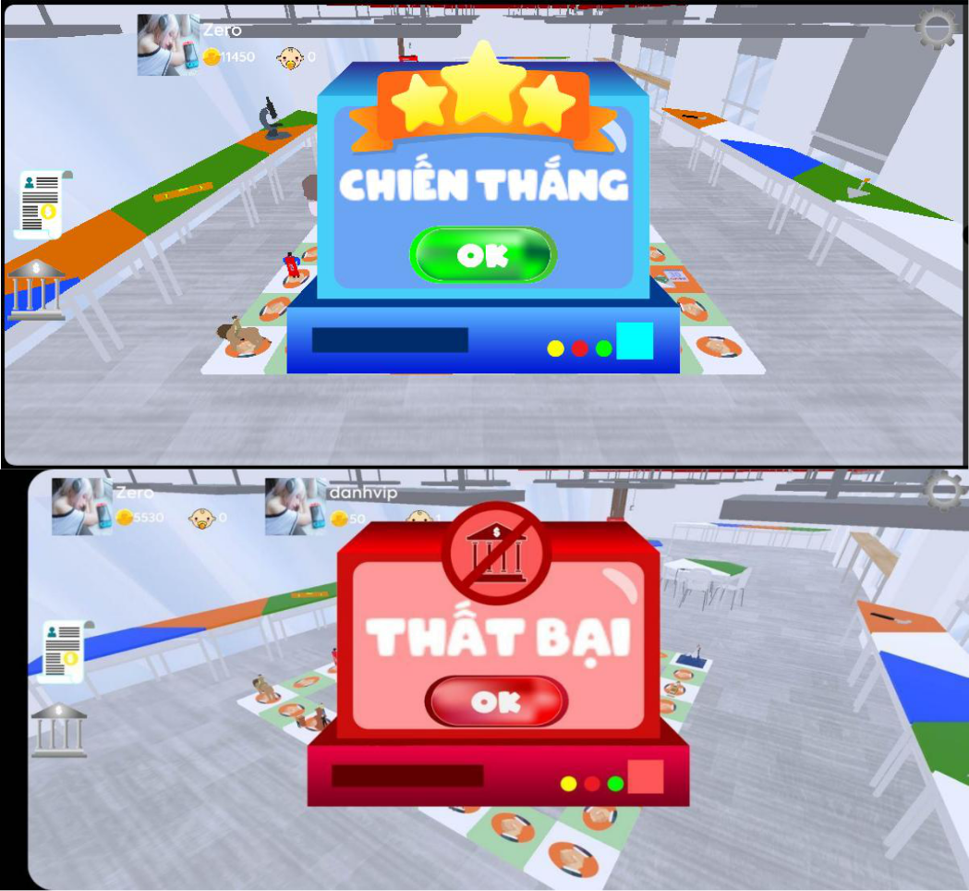

Image 40: Image of players win or lose

**4.3.4 Owning and changing outfits**

**4.3.4.1 Buy outfit**

**Description**: Buy outfit in shop.

**Content**: Use the money earned through playing the game to enter the shop to buy the costumes for sale and own them.

140

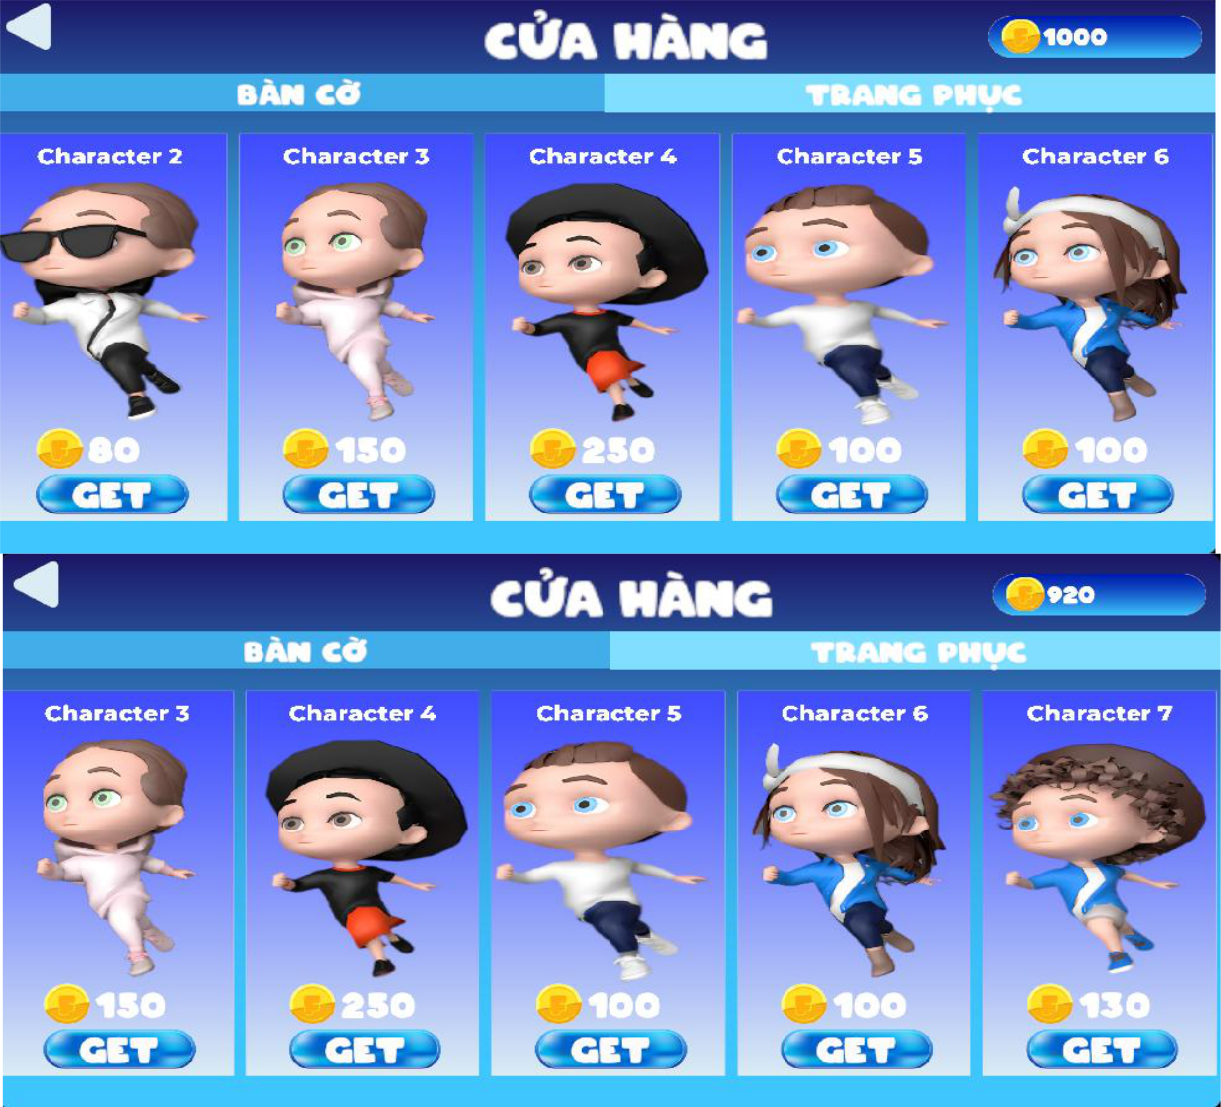

Image 41: Shop before and after buying outfit

**4.3.4.2 View inventory and change outfits**

**Description**: View inventory and change outfits

**Content**: Open the inventory to see the purchased skins, click on the outfit image to change the outfit.

141

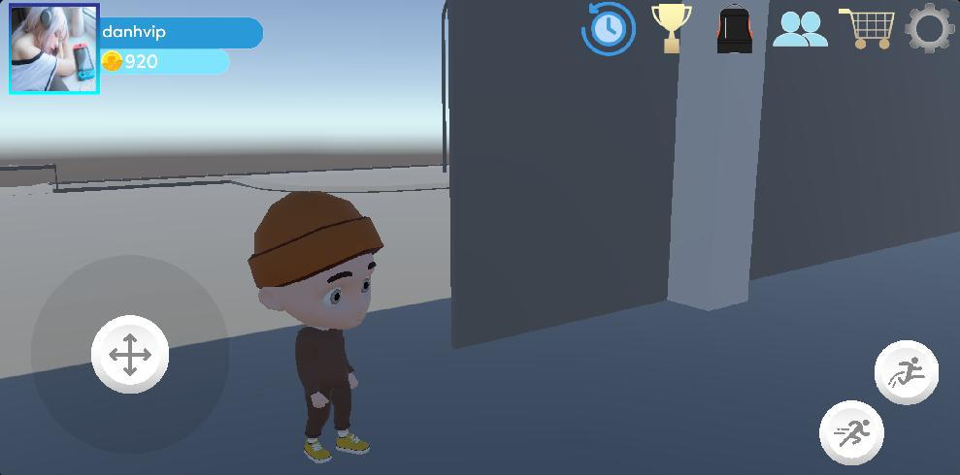

Image 42: Before changing outfit

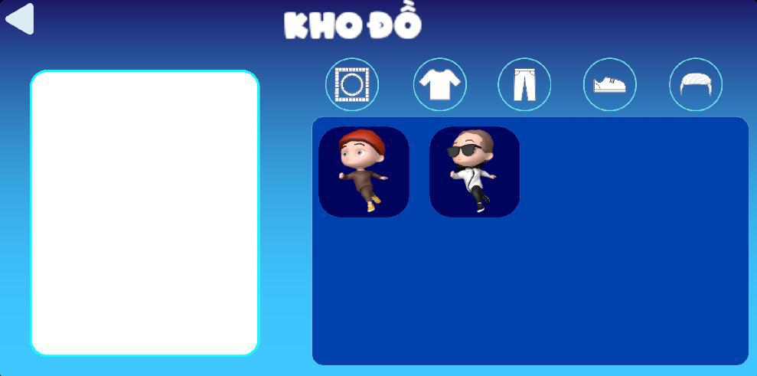

Image 43: Inside the inventory

142

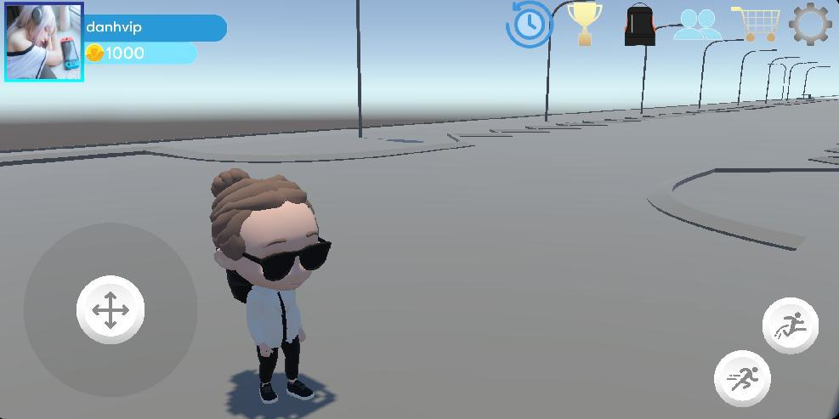

Image 44: After changing outfit

**4.3.5 Change Job**

Description: Change player's job.

Content: Change the player's current job.

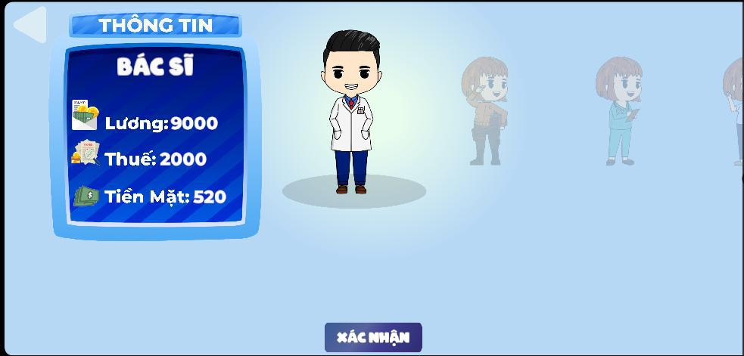

Image 45: Changing job is available in the game

**4.3.6 Build map and chessboards**

**4.3.6.1 Main map**

**Description**: A large area where players can go. Here you can find classrooms containing events and NPCs.

**Content**: Build 3D map according to real parameters based on FPT University.

143

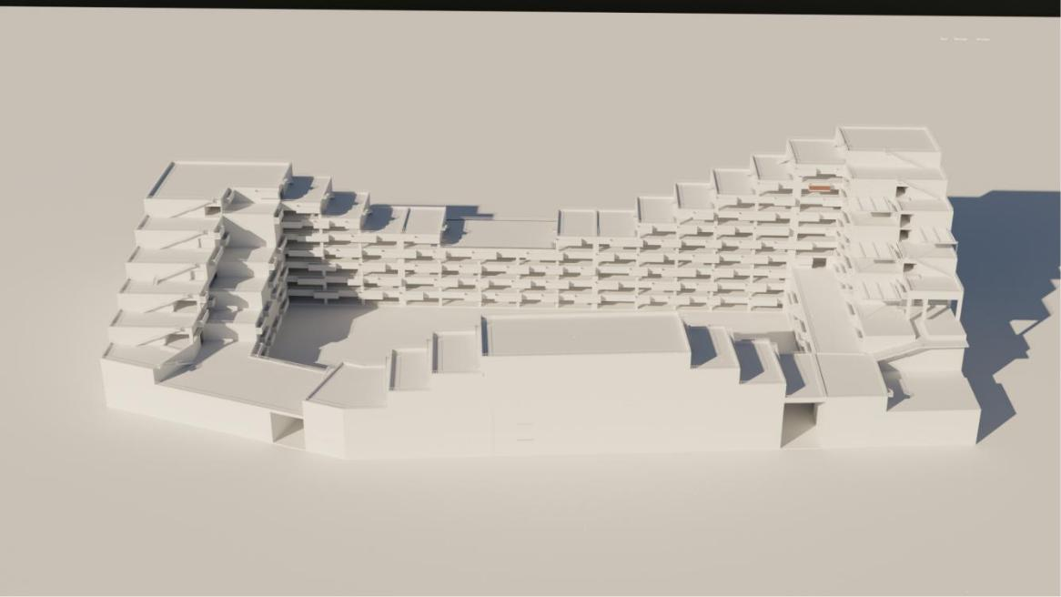

Image 46: Overall map

**4.3.6.2 Chessboard**

**Description**: This is where chess pieces and events appear.

**Content**: Build a chessboard in the classroom selected in the map.

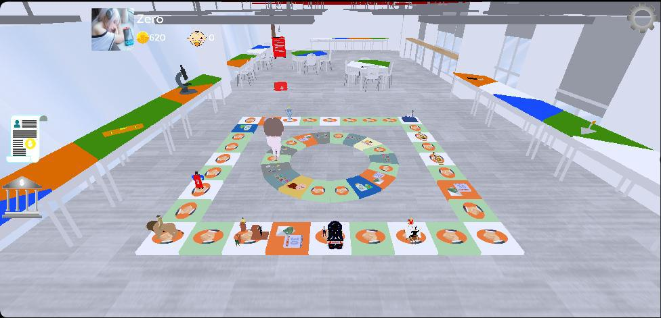

Image 47: Overall chessboard

**4.3.7 Make UI for game**

**Description**:

● Making the login and registration UI

144

* Making setting UI
* Making match history UI
* Making the job selection screen and create a name for the first player created in account
* Some UI in game and match

**Content**: The function buttons are all done.

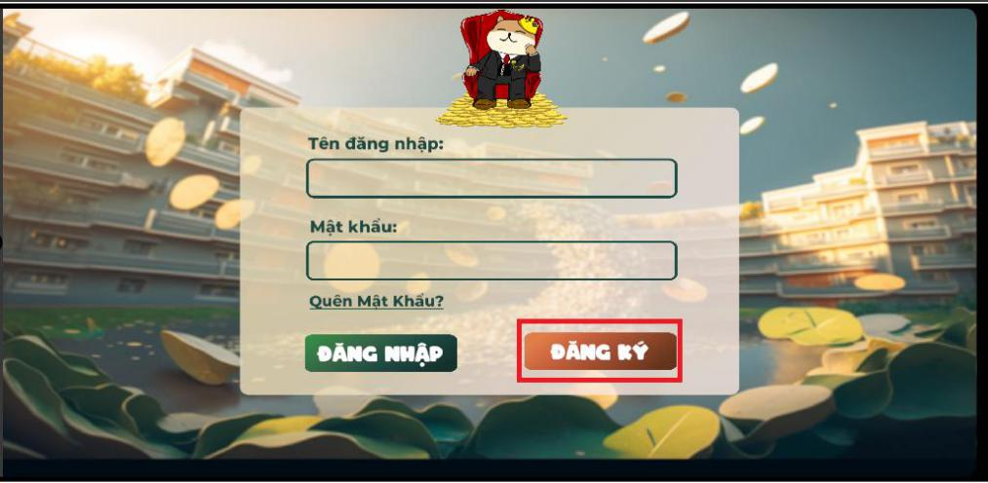

Image 48:Login UI

145

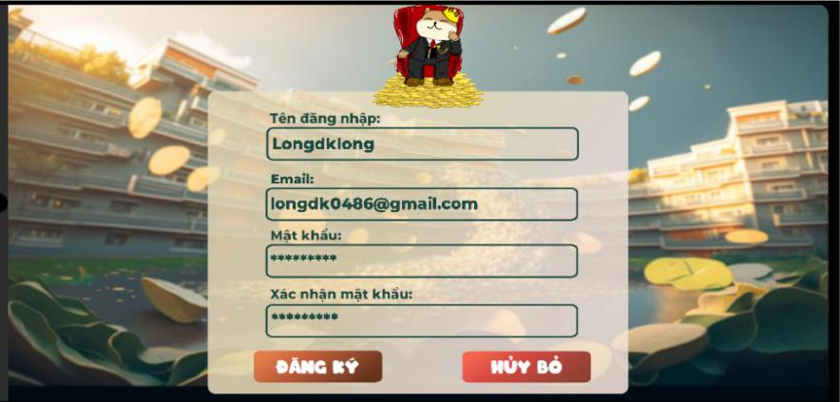

Image 49:Register UI

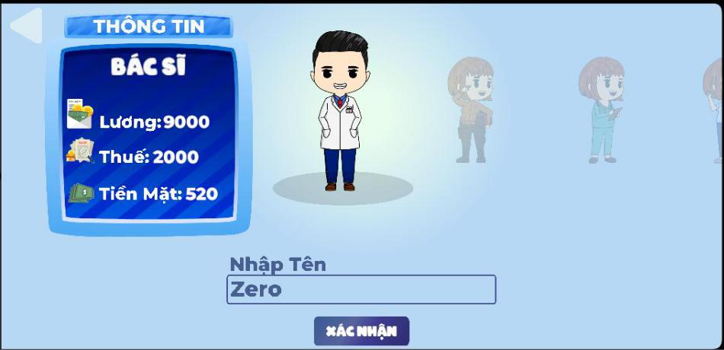

Image 50: Create character UI

146

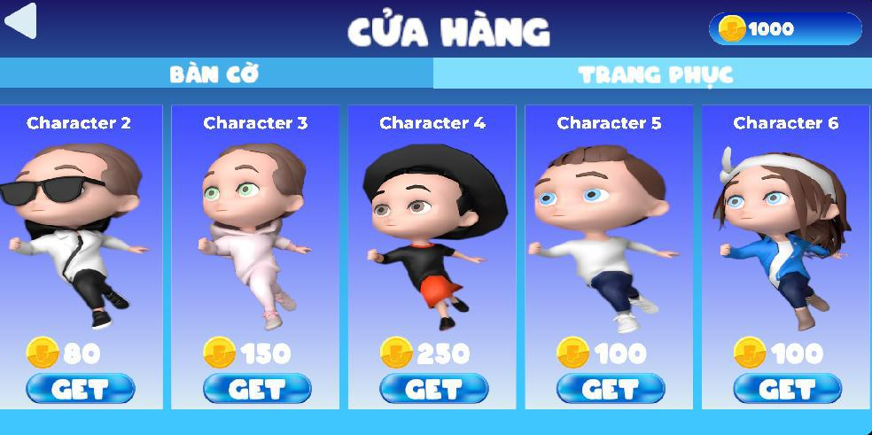

Image 51:Shop UI

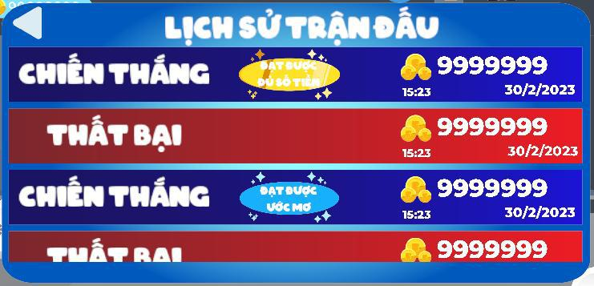

Image 52: Match history UI

**4.3.8 Add sounds**

**Description**: Add background sound to the game.

**Content**: Add sound to the game. Write an AudioManager to manage the background sound and effects, you can adjust the volume up and down in the game options. Music in the game:

* Infinite Doors
* Potato

147

**4.3.8 Game optimization**

**Description**:

* Optimize UI interface to suit more phone devices.
* Optimize 3D models in the game to reduce capacity and optimize performance. **Content**: Adjusted UI to suit many devices.

148

**V. Software Testing Documentation**

**1. Overall Description**

**1.1 Test Scope**

We plan to define test cases in main flow only.

**1.2 Test Model**

We use Incremental testing for some approaches:

* Each module is required a role to use clearly
* Each module could test at the early stage of the develop process

**1.3 Testing Levels**

* + Testing Level: User Acceptance Test
  + Testing Types: Functional Testing, User Interface Testing

1. **Test Plan**

**2.1 Test Stages**

|  |  |  |  |  |  |  |  |  |  |
| --- | --- | --- | --- | --- | --- | --- | --- | --- | --- |
|  | **Type of Test** |  |  |  |  | **Test Level** | |  |  |
|  |  |  |  |  |  |  |  |  |
|  |  | **Unit** |  | **Integration** | | **System** | **Acceptance** | |
|  |  |  |  |
|  |  |  |  |  |  |  |  |  |  |
|  | Function Testing |  |  |  |  |  |  | X | |
|  |  |  |  |  |  |  |  |  |  |
|  | User Interface Testing |  |  |  |  |  |  | X | |
|  |  |  |  |  | |  |  |  |  |
|  |  |  | Table 51 - Test Stages | | | |  |  |  |
| **2.2 Resources** | |  |  |  |  |  |  |  |  |
|  | **Worker** |  | **Role** | |  | **Specific Responsibilities** | | |  |
|  |  |  |  | |  |  | | |  |
|  | Thái Đức Lợi |  | Leader | |  | Planning, execute, verify test result | | |  |
|  |  |  |  | |  |  | | |  |
|  | Trịnh Gia Huy |  | Member | |  | Planning, execute, verify test result | | |  |
|  |  |  |  |  |  |  |  |  |  |

149

|  |  |  |  |  |  |  |  |  |  |  |  |
| --- | --- | --- | --- | --- | --- | --- | --- | --- | --- | --- | --- |
|  | Nguyễn Phùng Công | | | Member |  | Planning, execute, verify test result | | | | | |
|  | Danh | |  |  |
|  |  |  |  |  |  |  |  |  |  |
|  |  |  |  |  |  |  |  |  |  |  |  |
|  | Dương Kim Long | |  | Member |  | Planning, execute, verify test result | | | | | |
|  |  |  |  |  |  |  |  |  |  |  |  |
|  |  |  |  | Table 52 - Resources | | | | | | | |
| **2.3 Test Milestones** | | | |  |  |  |  |  |  |  |  |
|  | **No.** |  | **Deliverables** | |  |  |  |  | **Due Date** | | |
|  |  |  |  | |  |  |  |  |  |  |  |
|  | 1 |  | Test Document | |  |  |  | 30/04/2023 | |  |  |
|  |  |  |  |  | |  |  |  |  |  |  |
|  |  |  |  | Table 53 - Test Milestones | | | | | | | |
| **3. Test Cases and Test Reports** | | | | |  |  |  |  |  |  |  |
|  |  | **Testing Level** | |  |  |  |  | **File Name** | | | |
|  |  |  |  |  |  |  |  | |  |  |  |
|  | User Acceptance Test | | |  |  |  | [TestDocuments\2023.Spring-_-](http://testdocuments/2023.Spring-_-iTranslator-_-Capstone-Project-_-Test-Report.xlsx) | | | | |
|  |  |  |  |  | |  |  |  |
|  |  |  |  | iTranslator-_-Capstone-Project-_- | | | | |
|  |  |  |  |  |  |  | Test-Report.xlsx | | | |  |
|  |  |  |  |  |  |  |  |  |  |  |  |



[TestCase](https://docs.google.com/spreadsheets/d/1cn6_WUmxJJsc1nhPnTjmOvBNNYT_tp7r3lcXnFsCWyw/edit?usp=share_link)

Table 56 - Test Cases and Test Reports

150

**VI. Release Package & User Guides**

**1. Deliverable Package**

**1.1 Source codes & documents**

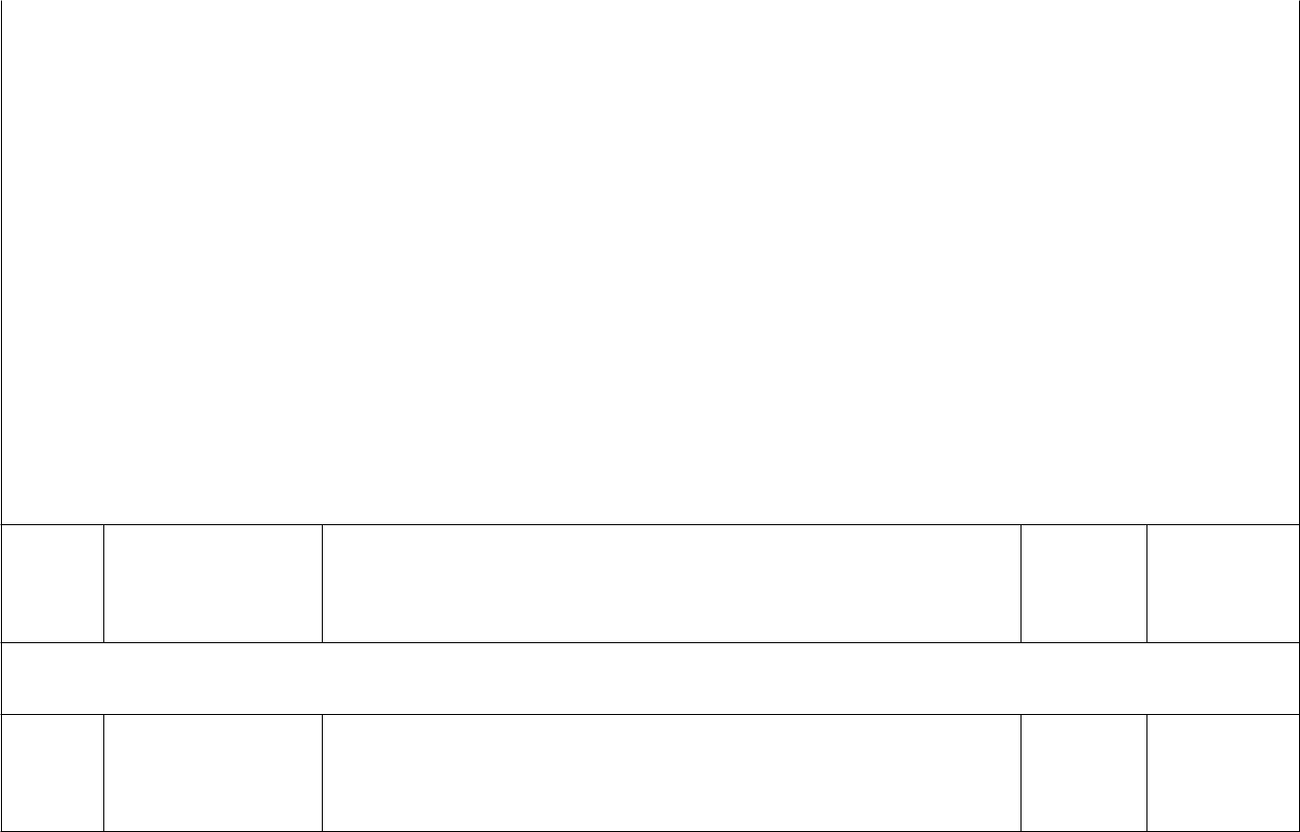

|  |  |  |  |  |  |  |
| --- | --- | --- | --- | --- | --- | --- |
|  | **No.** | **Items** | **Sub-Items** | **Type** | **Version** |  |
|  |  |  |  |  |  |  |
|  | **Code Package** | |  |  |  |  |

|  |  |  |  |  |
| --- | --- | --- | --- | --- |
| 1 | Web | iMobileBasedCashFlowWebUI.zip | New | 1.0.0 |
|  | Module |  |  |  |
|  |  |  |  |  |
| 2 | Web API | MobileBasedCashFlowAPI.zip | New | 1.0.0 |
|  | Module |  |  |  |
|  |  |  |  |  |
| 3 | Game | Cash_Flow.zip | New | 1.0.0 |
|  |  |  |  |  |

**Database**

1

Initialise Database

MobileBasedCashFlowGame.sql

New

**Documents**

1

Final Project MobileBasedCashFlow-FinalReport_Full.docx Report

Table 54 - Source codes & documents

**1.2 Known Issues, Limitations & Restrictions**

* Installers for each projects haven’t been packaged
* Database must be initialized by using database scripts

151

**2. Installation Guides**

**2.1 System Requirements**

***2.1.1 Web application***

|  |  |  |  |
| --- | --- | --- | --- |
| **PC** |  | **Minimum** | **Recommend** |
|  |  |  |  |
| Internet connection |  | LAN, internet access | LAN, Wi-fi (16 Mbps) |
|  |  | capability |  |
|  |  |  |  |
| Processor |  | Intel Core i5 1.5Ghz | Intel Core i7 2.6Ghz |
|  |  |  |  |
| Memory |  | 4GB RAM | 8GB RAM up |
|  |  |  |  |
| Storage |  | 4GB | 6GB up |
|  |  |  |  |
| Web Browser |  | Chrome (v69) | Chrome latest stable |
|  |  |  | version |
|  |  |  |  |
|  | Table 55 - <System Requirements> Web application | | |
| ***2.1.2 Game application*** |  |  |  |
|  |  |  |  |
| **Mobile** |  | **Minimum** | **Recommend** |
|  |  |  |  |
| Internet connection |  | Wi-fi | LAN, Wi-fi (16 Mbps) |
|  |  |  |  |
| Processor |  | Kirin 659 | Snapdragon 712 |
|  |  |
|  |  |  |  |
| Memory |  | 4GB RAM | 8GB RAM up |
|  |  |  |  |
| Storage |  | 4GB | 6GB up |
|  |  |  |  |
|  | Table 56 - <System Requirements> Software requirement | | |

**2.2 Setup Files**

MobileBasedCashFlowGame.sql: Database script for system

MobileBasedCashFlowAPI.zip: API for services MobileBasedCashFlowWebUI.zip

152

**2.3 Installation Instruction**

***2.3.1 Setup Database***

Install Sql Server 2019 by following guidelines link: [https://www.thegioididong.com/game-app/huong-dan-cai-dat-sql-server-2019-cuc-](https://www.thegioididong.com/game-app/huong-dan-cai-dat-sql-server-2019-cuc-don-gian-chi-1312926)don-gian-chi-1312926

***2.3.2***+***Setup Backend API***

Install Visual Studio by following guidelines link:

* https://thuthuatphanmem.vn/huong-dan-tai-va-cai-dat-visual-studio/ Extracting: MobileBasedCashFlowAPI.zip

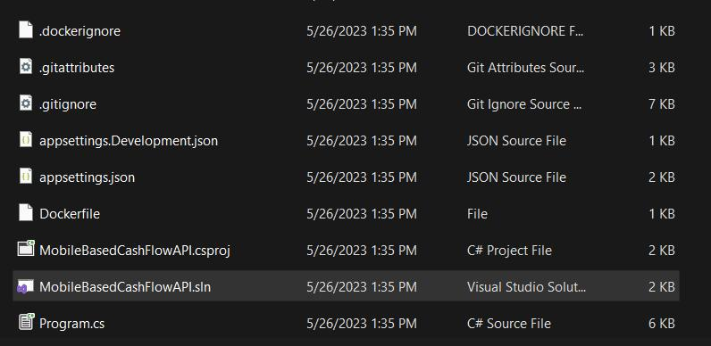

Figure 48- Setup Backend API

+

+ Open MobileBasedCashFlowAPI.sln file with Visual Studio Config your database connection

153

* Run project

Figure 49 - Setup Backend API

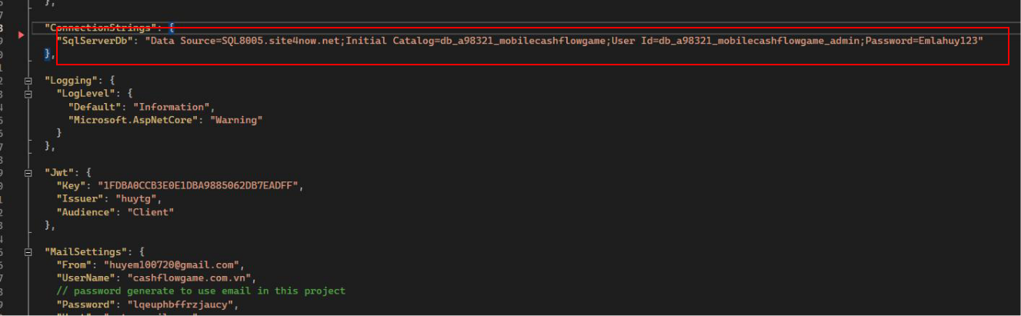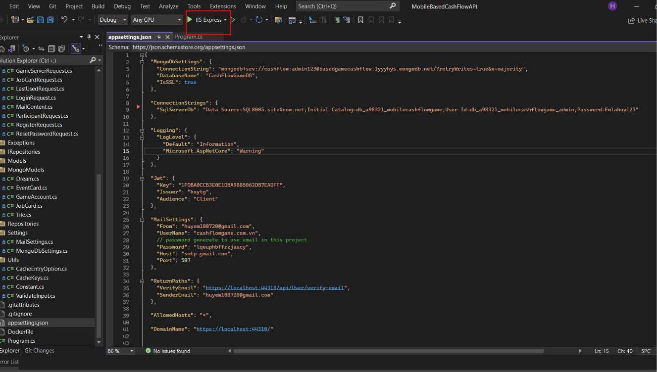

|  |  |  |  |
| --- | --- | --- | --- |
| + | Figure 50 - Setup Backend API | | |
|  |  |  |
| + | Test project in browser by go to url: |  |  |
| <https://localhost:44310/index.html> |
| Username: admin pass 12345678 | | |

154

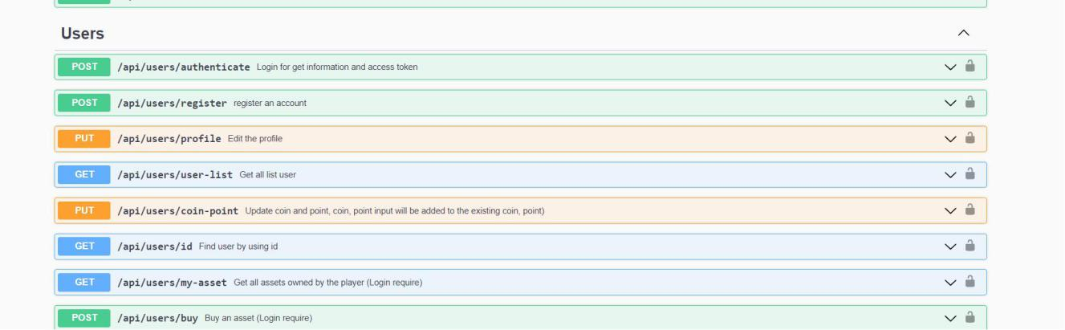

Figure 51 - Setup Backend API

***2.3.3***+***Setup Management Web***

Install Visual Studio Code by following guidelines link:

* <https://thaynhuom.edu.vn/cai-visual-studio-code-lap-trinh-c-c/>

Install npm through Visual Studio Code or you can install npm via NodeJS

* <https://nodejs.org/en/>

Extract MobileBasedCashFlowWebUI.zip and open folder with Visual Studio

* Code

Open terminal and enter npm I:



|  |  |
| --- | --- |
| + | Figure 52- Setup Management Web |
| Change baseUrl based on your backend configuration |

155

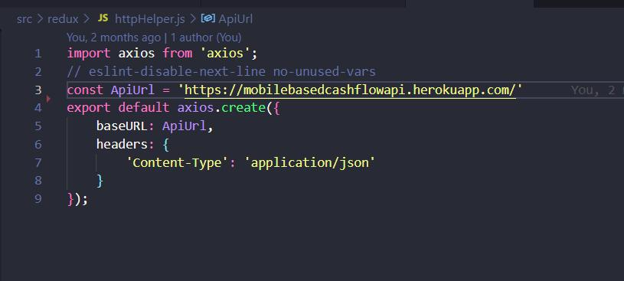

|  |  |
| --- | --- |
| + | Figure 53 - Setup Management Web |
| In terminal, enter npm start |



Figure 54 - Setup Management Web

* Project start with <http://localhost:3000/>

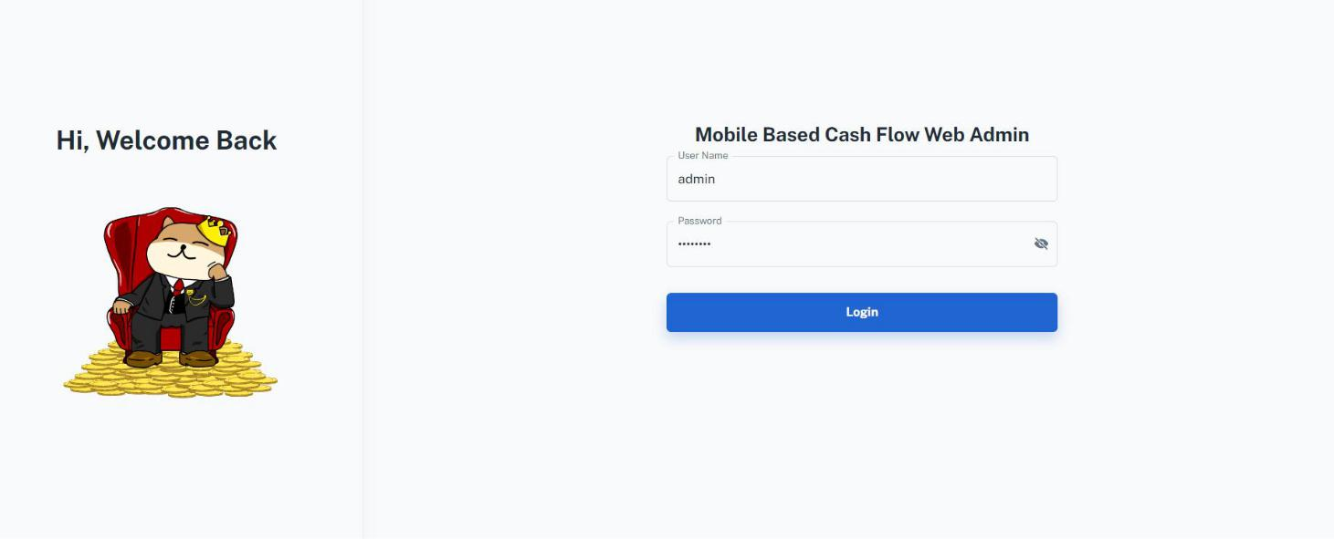

156

**3 User Manual**

**3.1 Overview**

* Admin manage dream, game account, asset , event card and user
* Player can play game, create room, join room, change outfit, view history, shopping, change job,.

**3.2 Application Usage**

***3.2.1 Guest register account***

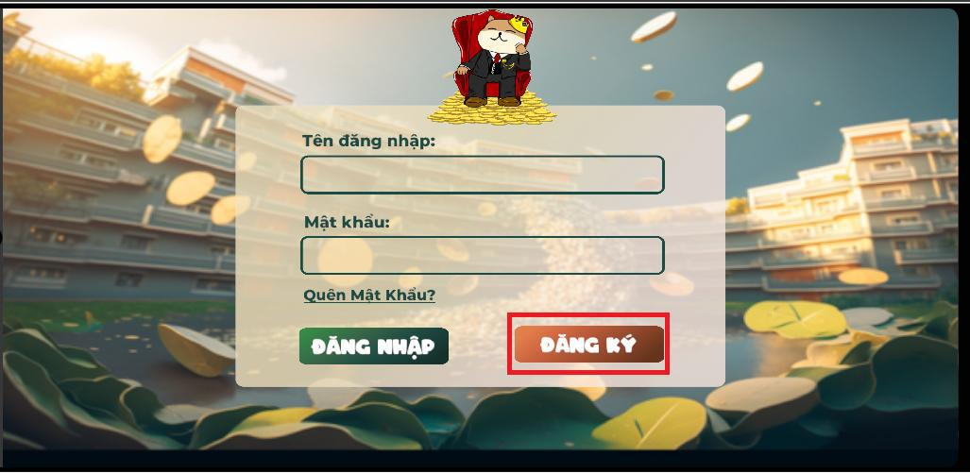

157

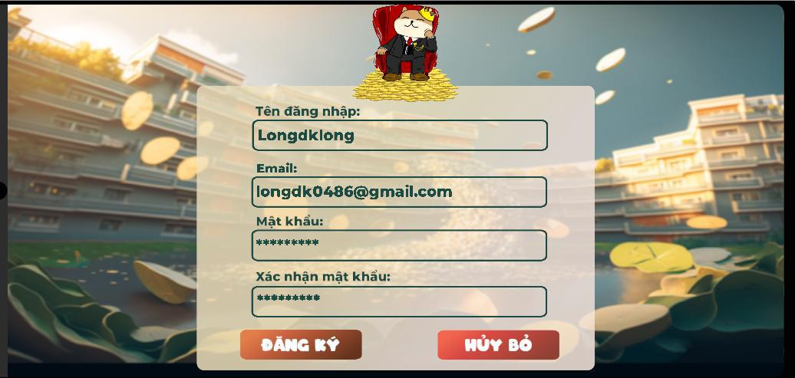

1. Click “đăng ký” button in login scene
2. Enter username: Longdklong
3. Enter email: [longdk0486@gmail.com](mailto:longdk0486@gmail.com)
4. Enter password: 123465789
5. Enter confirm password: 123465789
6. Click “đăng ký” button

158

***3.2.2 Player login into game***

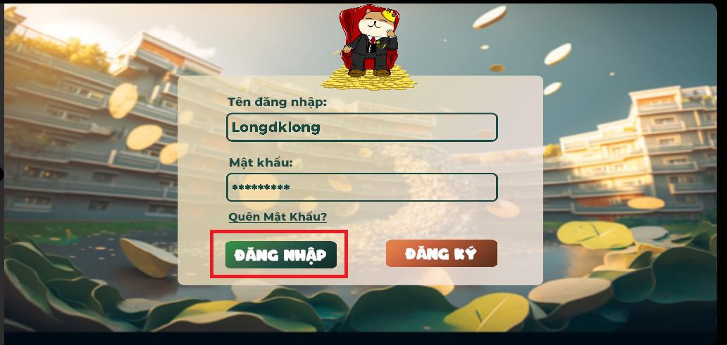

1. Enter username: LongdkLong
2. Enter password: 123456789
3. Click “đăng nhập” button

***3.2.3 Create name and choose job***

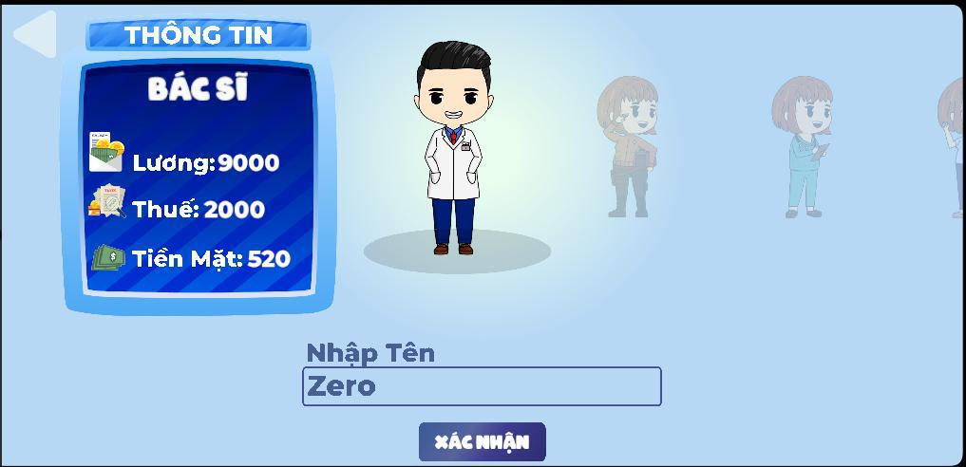

1. Swipe to choose job
2. Enter name: “Zero”
3. Click “Xác nhận ” button

159

***3.2.3 Talk npc to switch scene lobby***

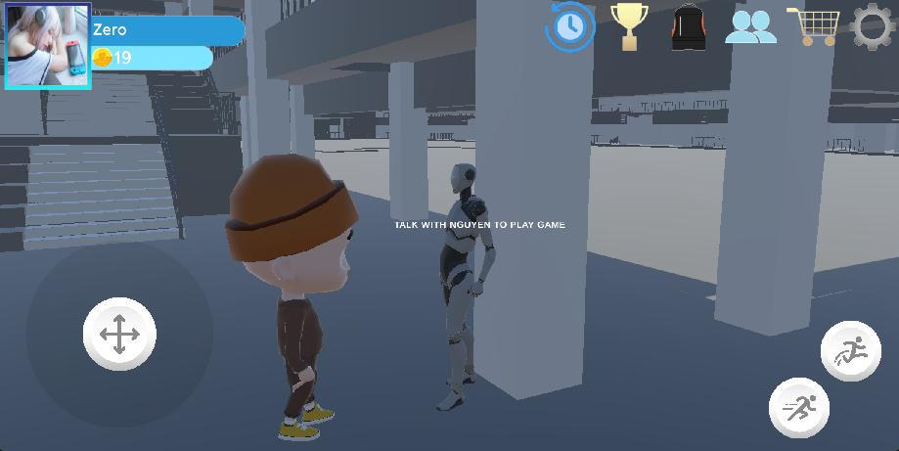

1. Use joystick to control character move near npc
2. Click white text to switch scene lobby

***3.2.4 Player View list room and join or create room***



160



1. Click “Tham gia” button to join room
2. Click “ Sẵn Sàng “ to start the match

***3.2.5 Play game***

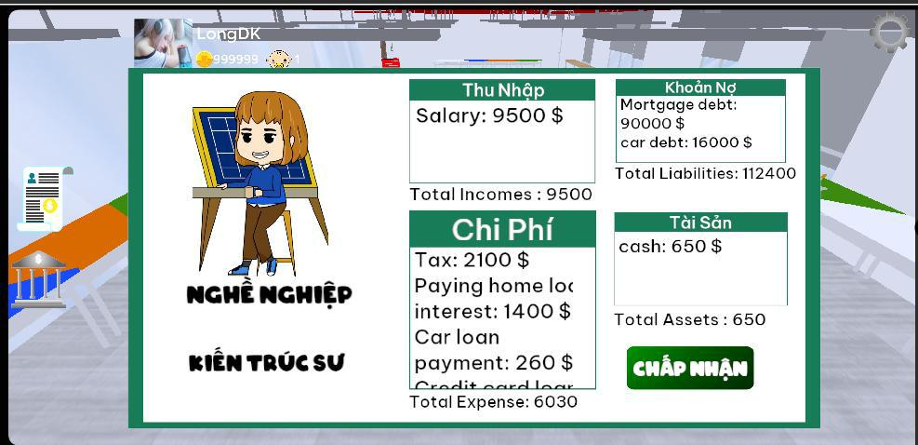

1. View detail info job
2. Click “Chấp nhận” button to accept

161

***3.2.6 Roll Dice***



1. Click “Đổ Xúc Xắc” button to roll Dice

***3.2.7 Do Ratrace event***



162

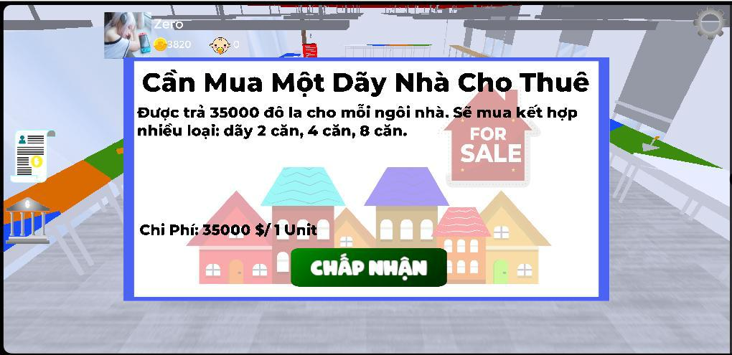

1. Click “Chấp Nhận” button to accept envent card



2. Only big deal/small deal card player can click “Từ chối” button to cancel event

163

***3.2.8 View financial report***

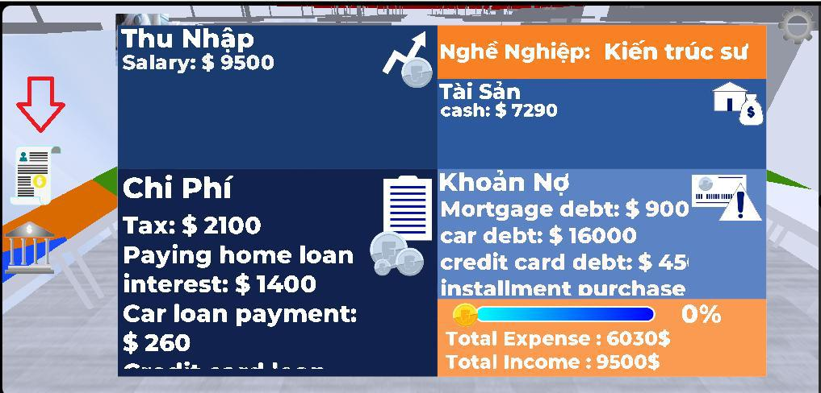

1. Click button have report icon



2. If it slider have 100% player can move out to fasttrack

164

***3.2.9 Move out Fasttrack***



***3.2.10 Do event in Fasttrack***

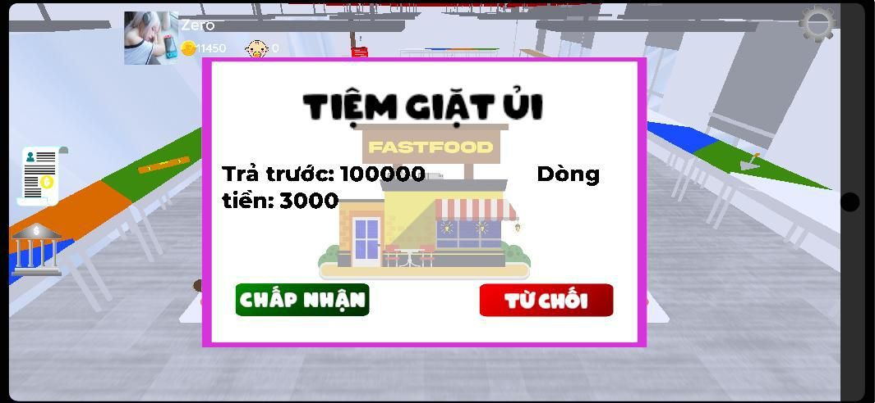

165

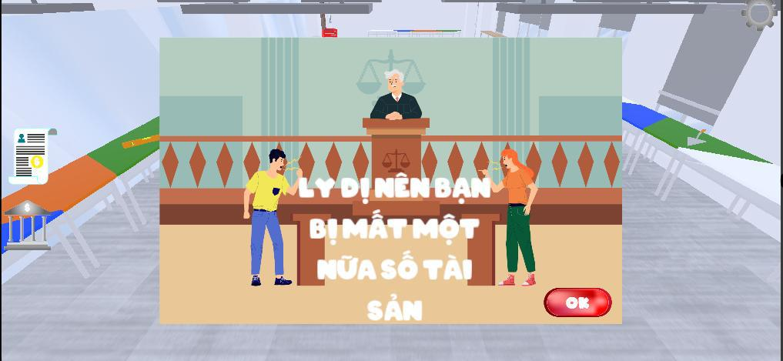

1. Click “Chấp nhận” or “Ok” button to do event card in Fasttrack

***3.2.11 View financial report in Fasttrack***

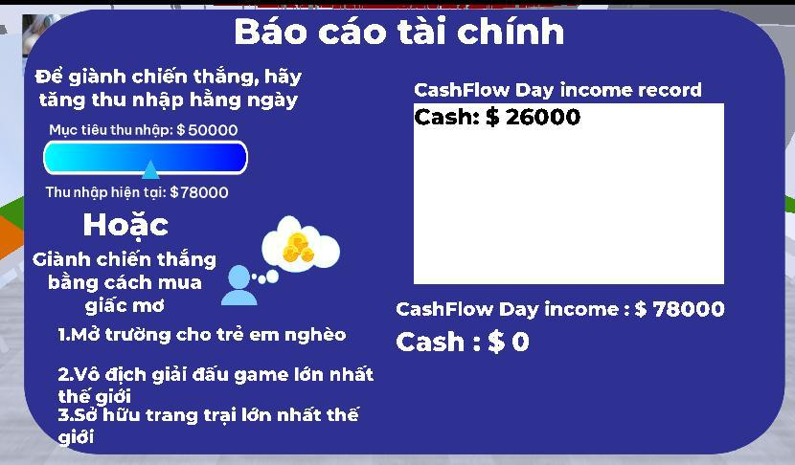

1. Click button have report icon

166

***3.2.12 Finish game***

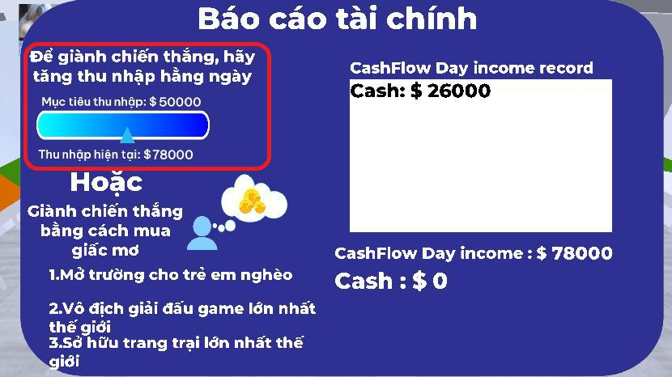

1. If it current income equal income target player can win game

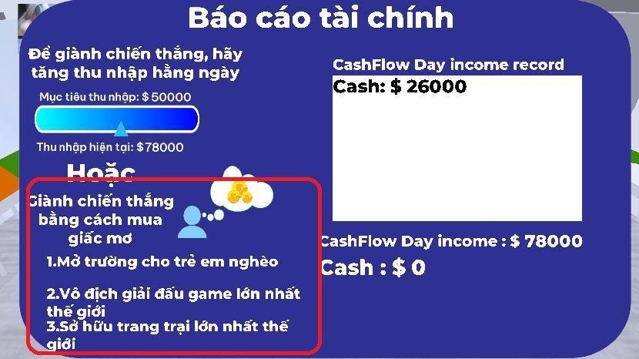

167

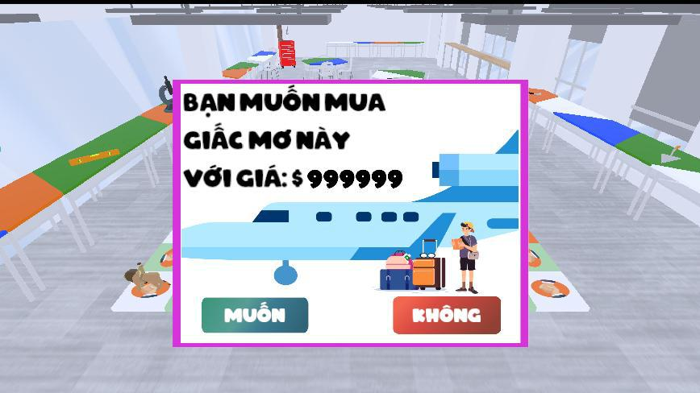

1. Or player can win game by buy dream
2. Click “Muốn” button to buy dream

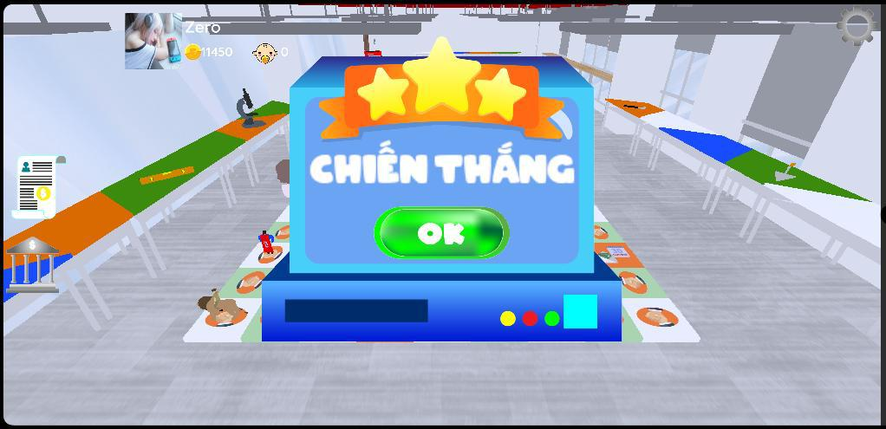

168

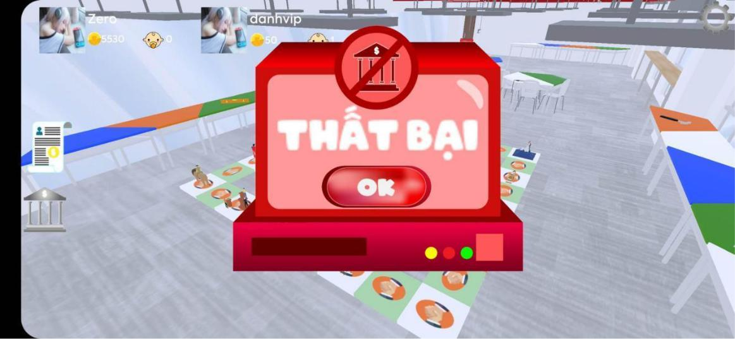

4. Click “Ok” button to finish match

***3.2.13 View match history***

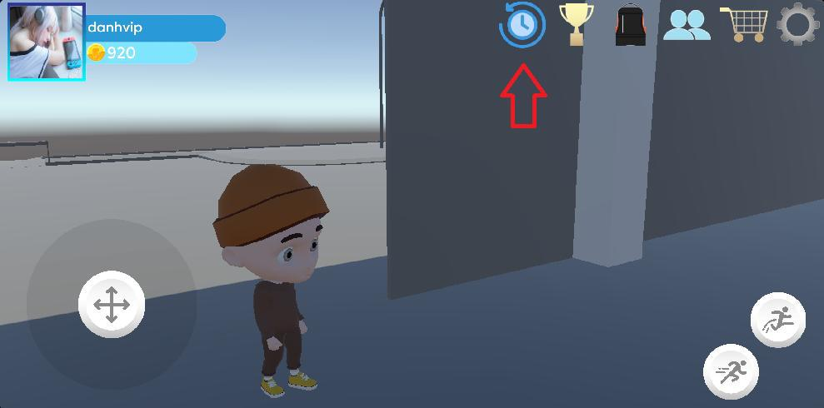

1. Click button have icon History

169

***3.2.14 Buy item***

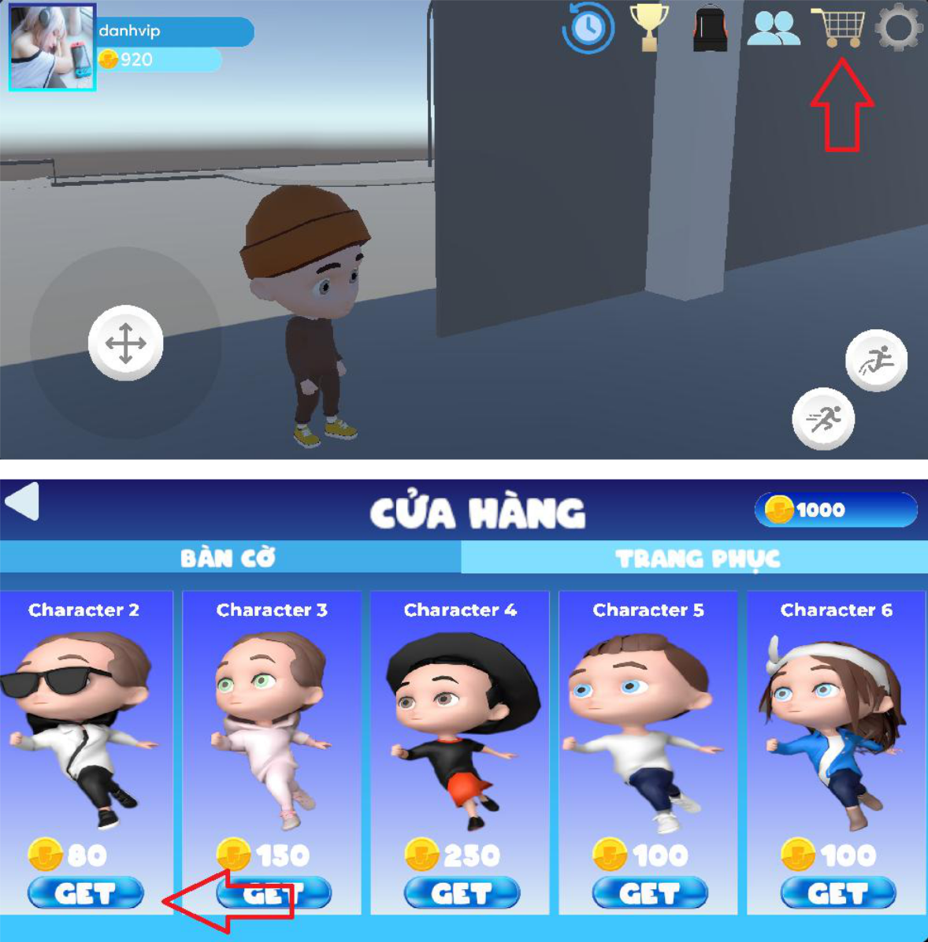

170

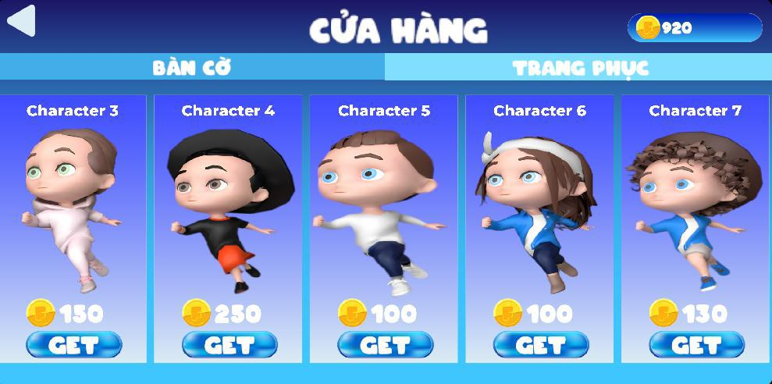

1. Click button have icon shop
2. Click button “Get” to buy item
3. Item has been purchased will be disappear in shop

***3.2.15 Change outfit***

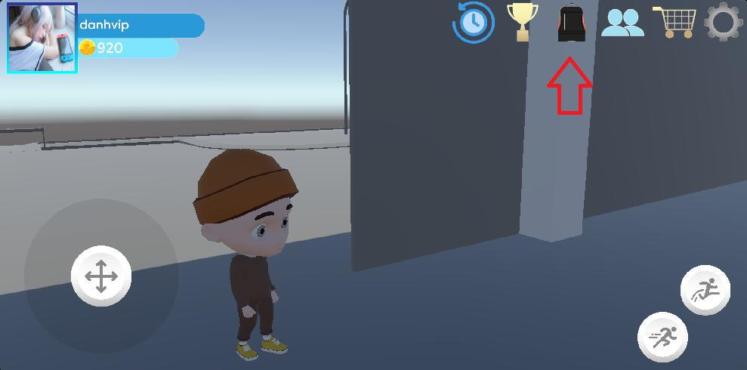

171

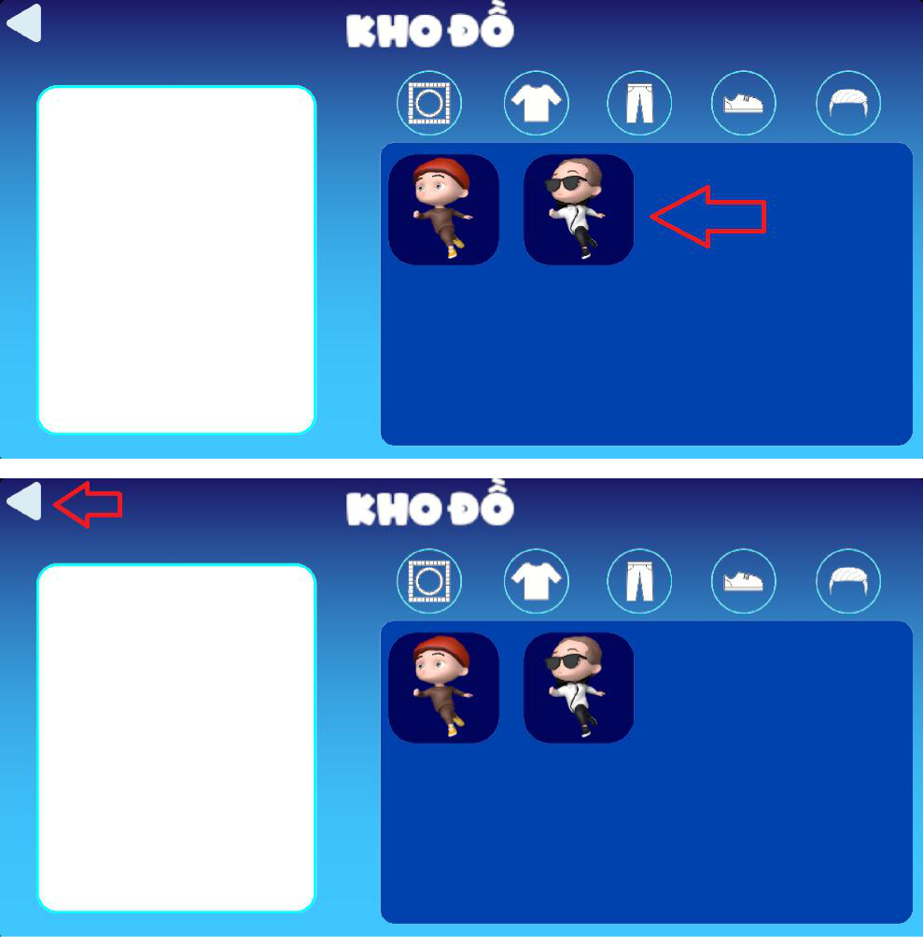

172

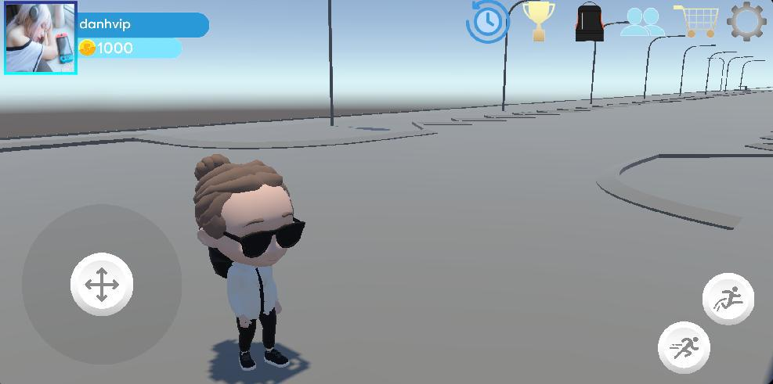

1. Click button have icon Inventory
2. Click button have outfit picture
3. Click back button to see outfit change

***3.2.16 Admin login***

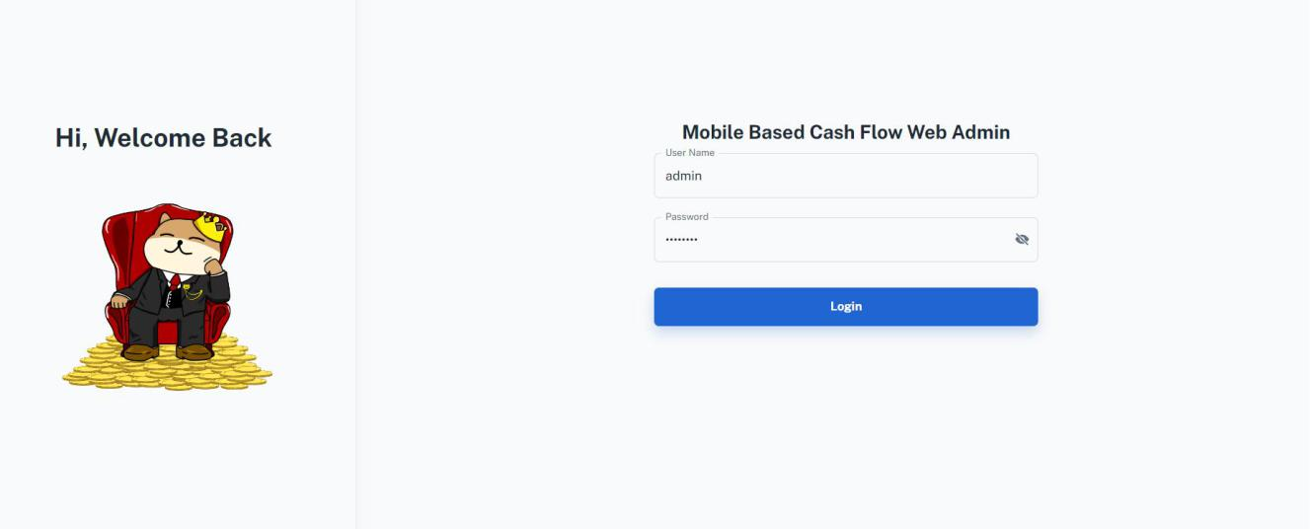

1. Enter UserName: Admin
2. Enter Password:12345678
3. Click Login button

173

***3.2.17 Admin Create Event Card***

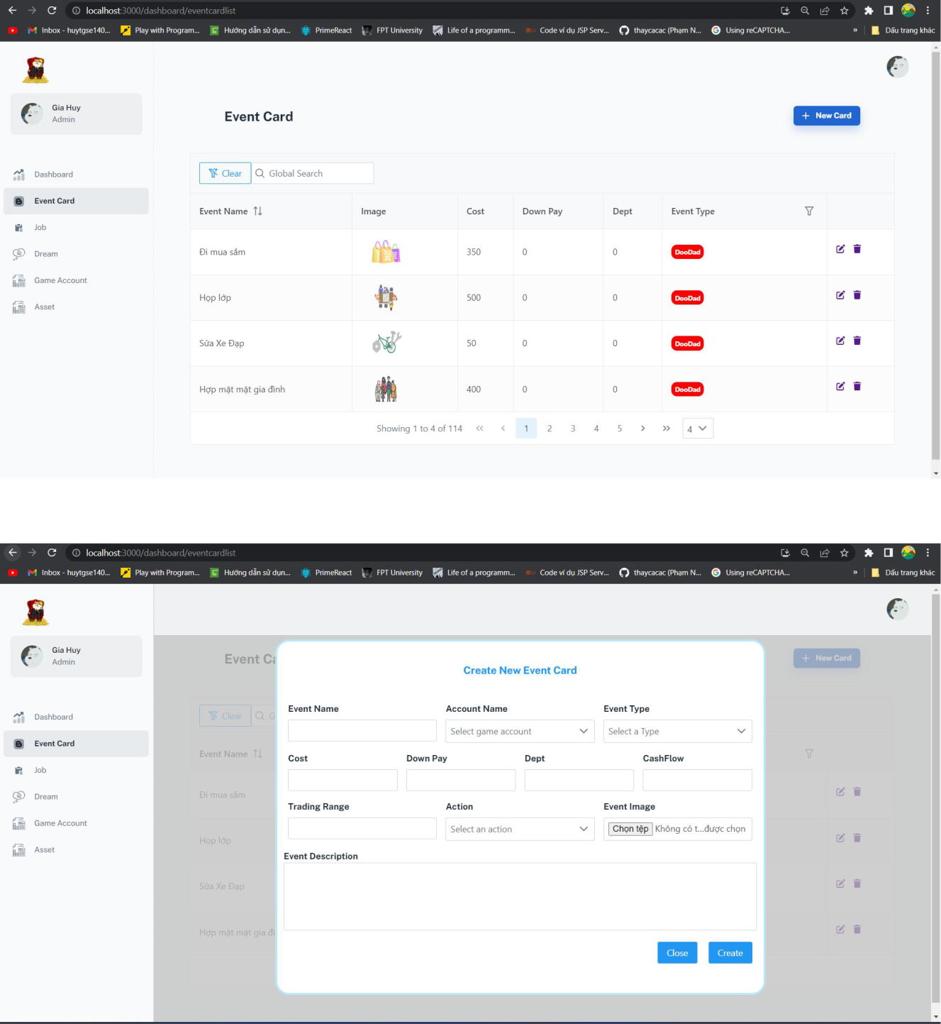

1. Click Event Card button in navbar
2. Click “New Card” button

174

1. Fill all information
2. Click “Create” button

***3.2.18 Admin update event card***

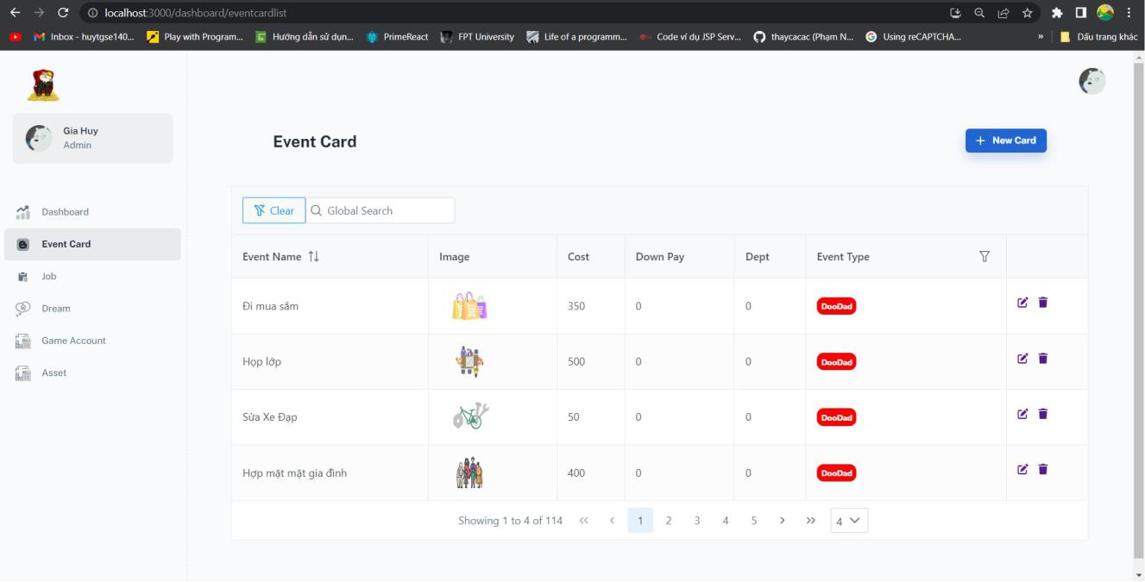

175

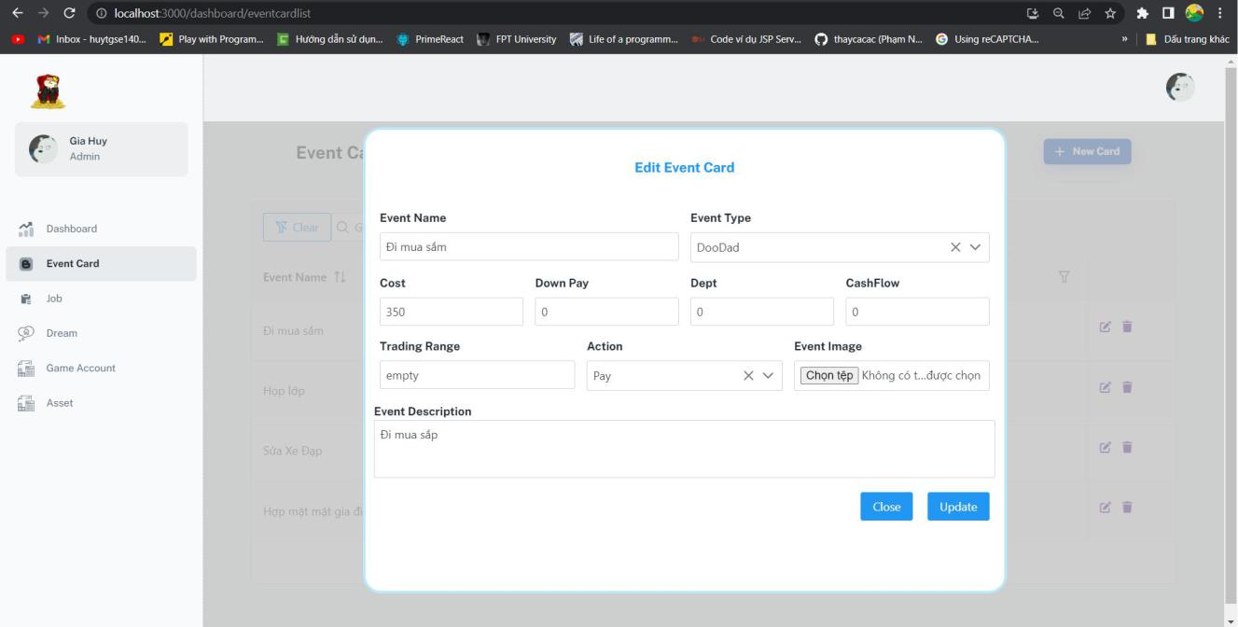

1. Click “edit” icon button on the row want to update
2. Fill all information
3. Click “Update”

176

***3.2.19 Admin delete event card***

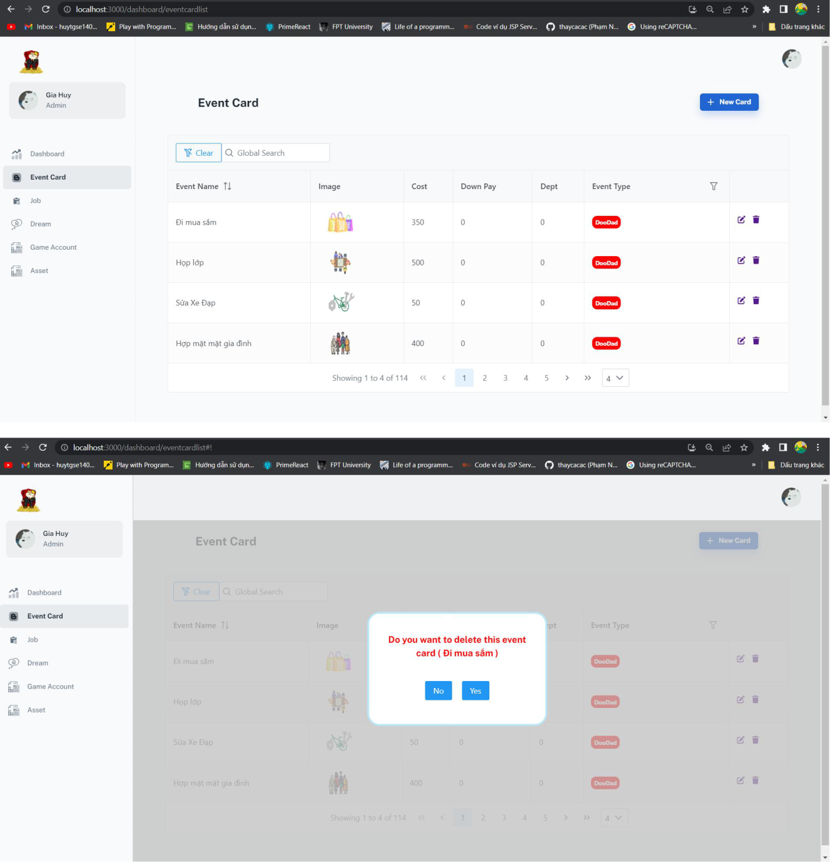

1. Click “bin” icon button on the row want to delete
2. Click “Yes” button to delete or “No” to cancel

177

***3.2.20 Admin update job***

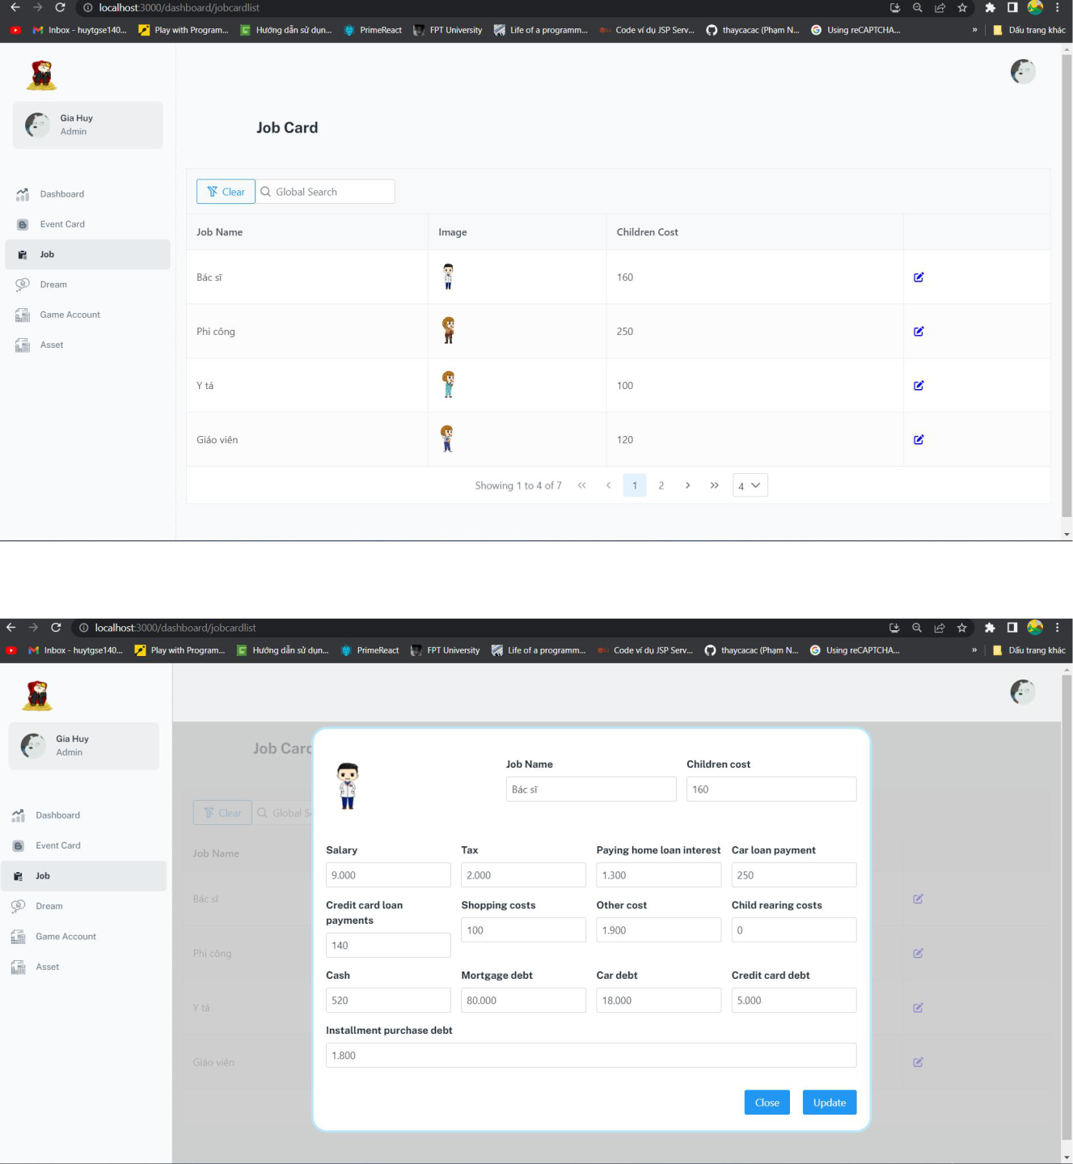

1. Click Job button in navbar
2. Click “edit” icon button on the row want to update

178

1. Fill all information
2. Click “Update” button

***3.2.21 Admin update dream***

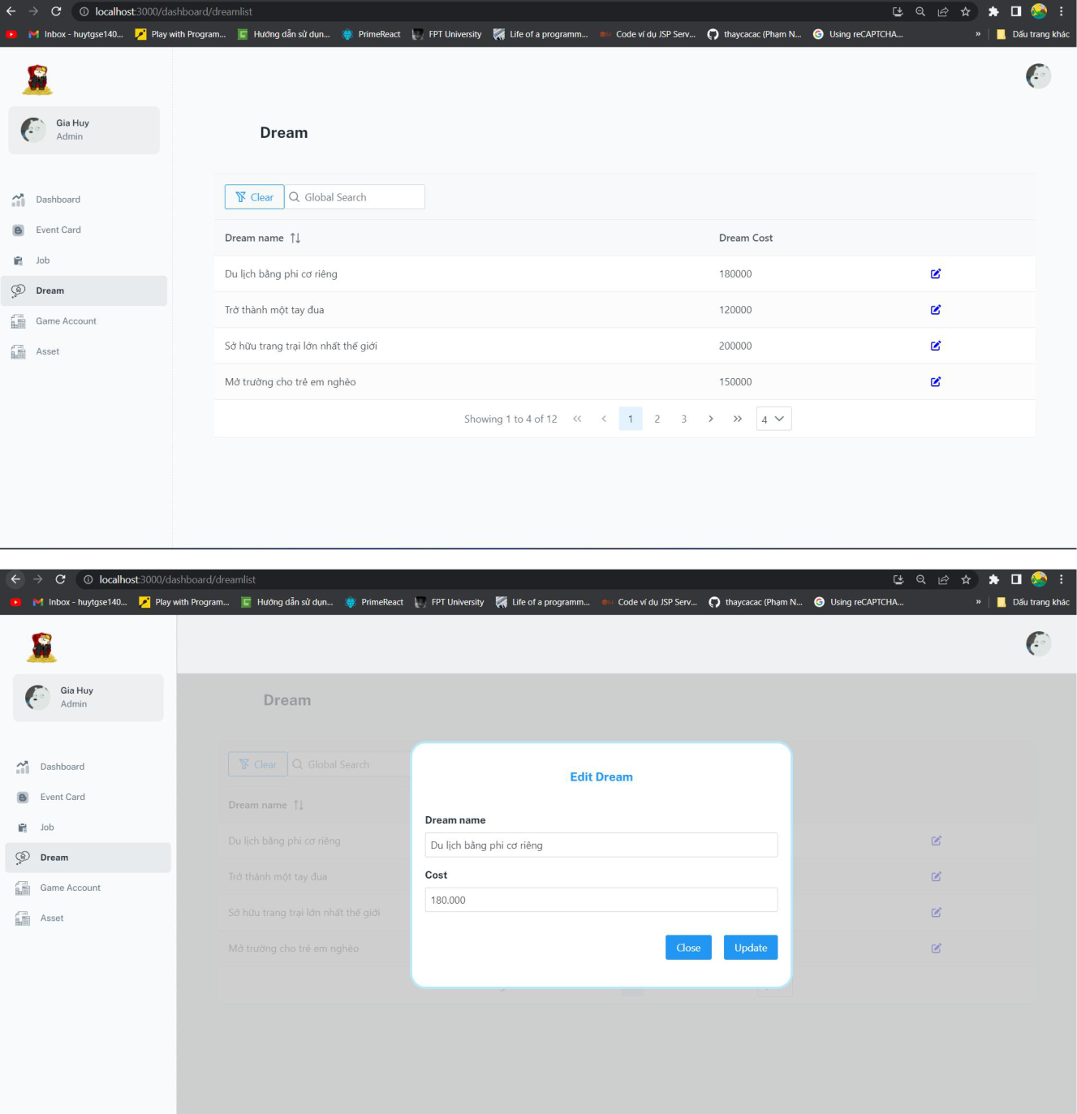

179

1. Click Dream button in navbar
2. Click “edit” icon button on the row want to update
3. Fill all information
4. Click “Update” button

***3.2.22 Admin create game account***

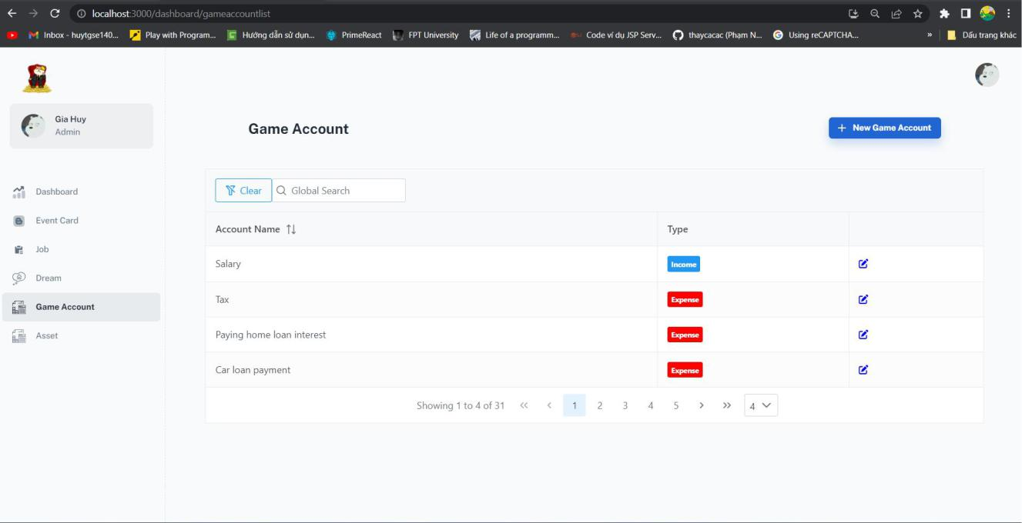

180

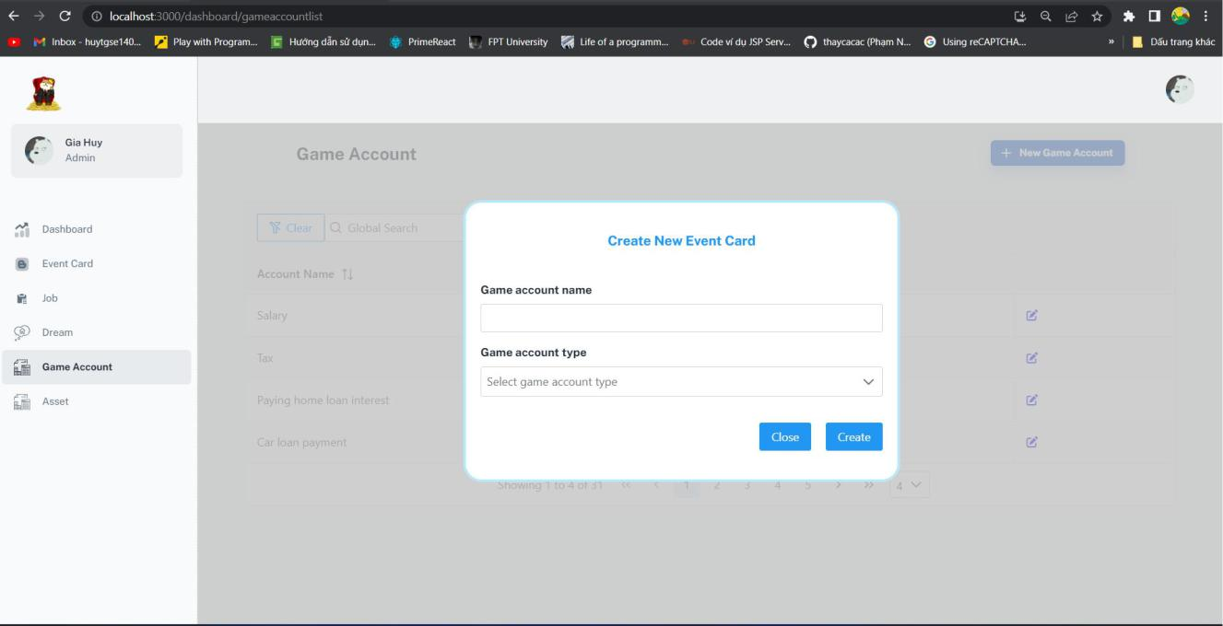

1. Click Game account button in navbar
2. Click “New Game Account” button
3. FIll all information
4. Click “Create” button

181

***3.2.23 Admin update game account***

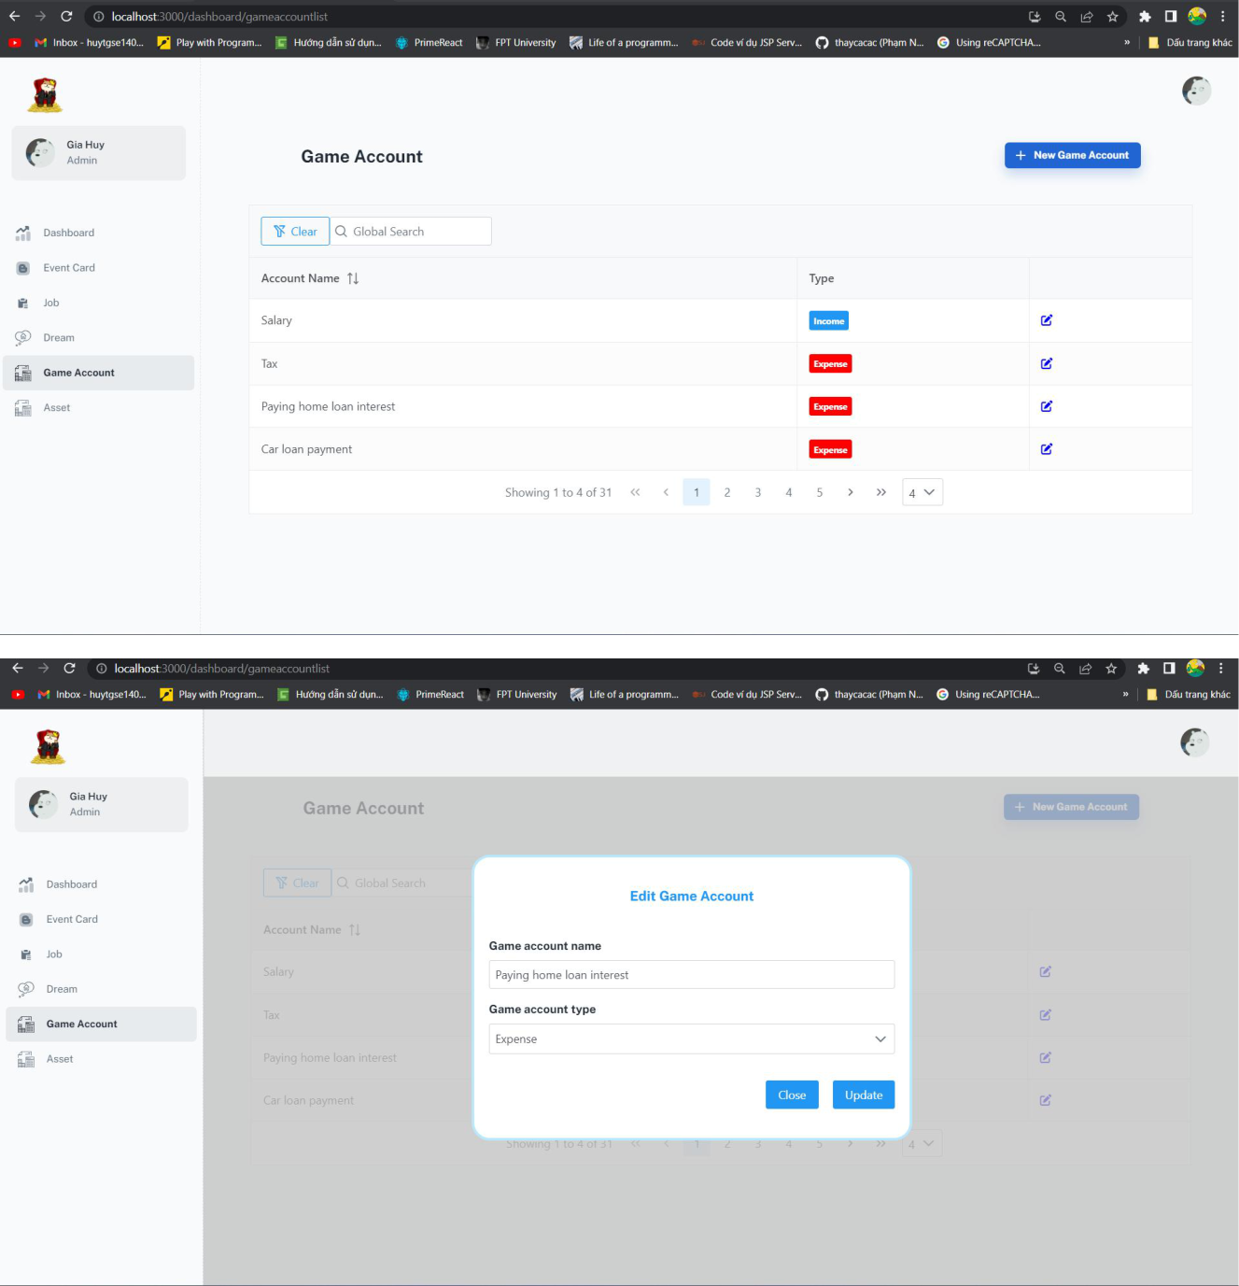

1. Click “edit” icon button on the row want to update
2. FIll all information
3. Click “Update” button

182

***3.2.24 Admin delete game account***

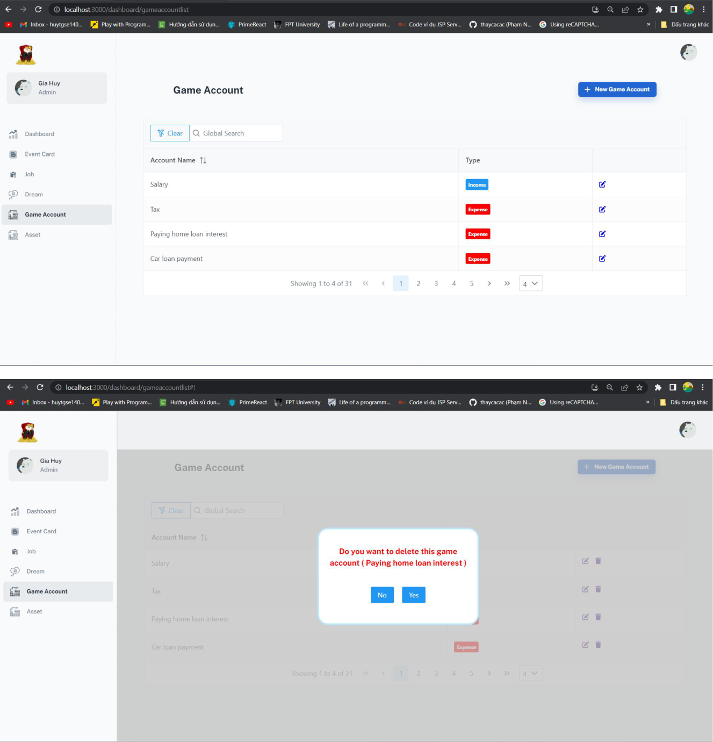

1. Click “bin” icon button on the row want to delete

183

2. Click “Yes” button to delete or “No” to cancel

***3.2.25 Admin Update asset***

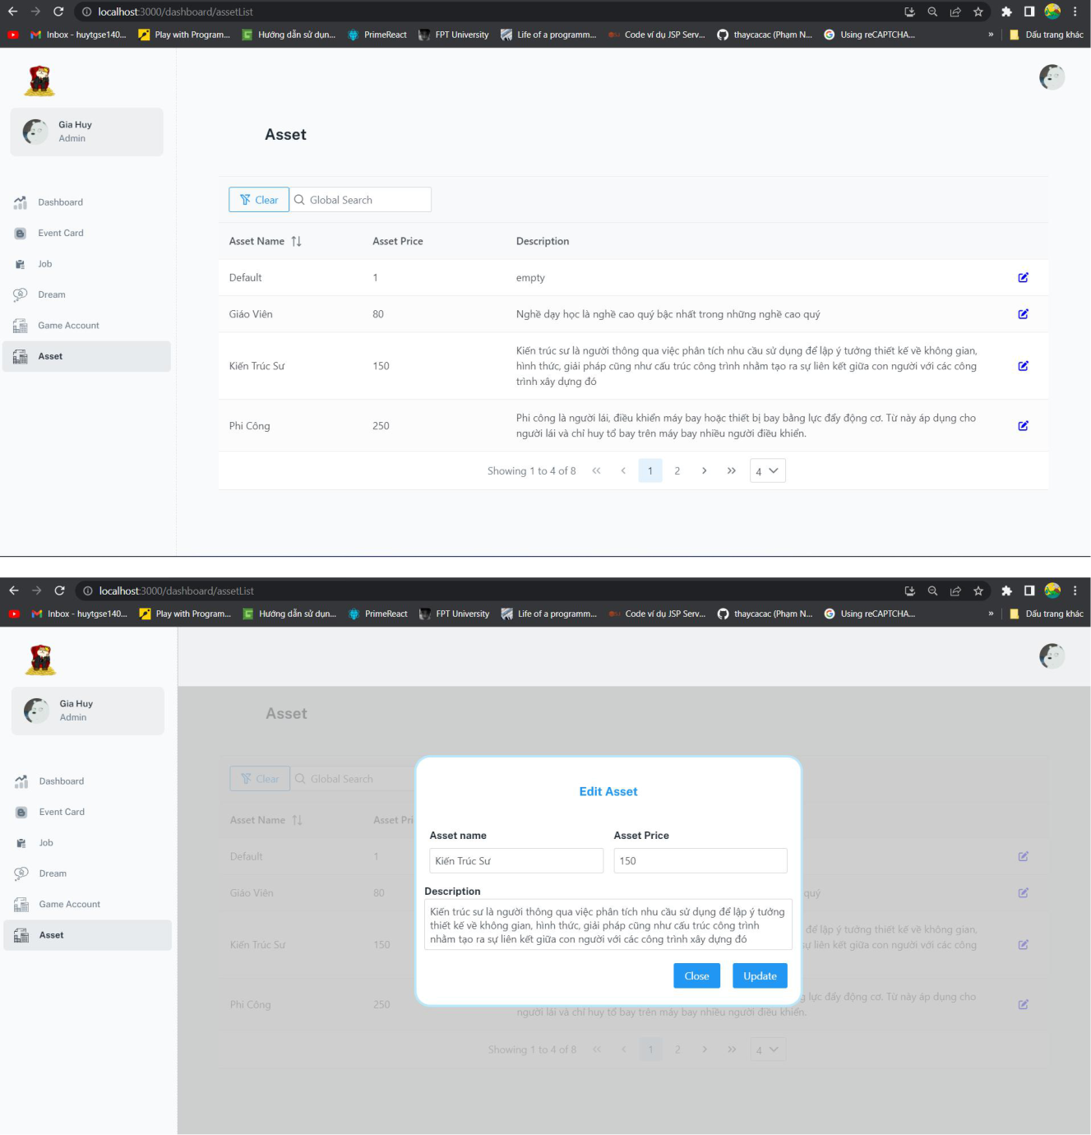

184

1. Click Asset button in navbar
2. Click “edit” icon button on the row want to update
3. Fill all information
4. Click “Update” button

185